Project Specification Document

--------------------------------------------------------------------------------------------------- **Document Version 1.0** **Latest updated: 16-03–2022**

**Author: Suraj Singh**

**E-commerce Website for Sporty Shoes Along with Other Categories**

**Content**

**1. About this Document------------------------------------------------------------1**

**1.1 How this Document is organized-------------------------------------1**

**1.2 Contact Information----------------------------------------------------2**

**2. Introduction------------------------------------------------------------------------3**

**2.1 Objectives------------------------------------------------------------------4**

**3. Flow chart--------------------------------------------------------------------------5**

**3.1 Flow chart diagram--------------------------------------------------------5**

**4. Solution Overview-----------------------------------------------------------------6**

**UI for User along with Functionalities---------------------------------5 to 28**

**UI for Admin along with Functionalities------------------------------28 to 51**

**Shopping Action Before Login Operation-----------------------------51 to 59**

**AboutUs View Page--------------------------------------------------------59 to 60**

**ContactUs View Page------------------------------------------------------60 to 62**

**5. Database Description---------------------------------------------------------62 to 67**

**6. Admin Credentials Detail-------------------------------------------------------68**

**7. GitHub link-------------------------------------------------------------------------68**

1. **About this Document**

This functional and integration (FIS) document will enable you to understand the proposed solution of E-commerceWebsite.com

The content of the document will have a solution and its configuration details as it will be available for our client.

**1.1 How this Document is organized**

This document is organized into following chapters:

**Chapter 1 -** "Introduction" provides solution scope to be delivered to our client.

**Chapter 2 -** "Flow chart" provides how the user is interacting with the application.

**Chapter 3 -** "Solution Overview" provides information on Company Lockers Pvt. Ltd., Components and Interfaces in system.

**Chapter 4- “GitHub link”** provides the information where the project is located.

**1.2 Contact Information**

E-commerce Website welcomes your comments and suggestions on the quality and usefulness of this document. For any questions, comments, or suggestions on the documentation, you can contact us at the following address:

|  |
| --- |
|  |

**2. Introduction**

This document describes the implementation of *E-commerce Website* and how its users can interact with the application.

*E-commerce Website is a portal that has an online Shopping Management System.*

***Under this website there is a special module called Sporty Shoes that will manage shopping and store for Sporty Shoes.***

*The system keeps track of its orders, products, products category, and purchase history. It has a back-office application with a single administrator login.*

**2.1    Objectives**

*E-commerce Website* is a company that manufactures and sells sports shoes, laptops, mobiles, kitchen, shoes and clothes. They have a walk-in store, and now, they wish to launch their e-commerce portal **sportyshoes** along with other categories of products.

We’re asked to develop a prototype of the application. It will be then presented to the relevant stakeholders for budget approval. Our manager has taken up a meeting where you’re asked to do the following things:

● Presenting the specification document which has the product’s capabilities, appearance, and user interactions

● Setting up Git and GitHub account to store and track your enhancements of the prototype

● Explaining the Java concepts used in the project

● Discussing the generic features of the product:

● There will be an admin to manage the website. An administrator login will be required to access the admin page.

**The admin should be able to change his password if he wants, he should be able to:**

● Manage the products in the store including categorizing them

● Browse the list of users who have signed up and be able to search users

● See purchase reports filtered by date and category

**3. Flow chart**

**3.1** The objective of this session to show how the user interacts with the flow of the *E-commerce Website for shopping modules Like SportyShoes, Laptops, Mobiles and etc.*

Home Page of App, Contains Product List and product list by categories

Registration

Login

If Check-out

Check-out Page and Removal Page

Logout

If Removal of Items

Will be eligible to perform Admin’s operations

**5 Solution Overview**

**Platform requirement**

The platform used for this project is the STS3 (Spring Tool Suit 3), Tomcat, MySQL Workbench and technologies I have used in this project are Hibernate, JAVA, Servlet, JSP, HTML, CSS, Maven and Java Script.

**5.1. UI for User:**

**Below is the welcome page of the application**

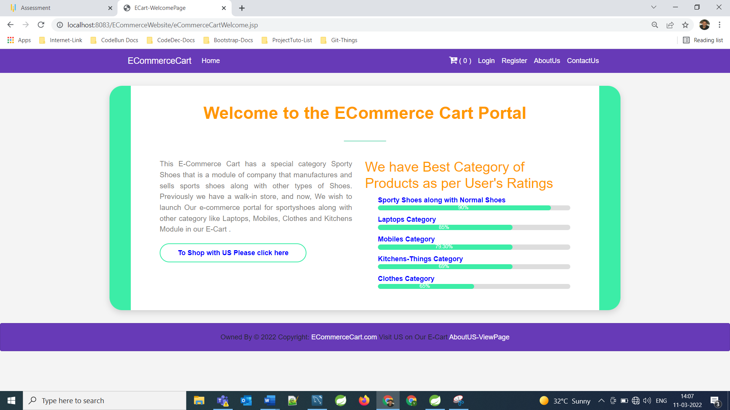

**Below is the home page of the application**

**====================================================================================================================**

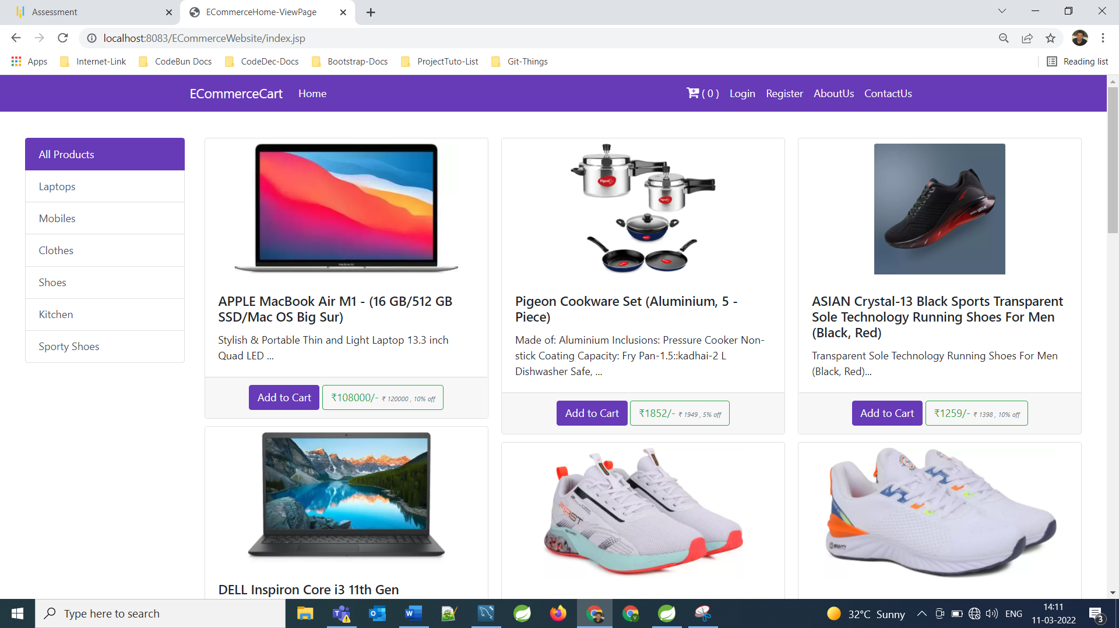

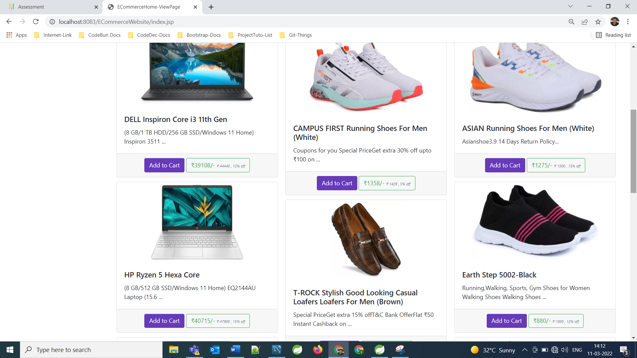

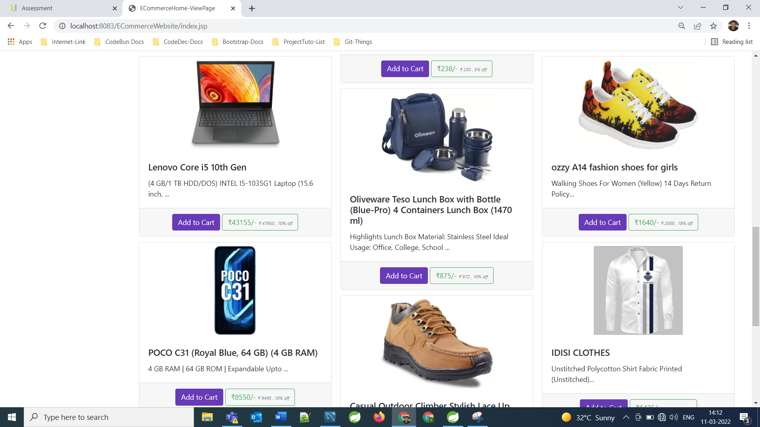 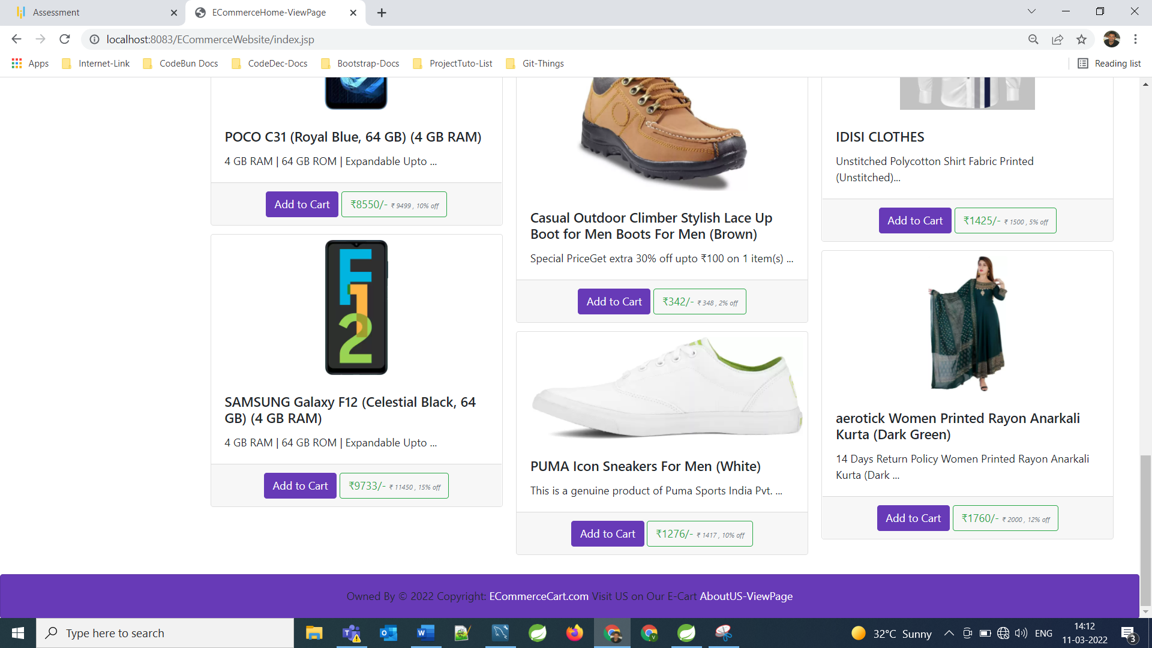

**Step 1 –**

User is allowed toregister as a user for shopping at E-Commerce Website. After that they can login as user and they can shop with us in the following category...

Laptops

Mobiles

Clothes

Shoes

kitchen

**And a Special Category on demand of application that is**

**Sporty Shoes**

In order to access the admin panel, the admin must provide Admin’s credentials, then admin panel will be opened where admin can perform admin’s actions and admin’s management.

**Registration Form for User**

**====================================================================================================================**

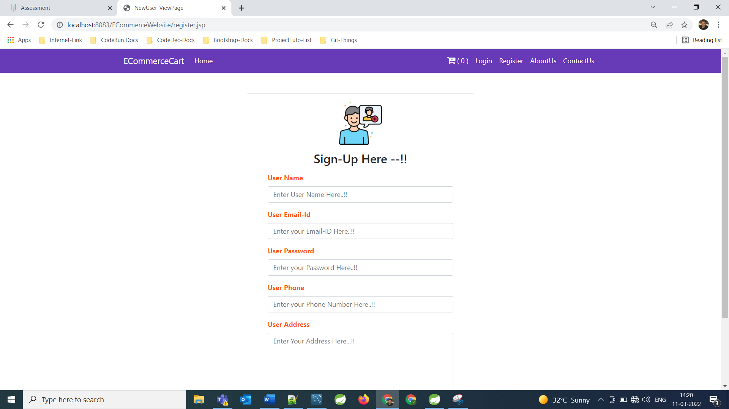

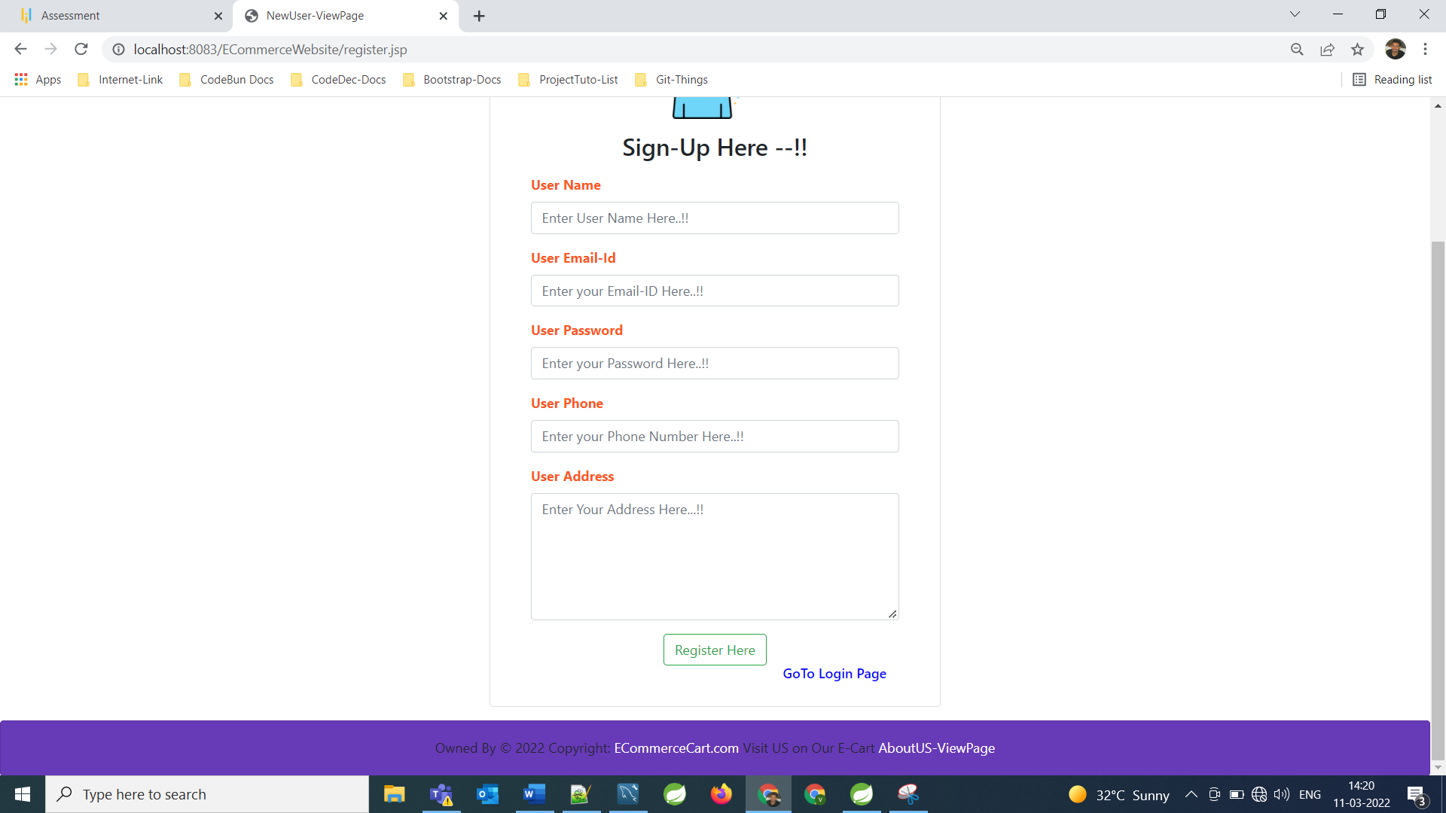

**Login Form:**

**====================================================================================================================**

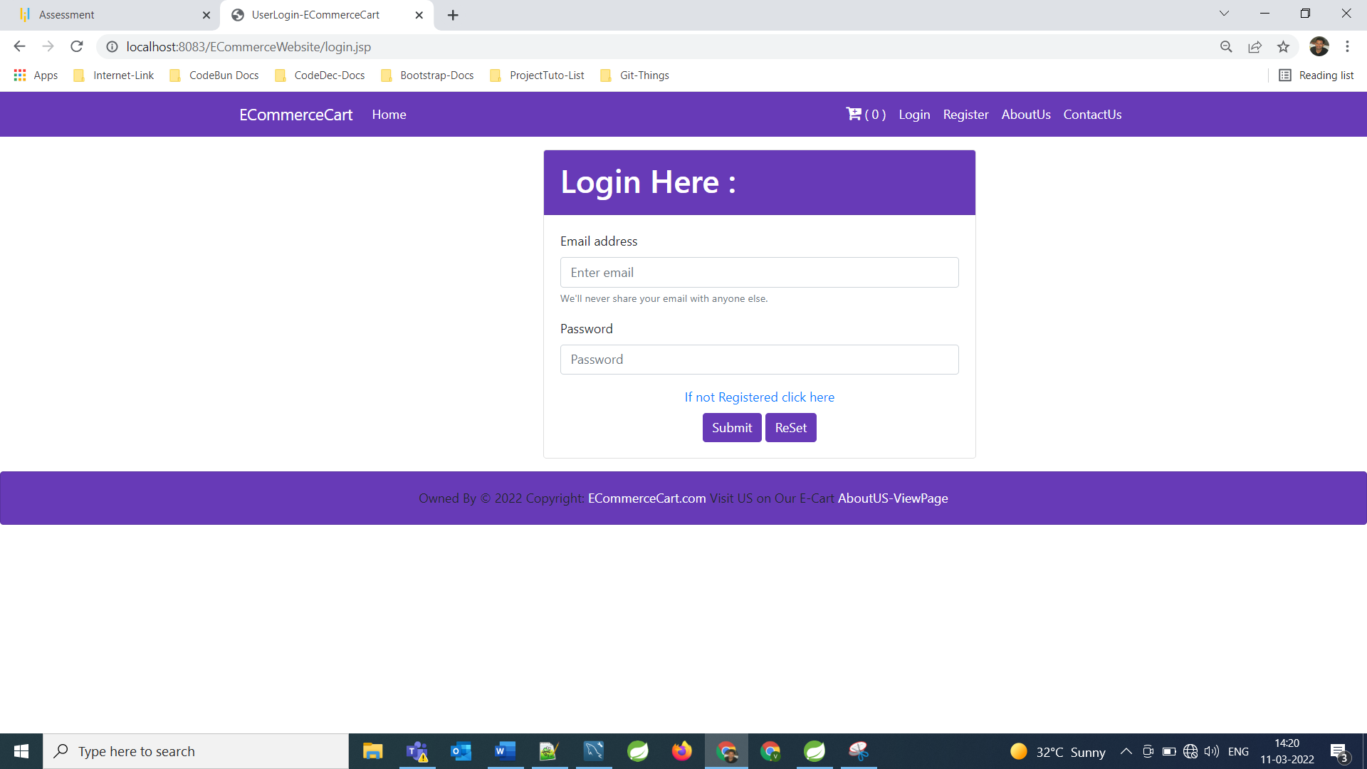

**After Logined as User:**

**====================================================================================================================**

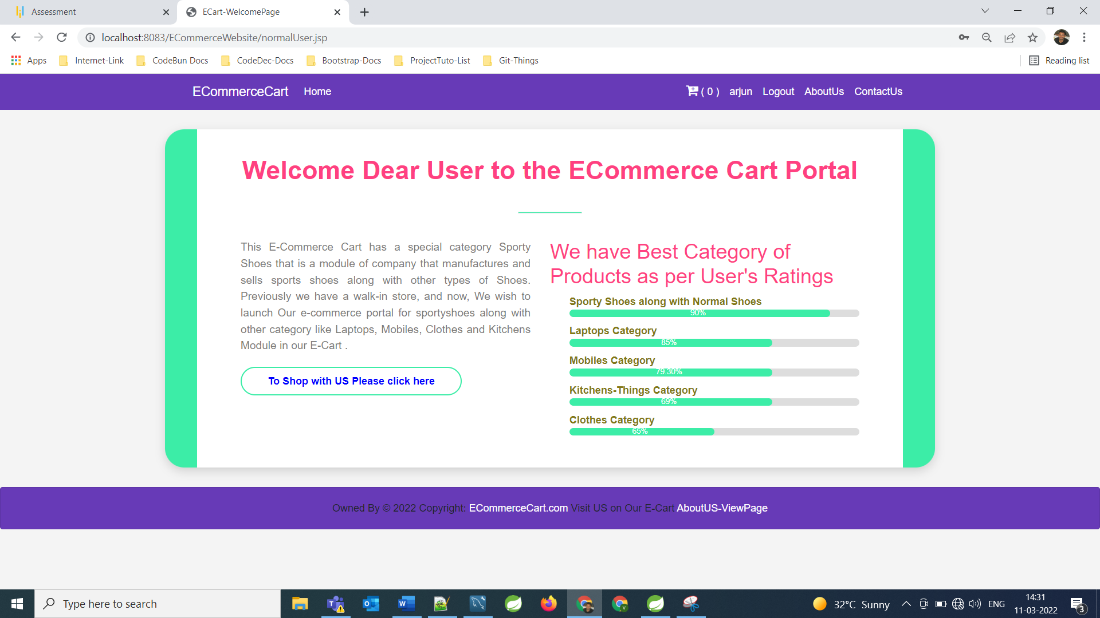

Now User Session will be activated as we can see in the navbar-logout button is activated.

Now for Shopping user can go to their home page and they can start their shopping with US.

Even without Logined also user or admin can shop and can add items in the cart and later during checkout or payment Login operation by default will be activated and then they need to login to complete shopping.

**For Shopping action user or admin can go to Home Page and from there they can choose their category of Shopping List then they can add product to the cart, Screen shots for these Operation are:**

**====================================================================================================================**

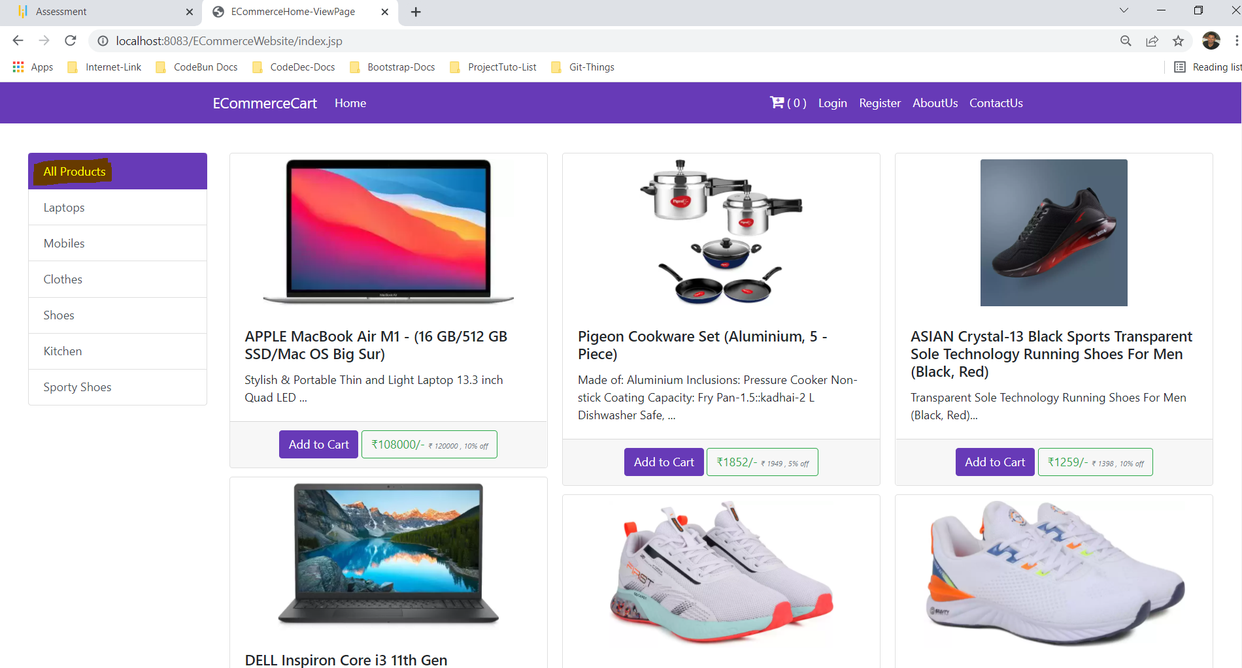

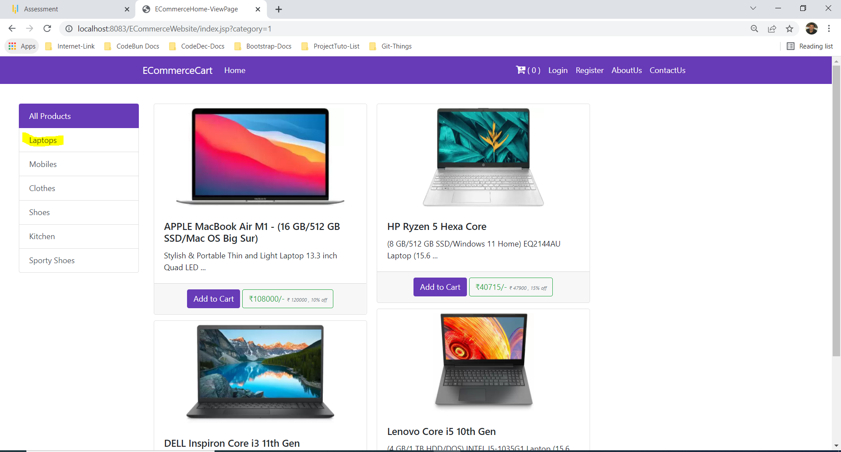

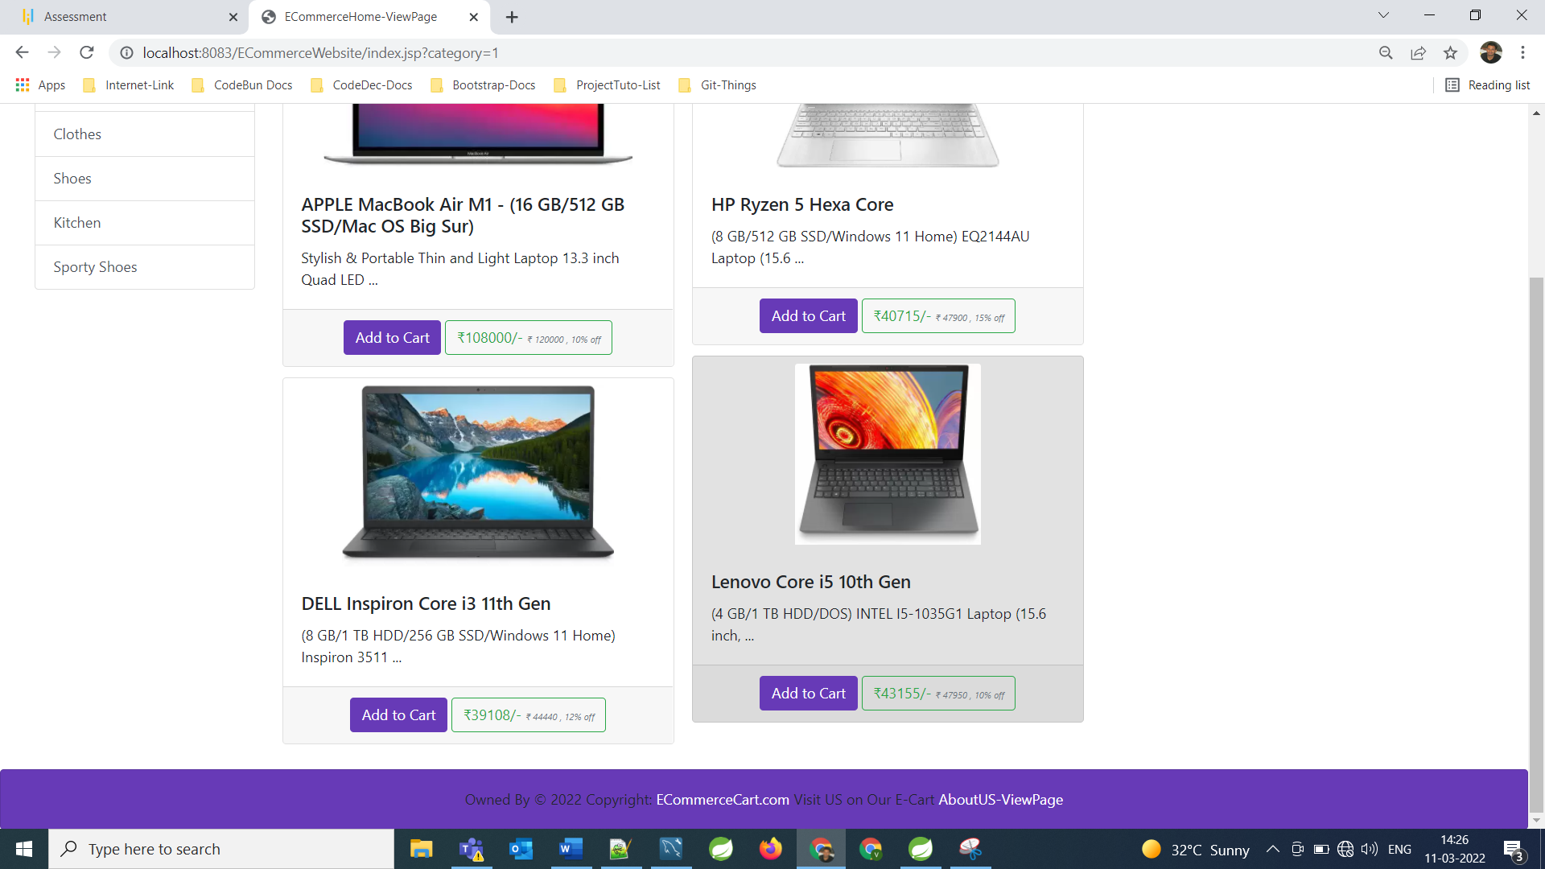

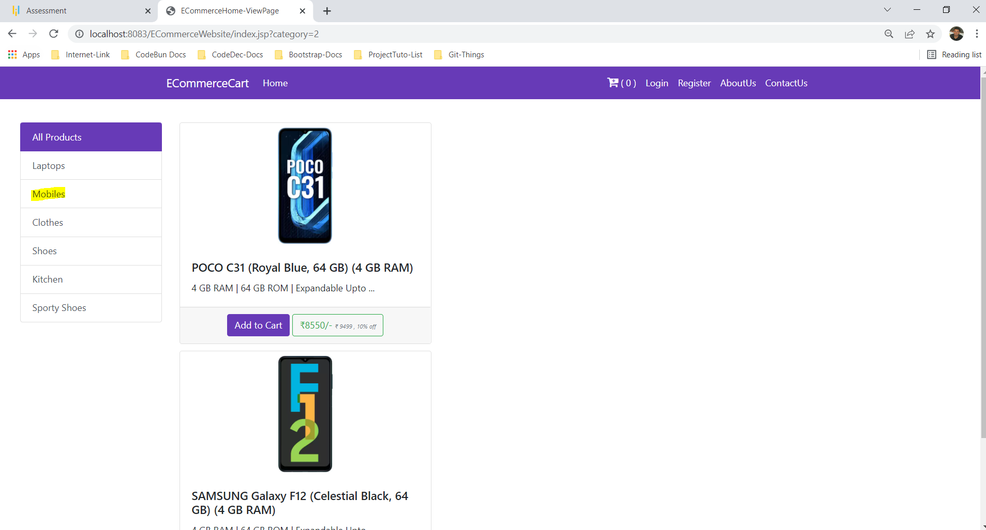

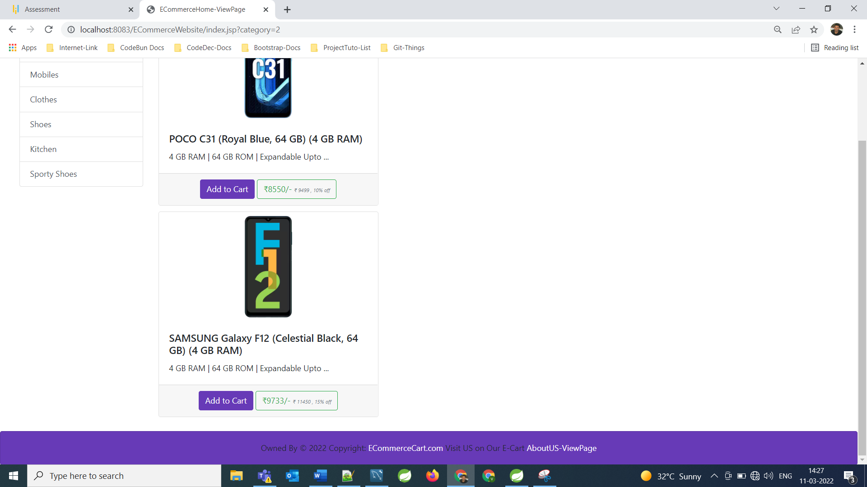

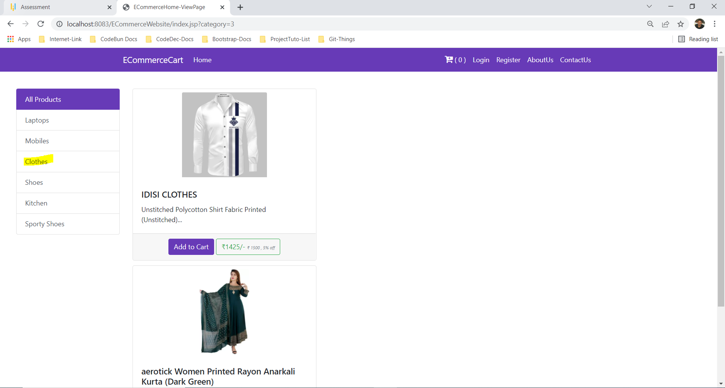

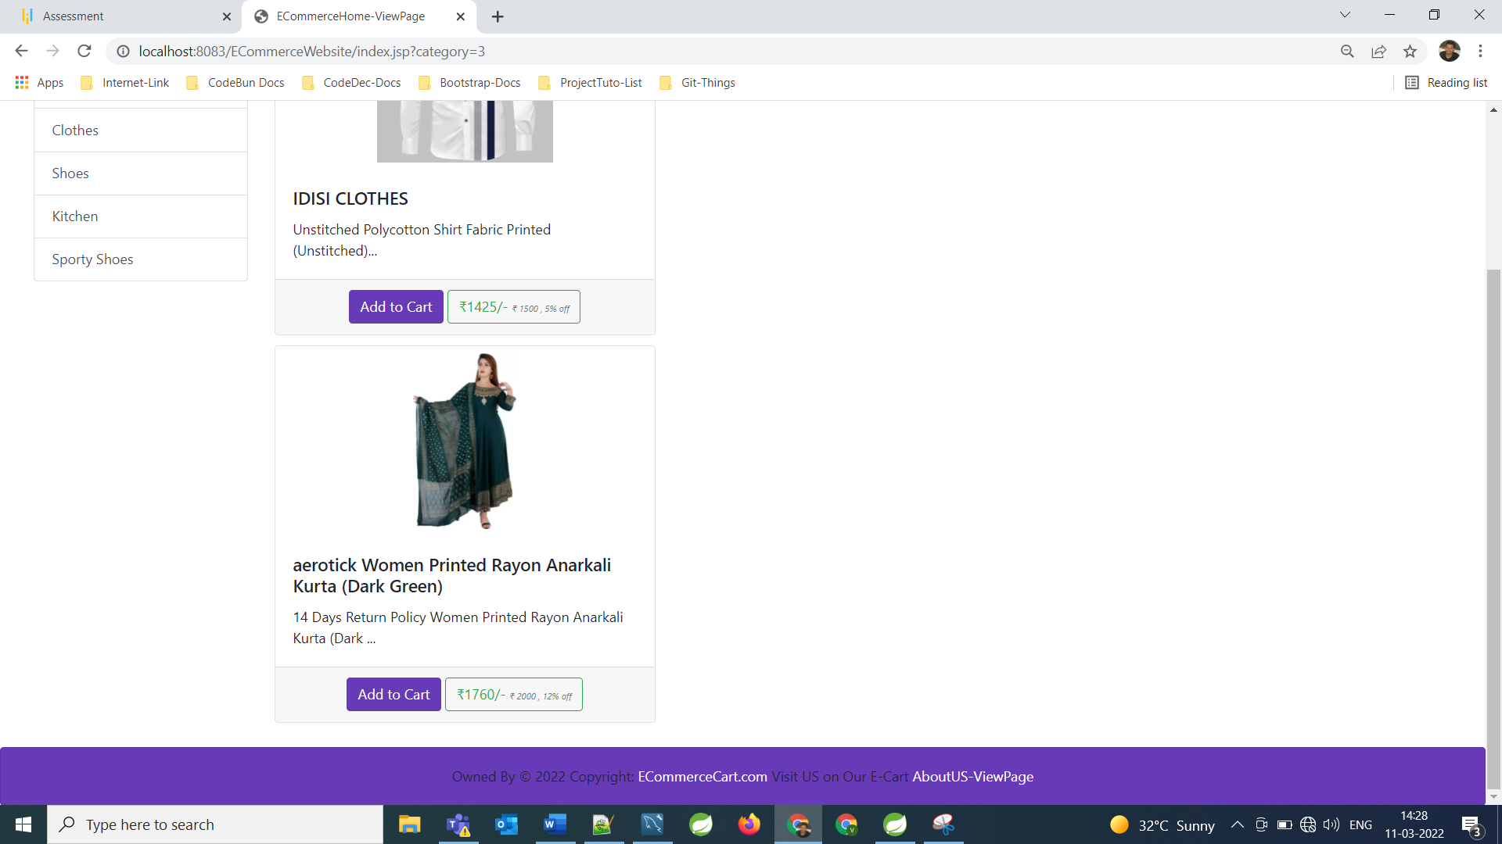

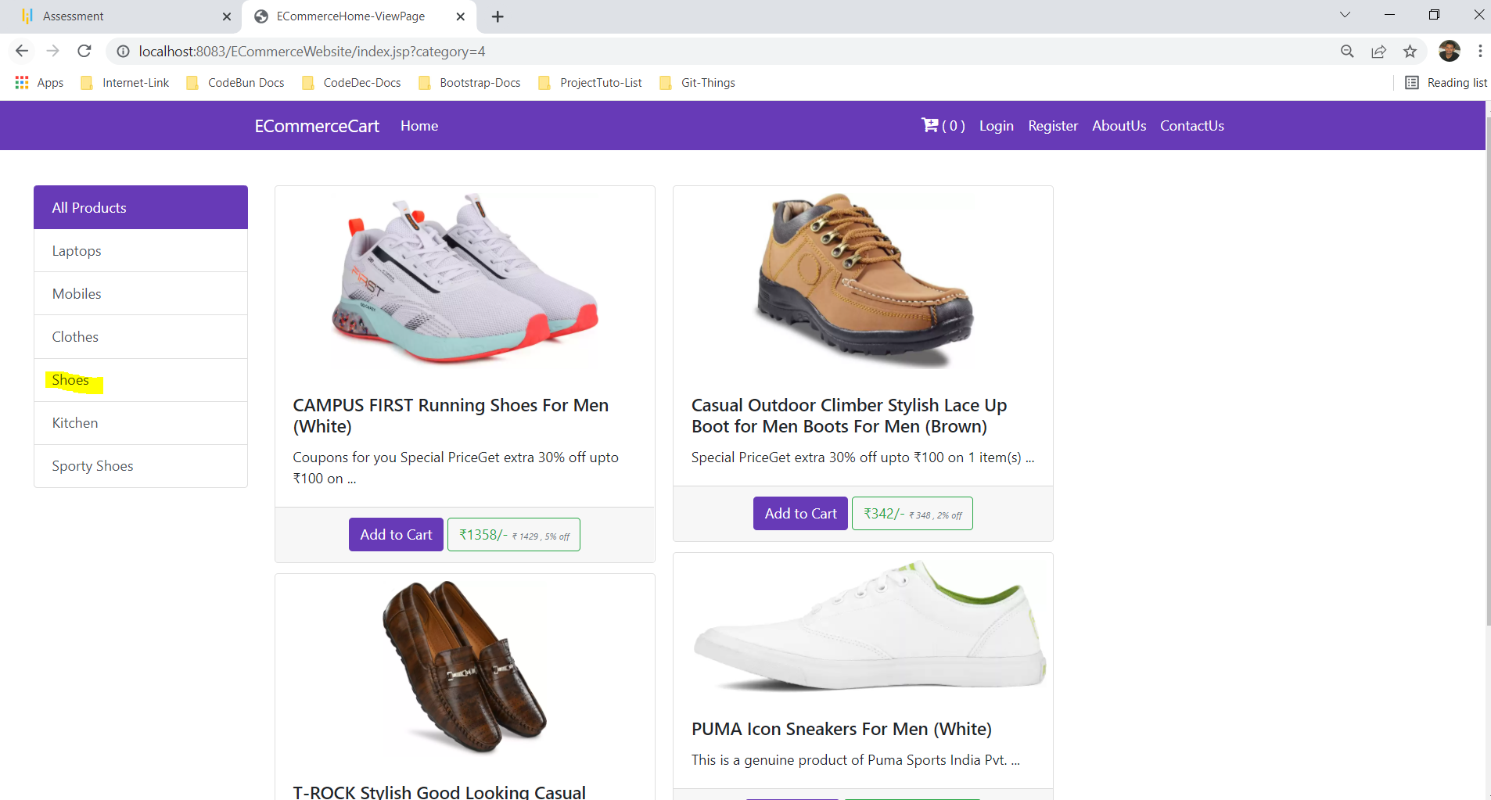

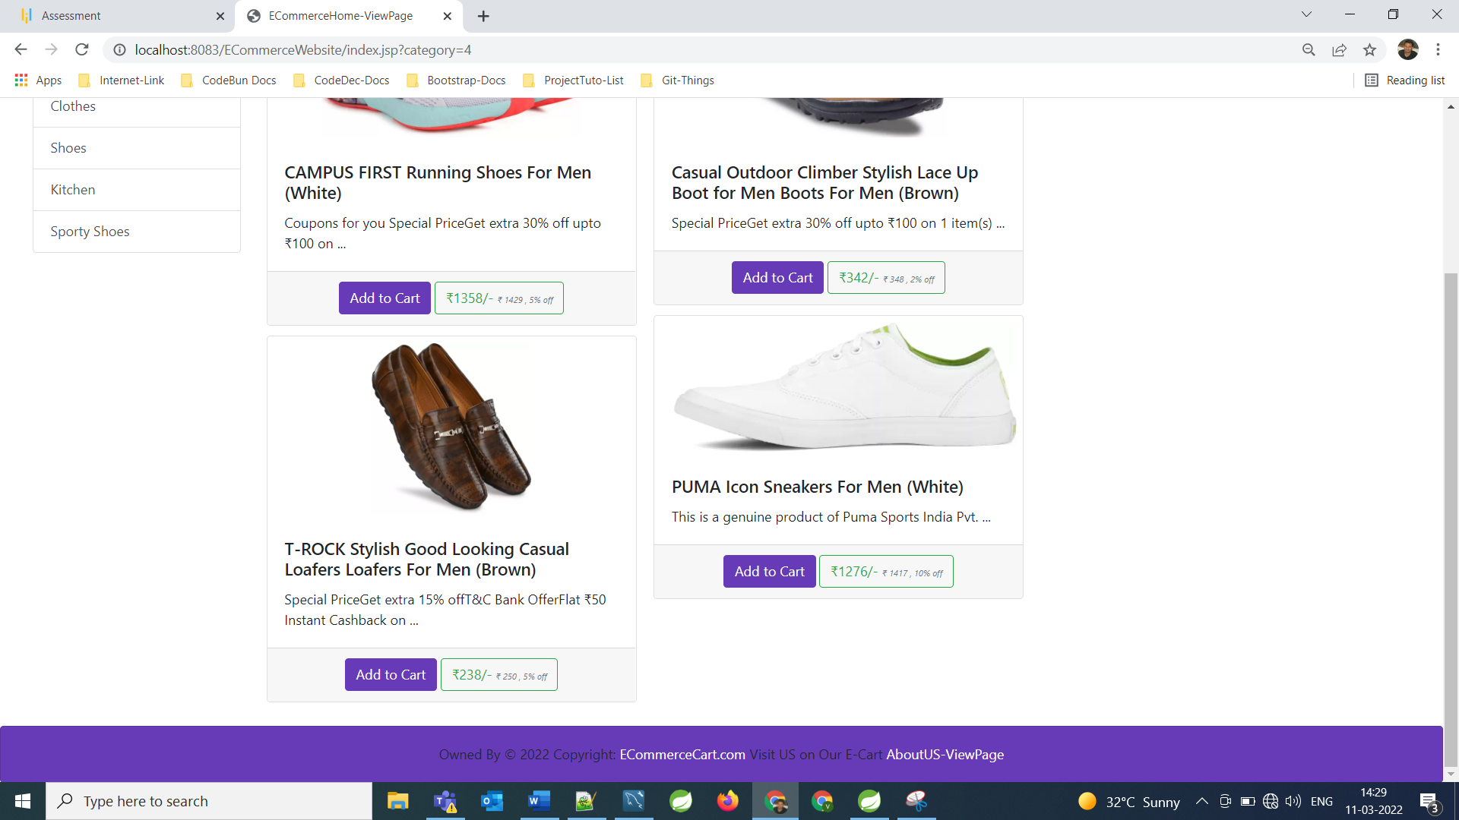

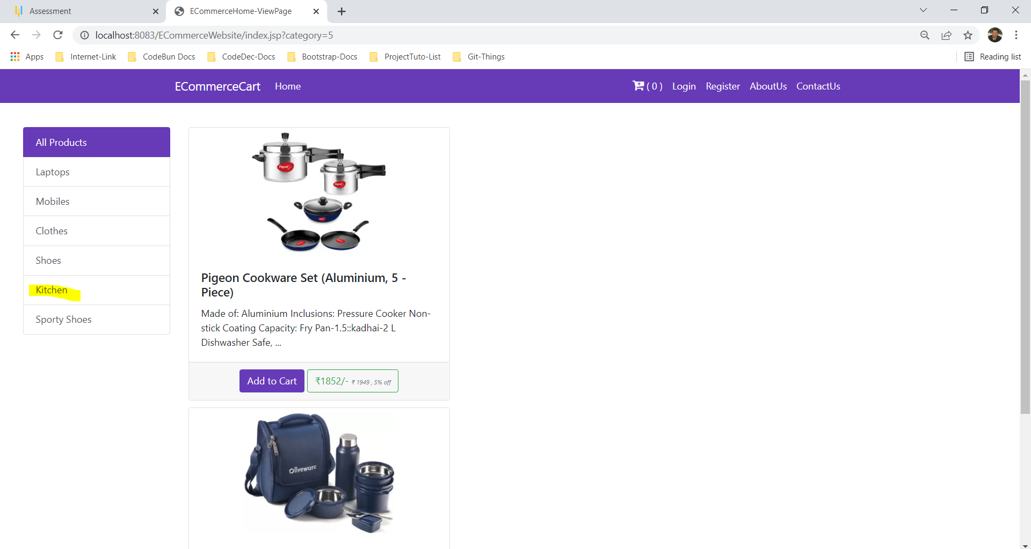

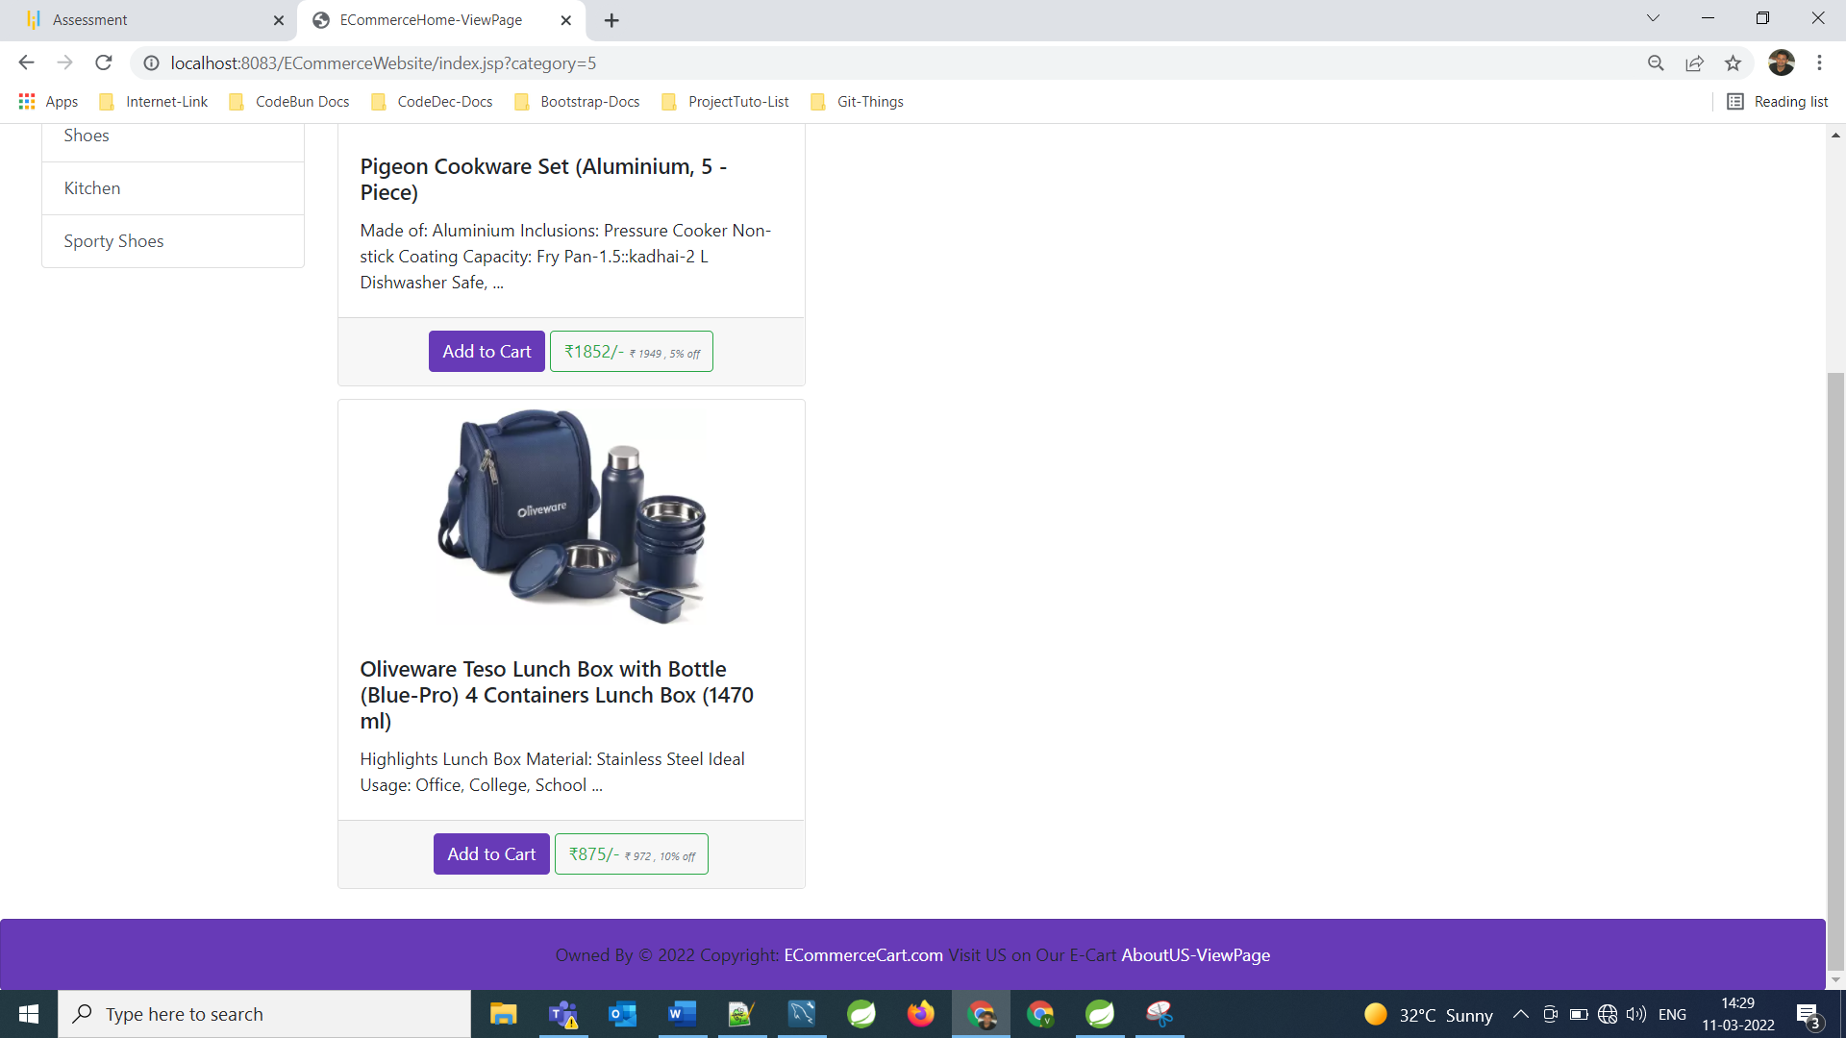 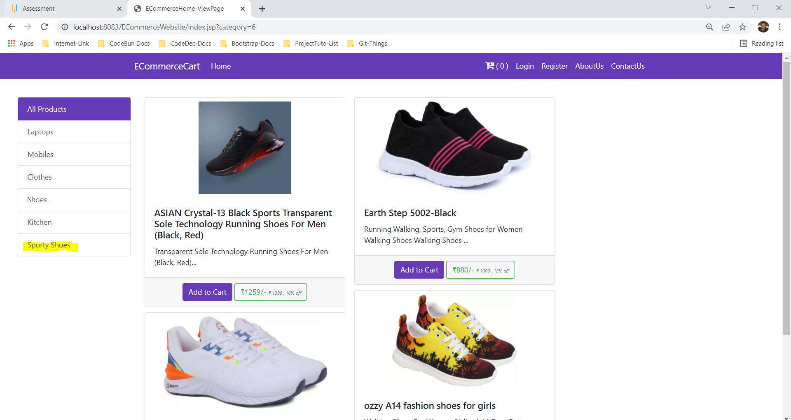

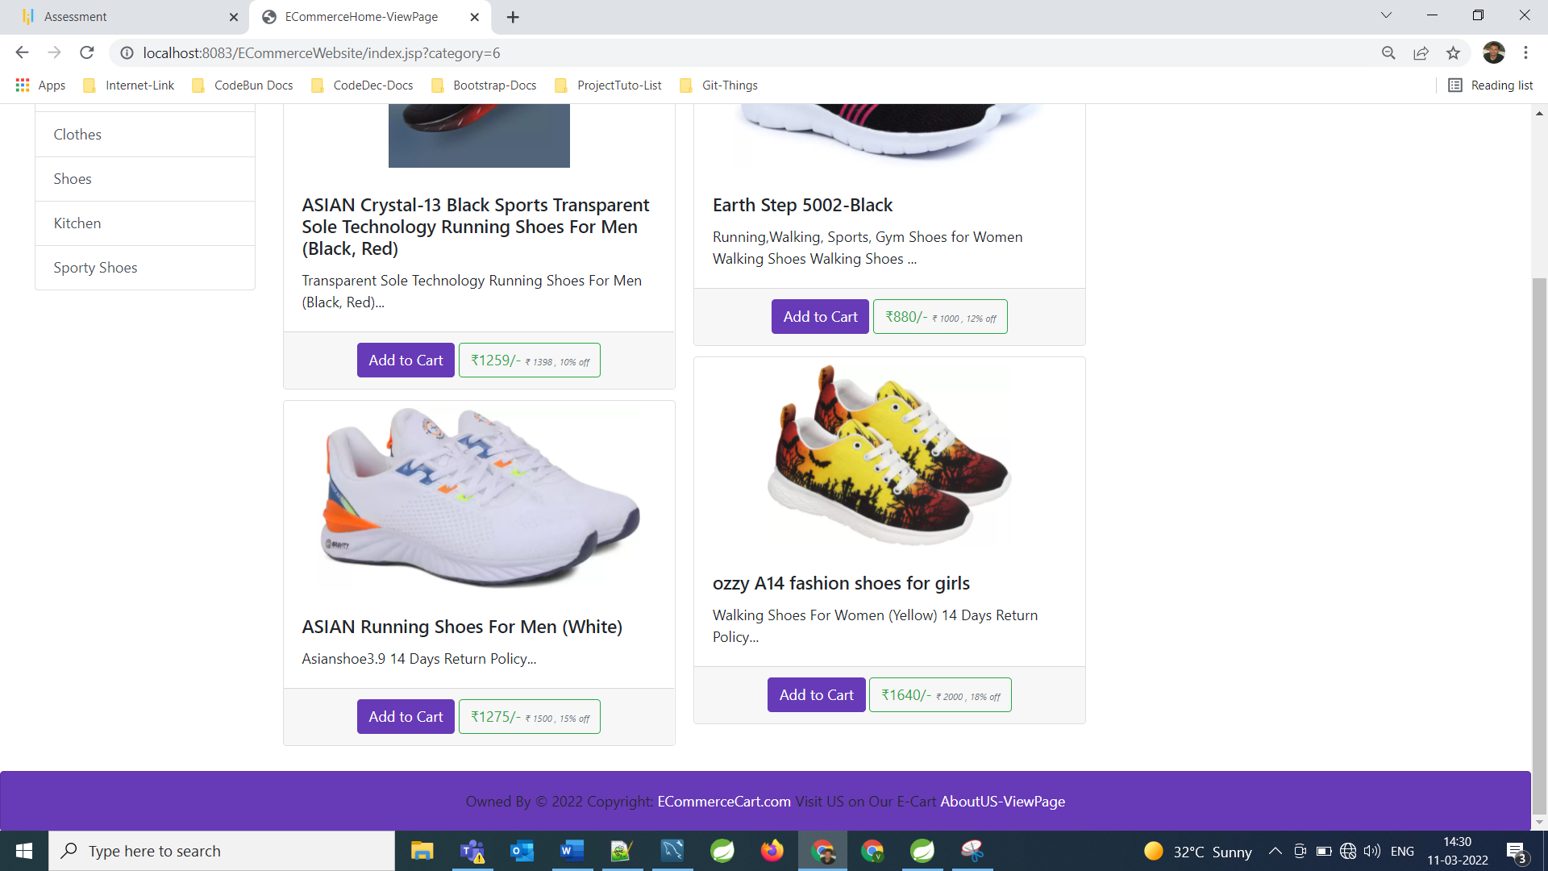

**Shopping while Login as User**

**====================================================================================================================**

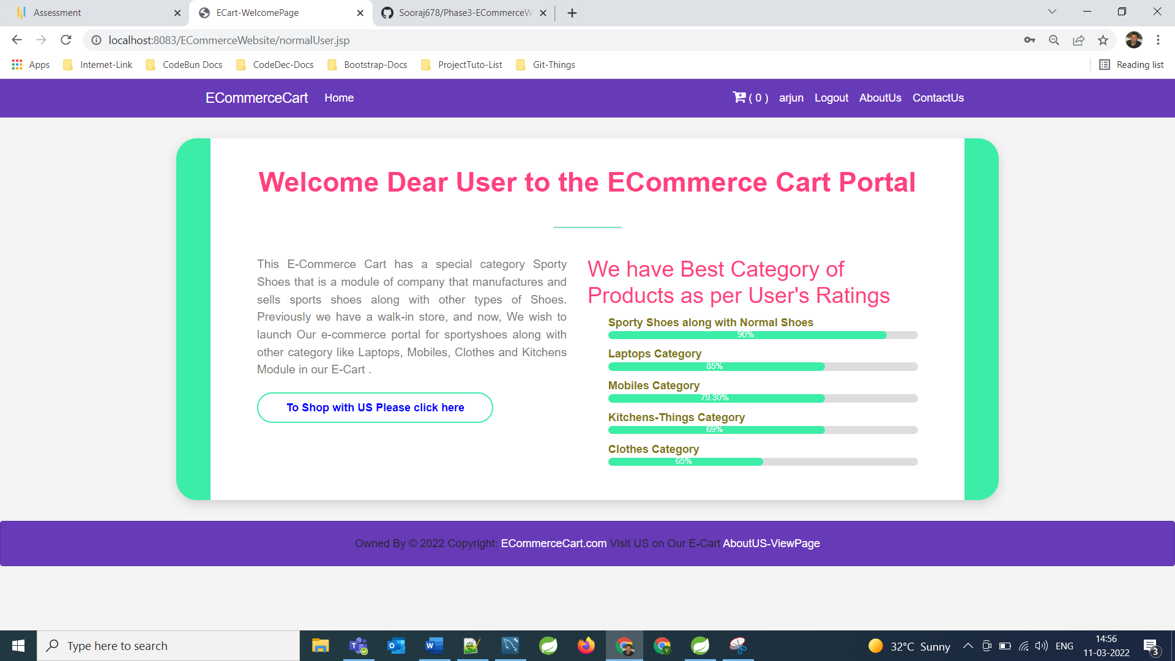

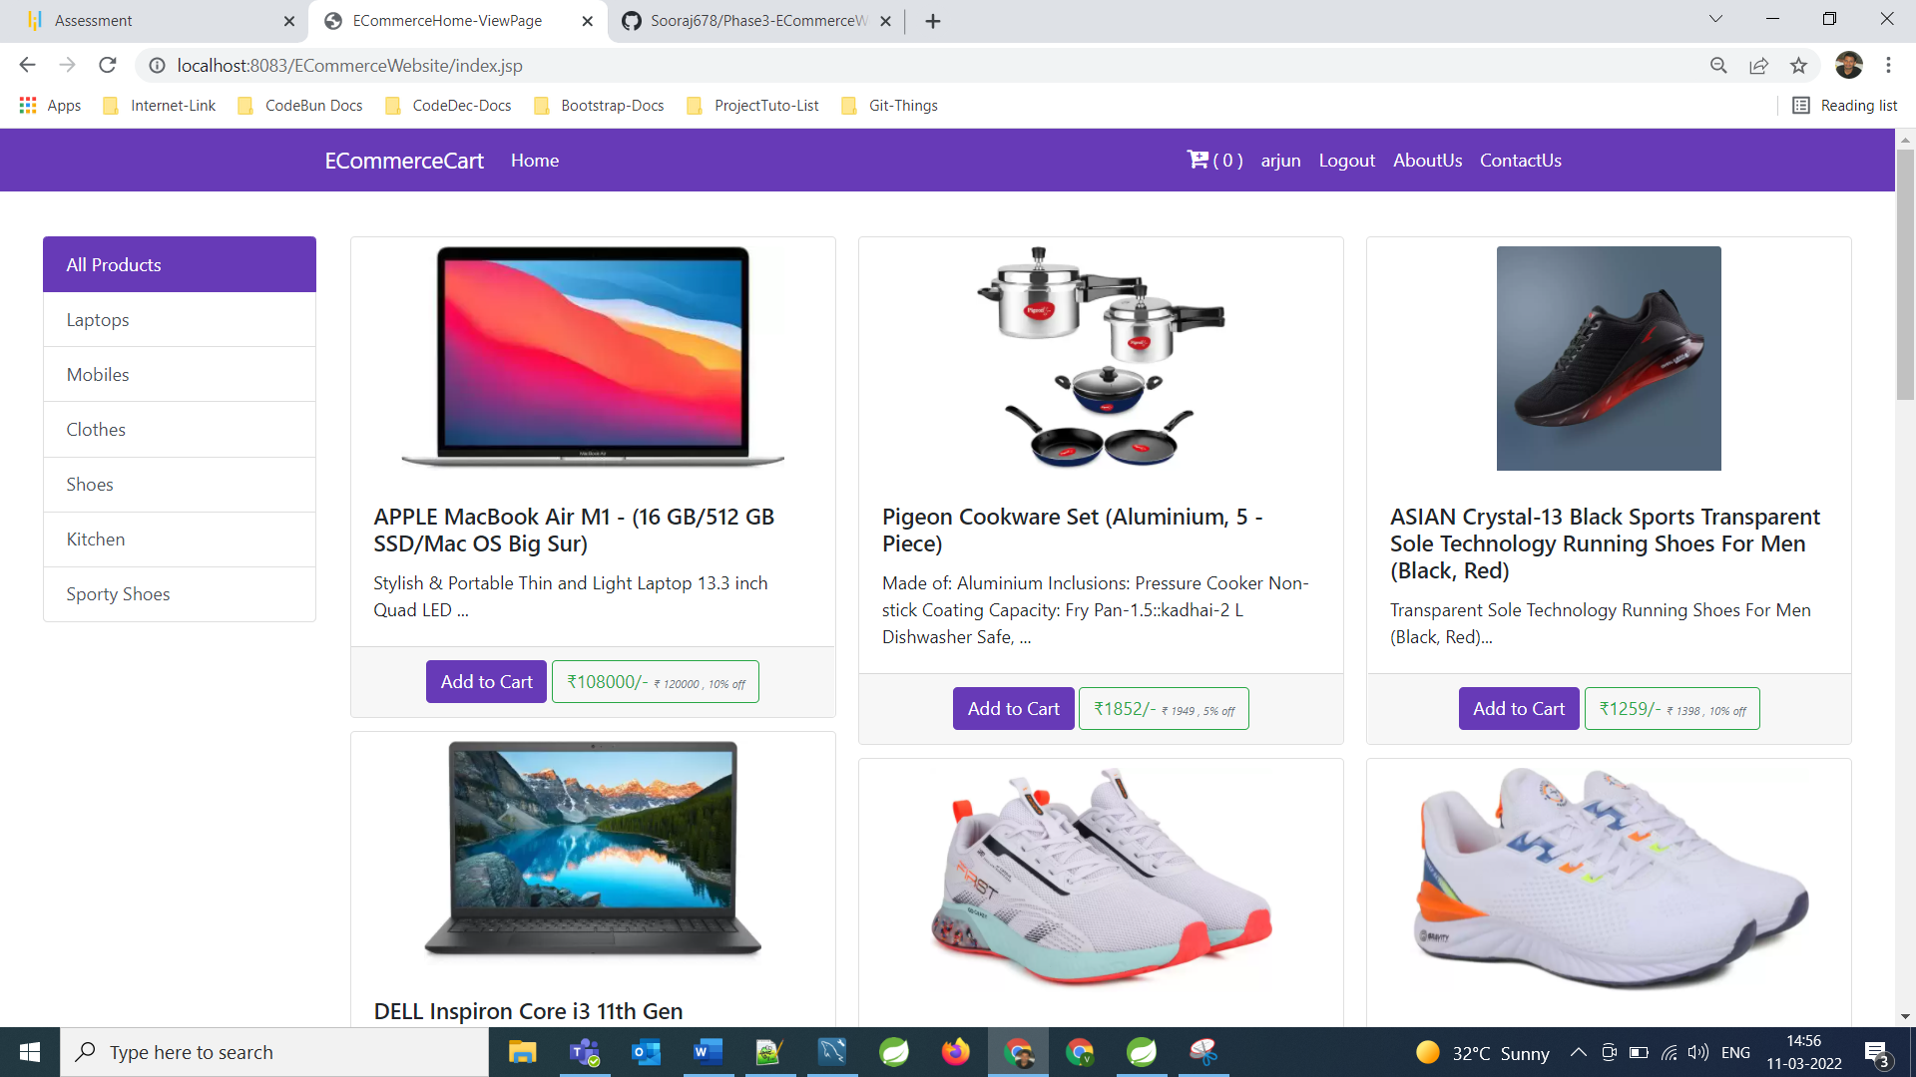

**Added 3 items of different category in the cart**

**====================================================================================================================**

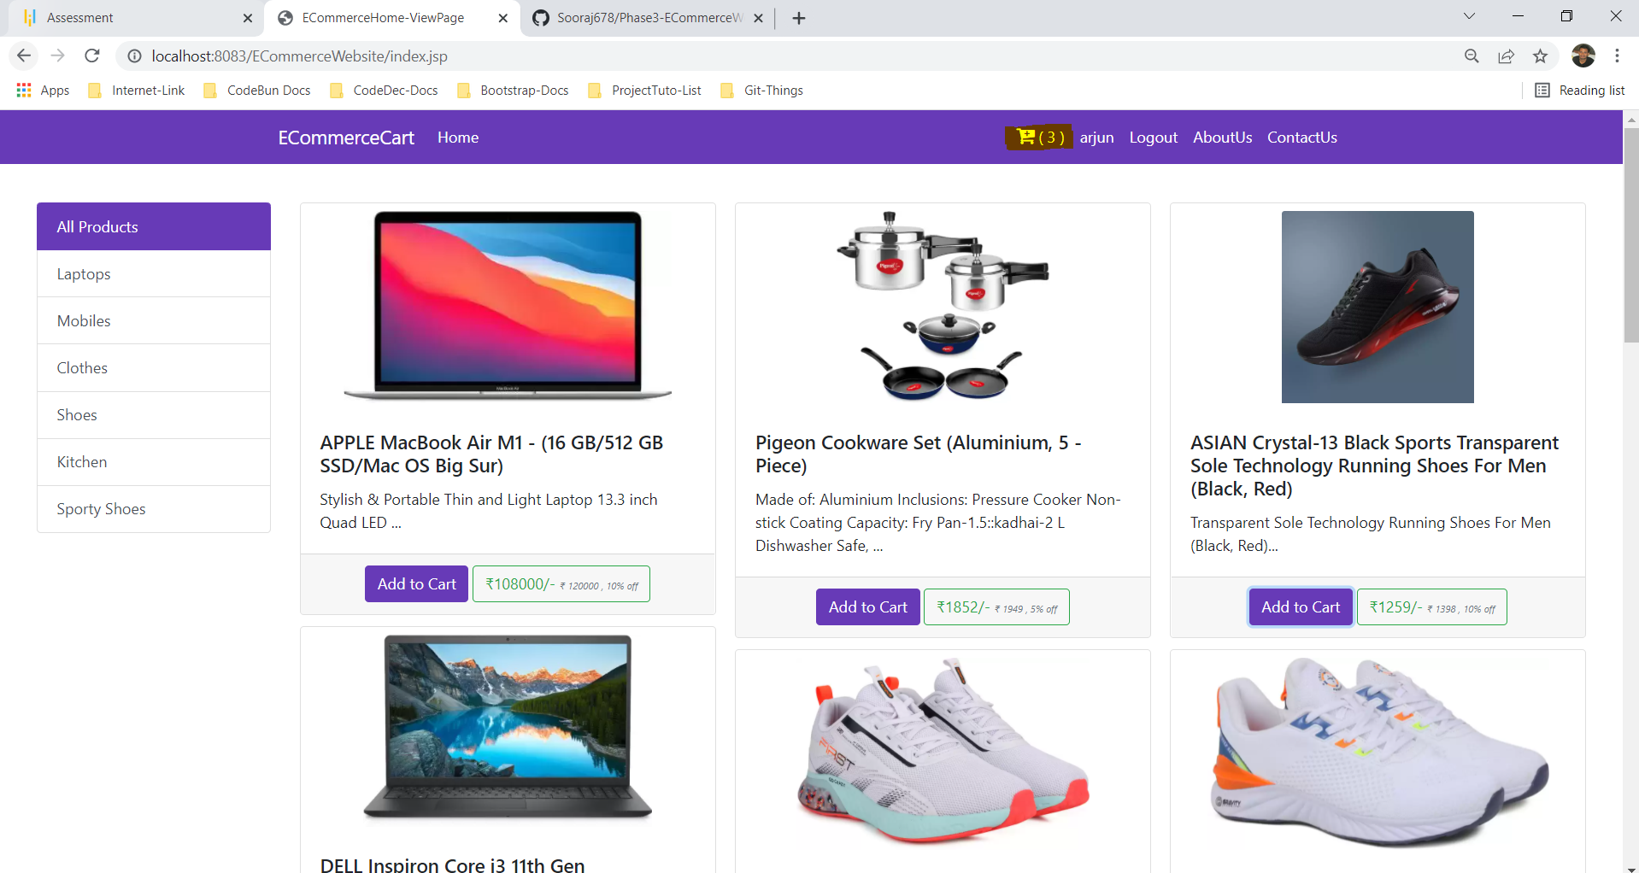

**Cart View:**

**====================================================================================================================**

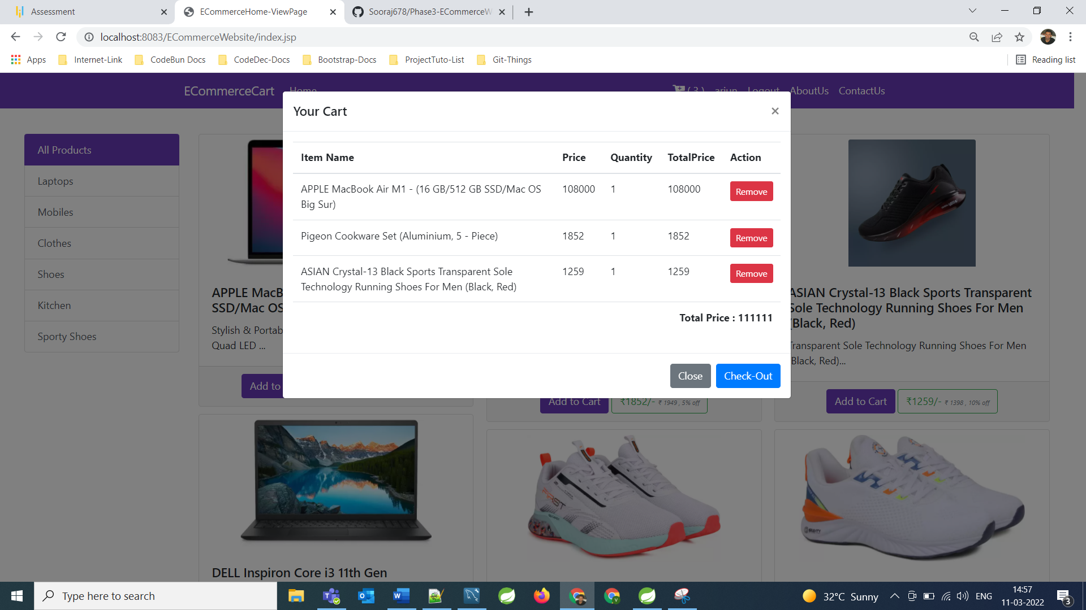

**From Cart we can remove the items also:**

**====================================================================================================================**

**Checkout Page View:**

======================================================================================================

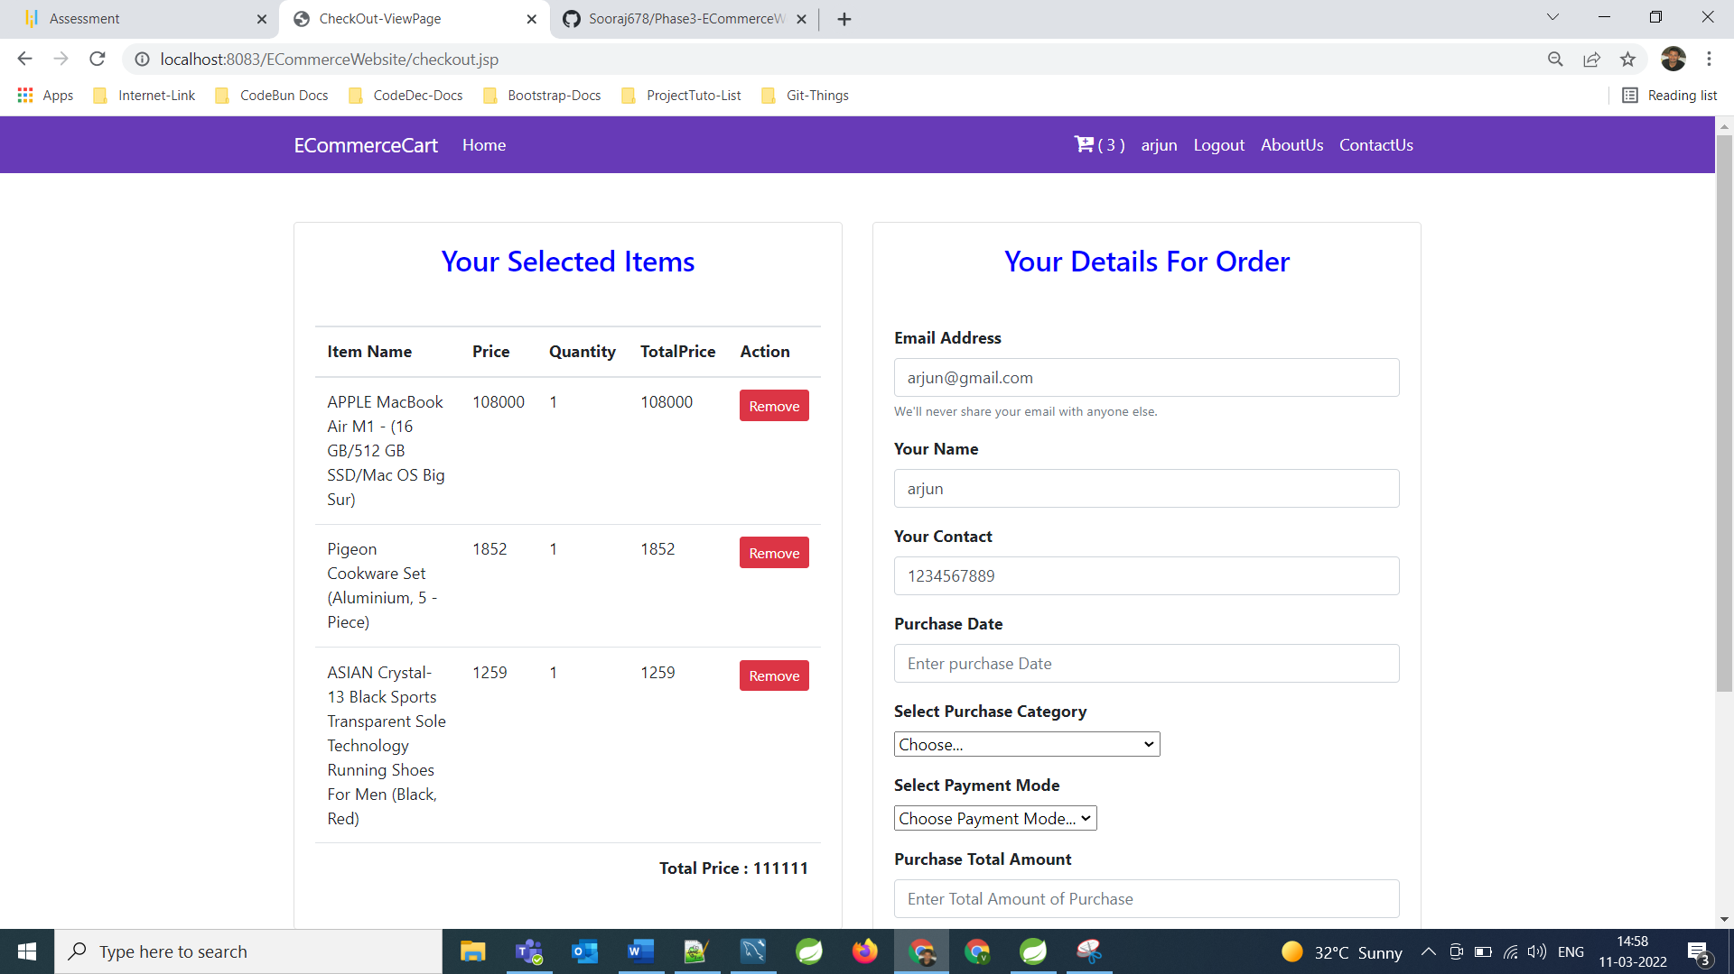

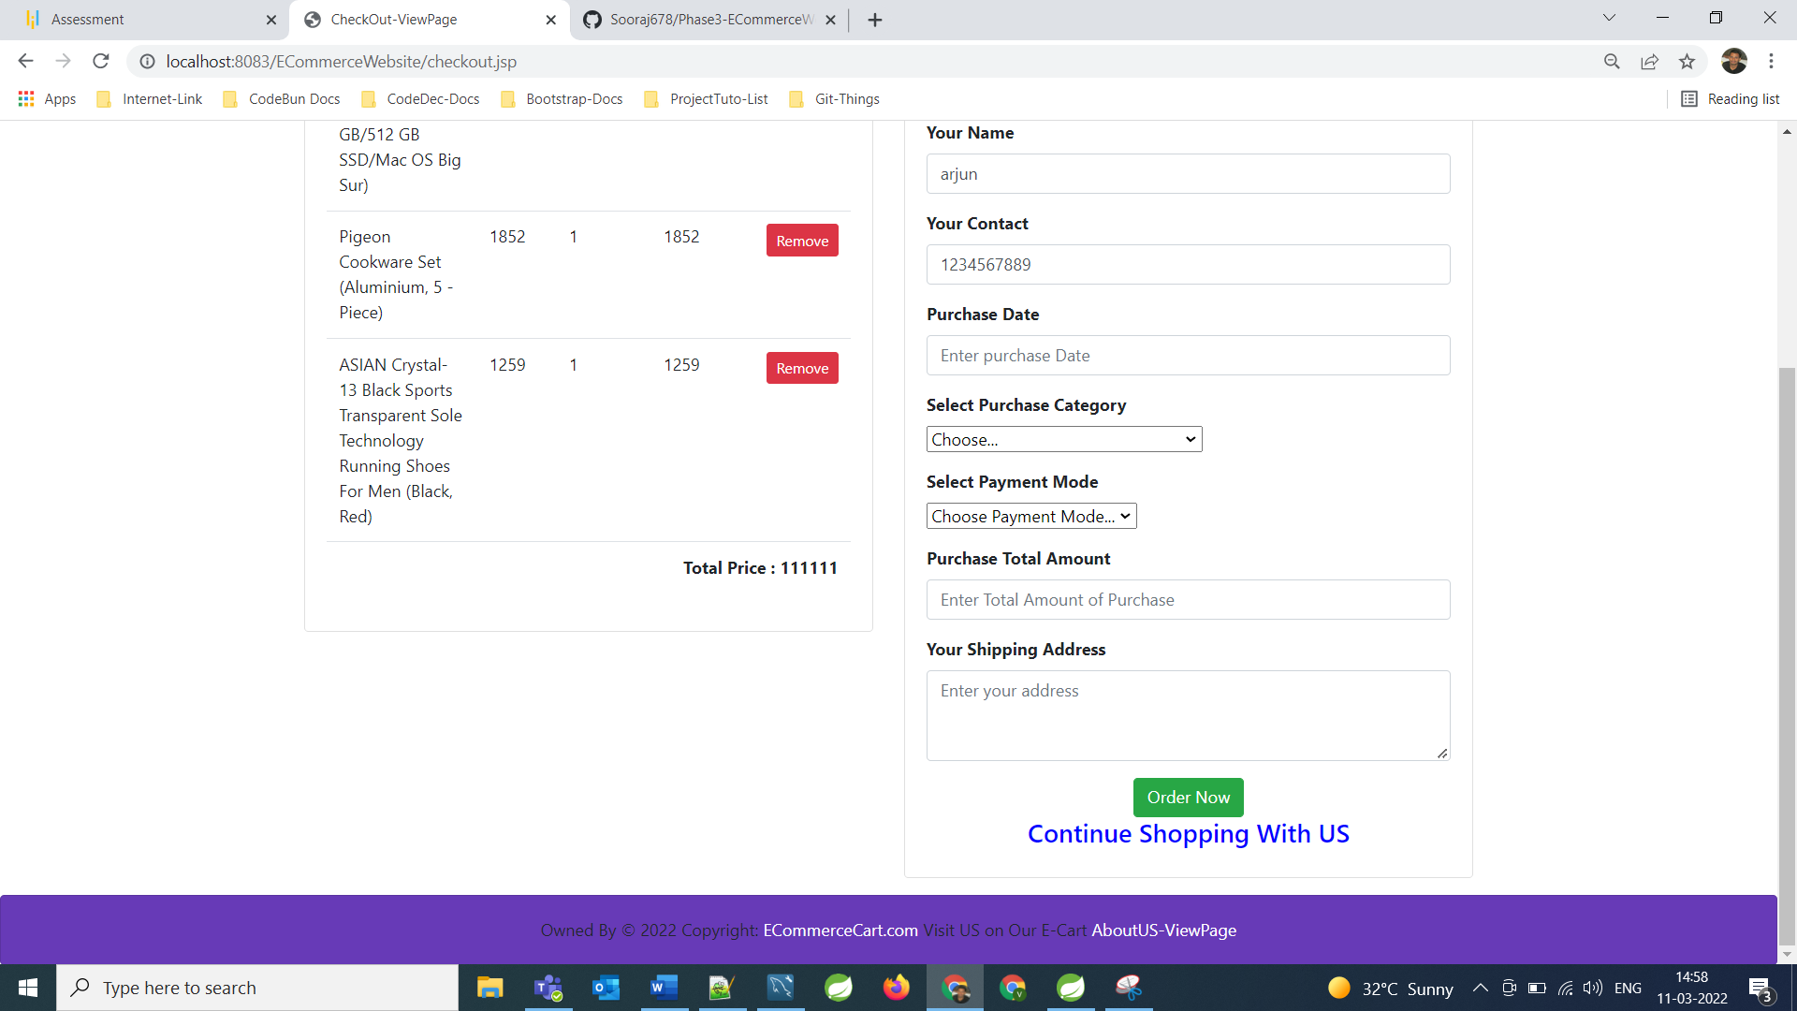

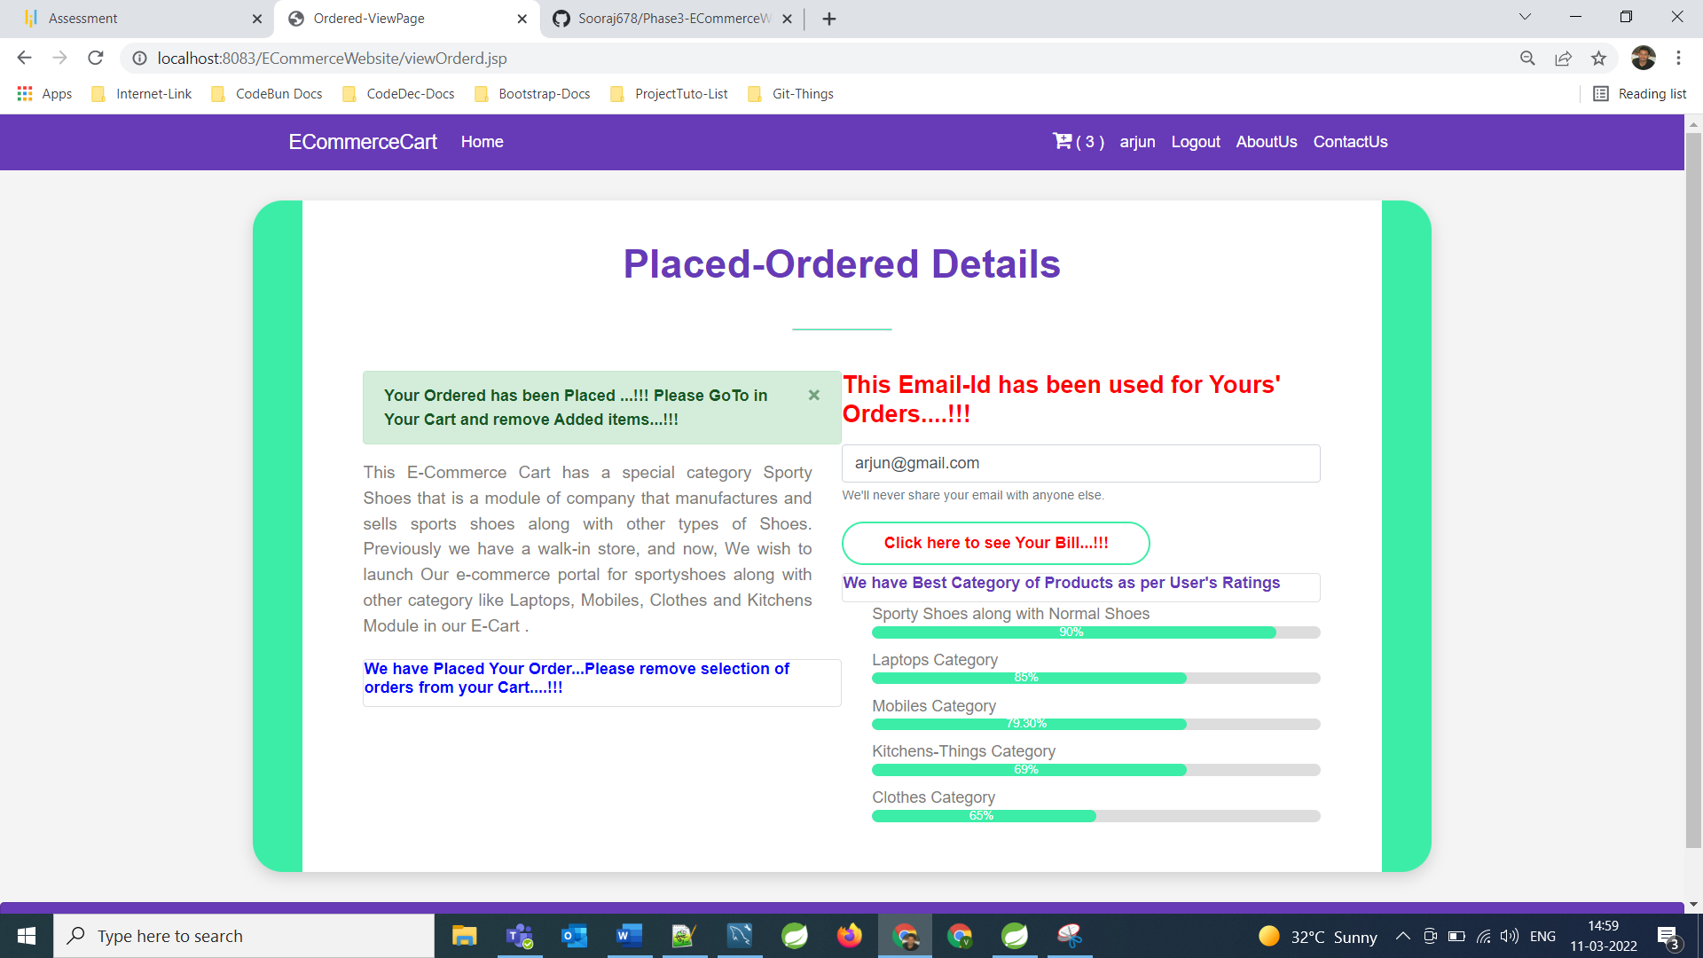

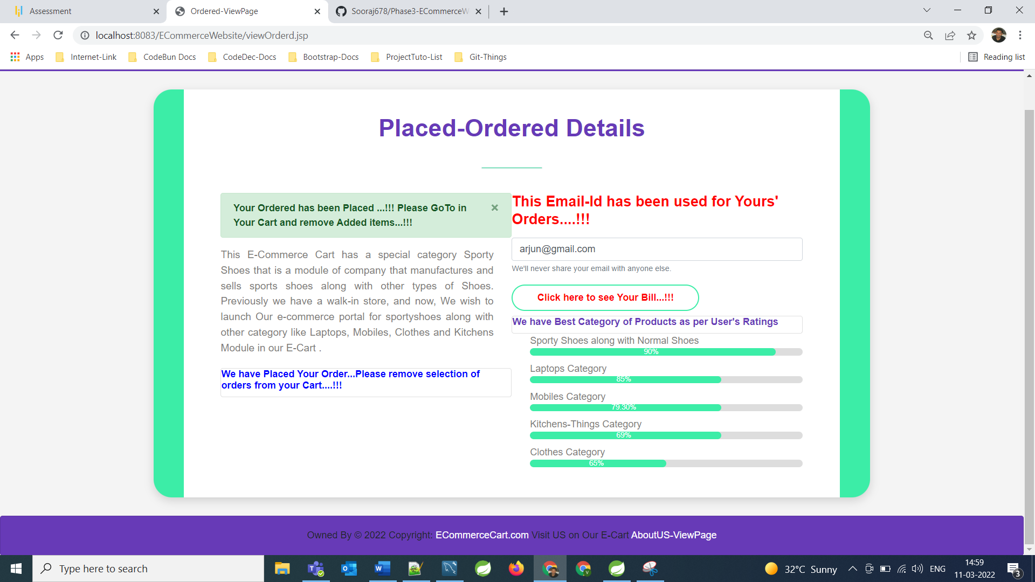

**Click to see your Bill:**

**====================================================================================================================**

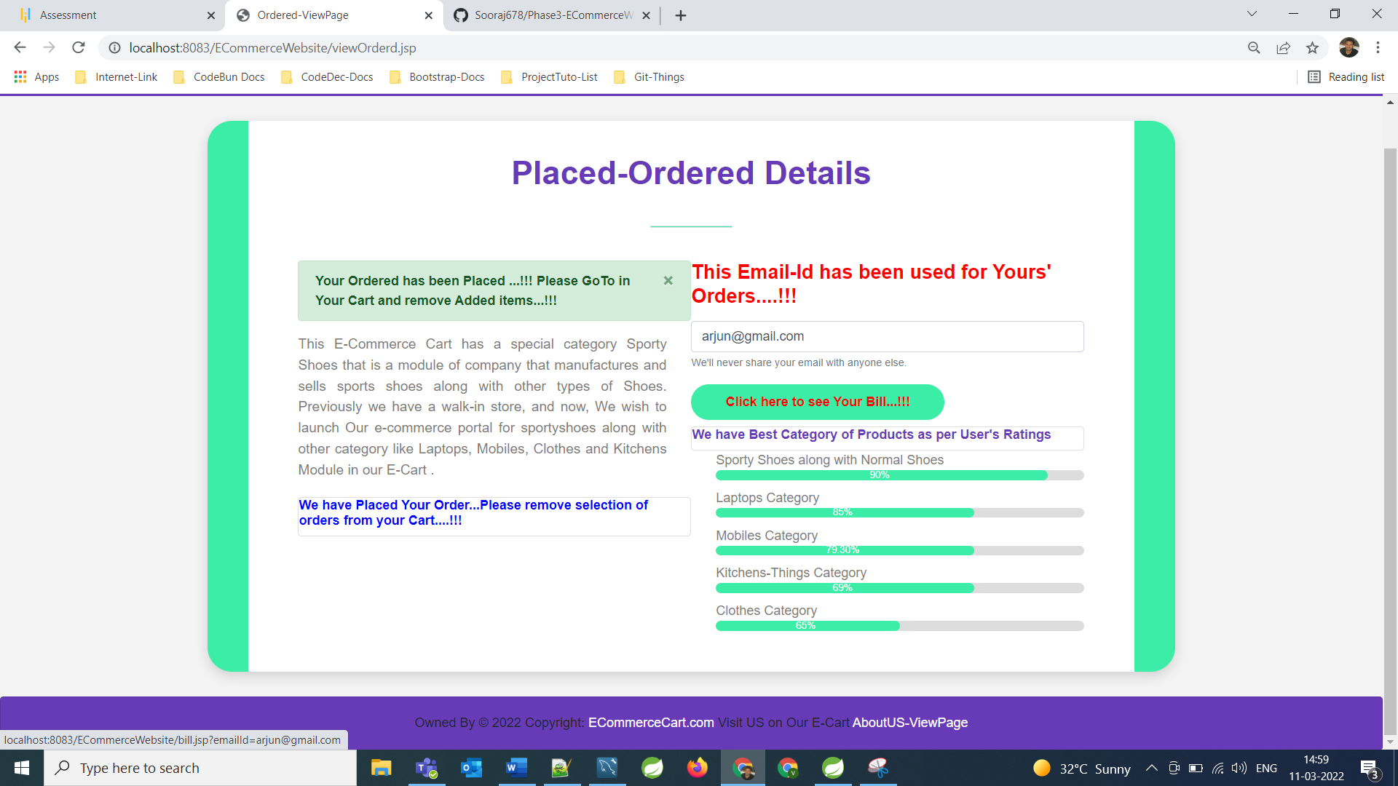

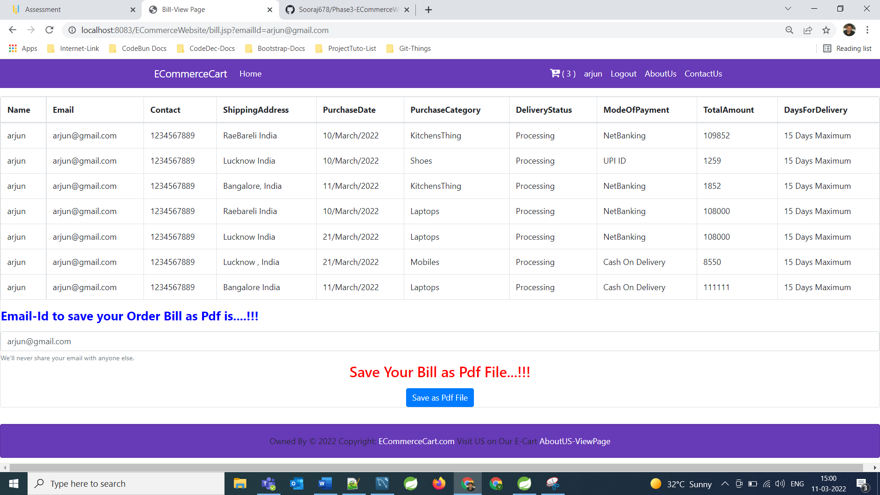

**Click on Save as Pdf File of your bill locally**

**====================================================================================================================**

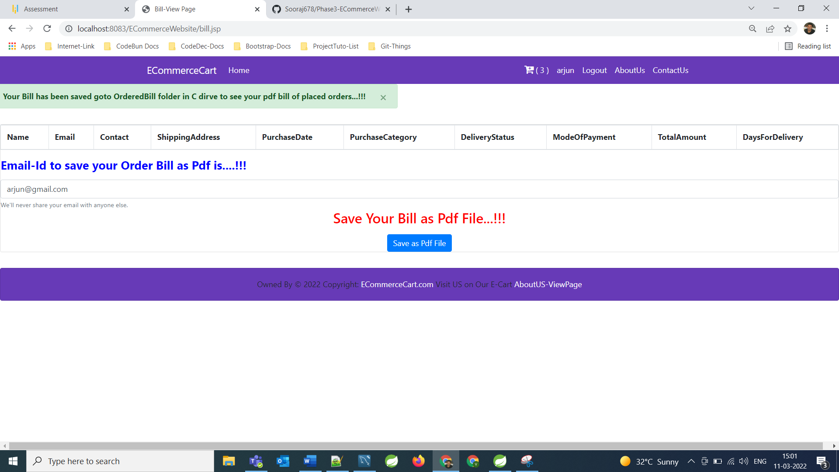

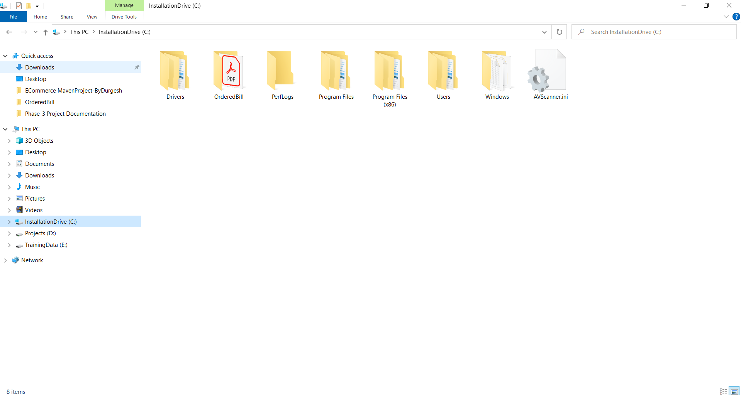

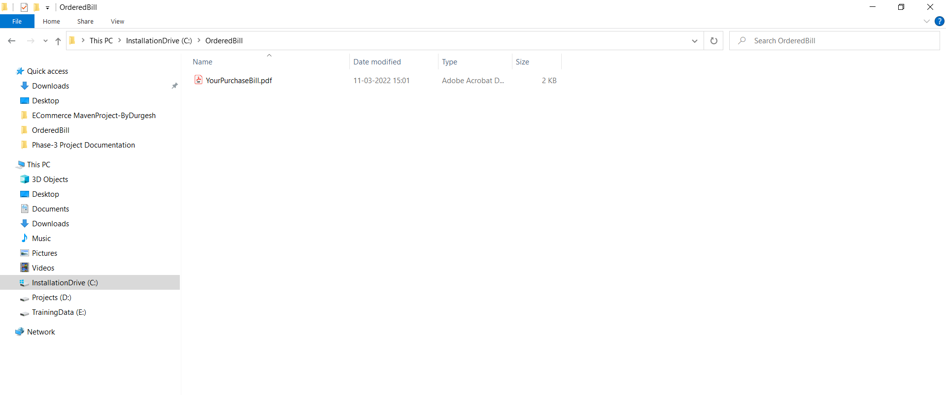

**Total Bill of Your Purchase History**

**====================================================================================================================**

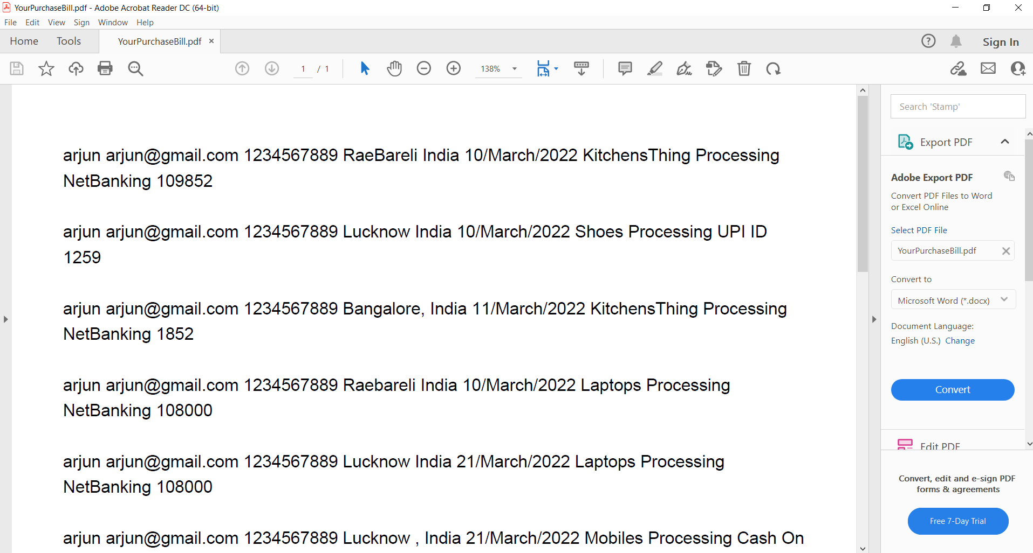

**Step 2 -**

The admin is allowed to perform following operations, the credentials for admin is

Username [- surajsingh9090@gmail.com](mailto:-%20%20surajsingh9090@gmail.com)

Password -123

User_Type -Admin

The admin can perform operations once he is logged in.

Very first admin can view Dashboard where admin can show complete report related to all the Module.

**Login View for Admin:**

======================================================================================================

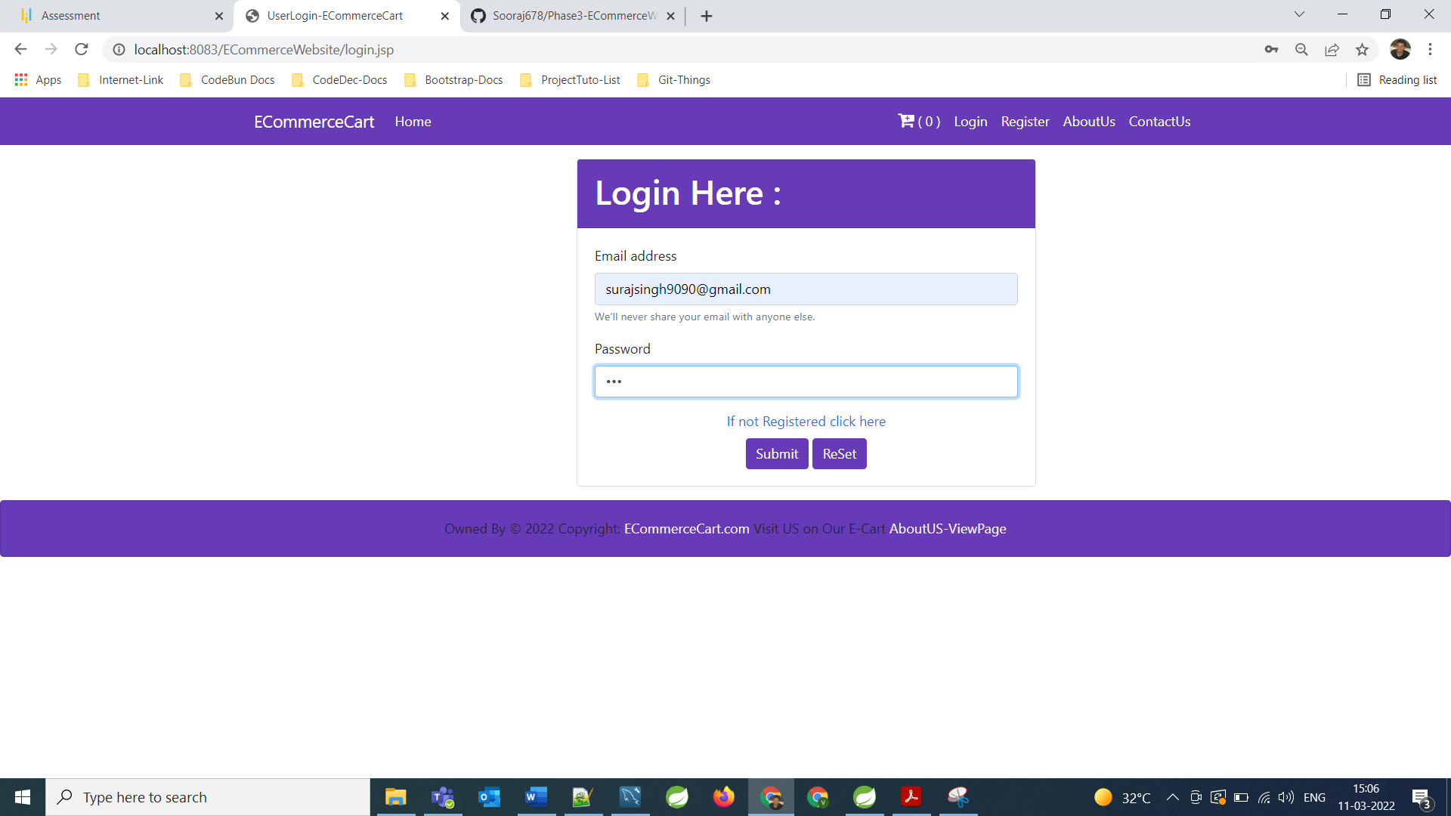

**Now Login Session of Admin is activated, Admin Page View**

**====================================================================================================================**

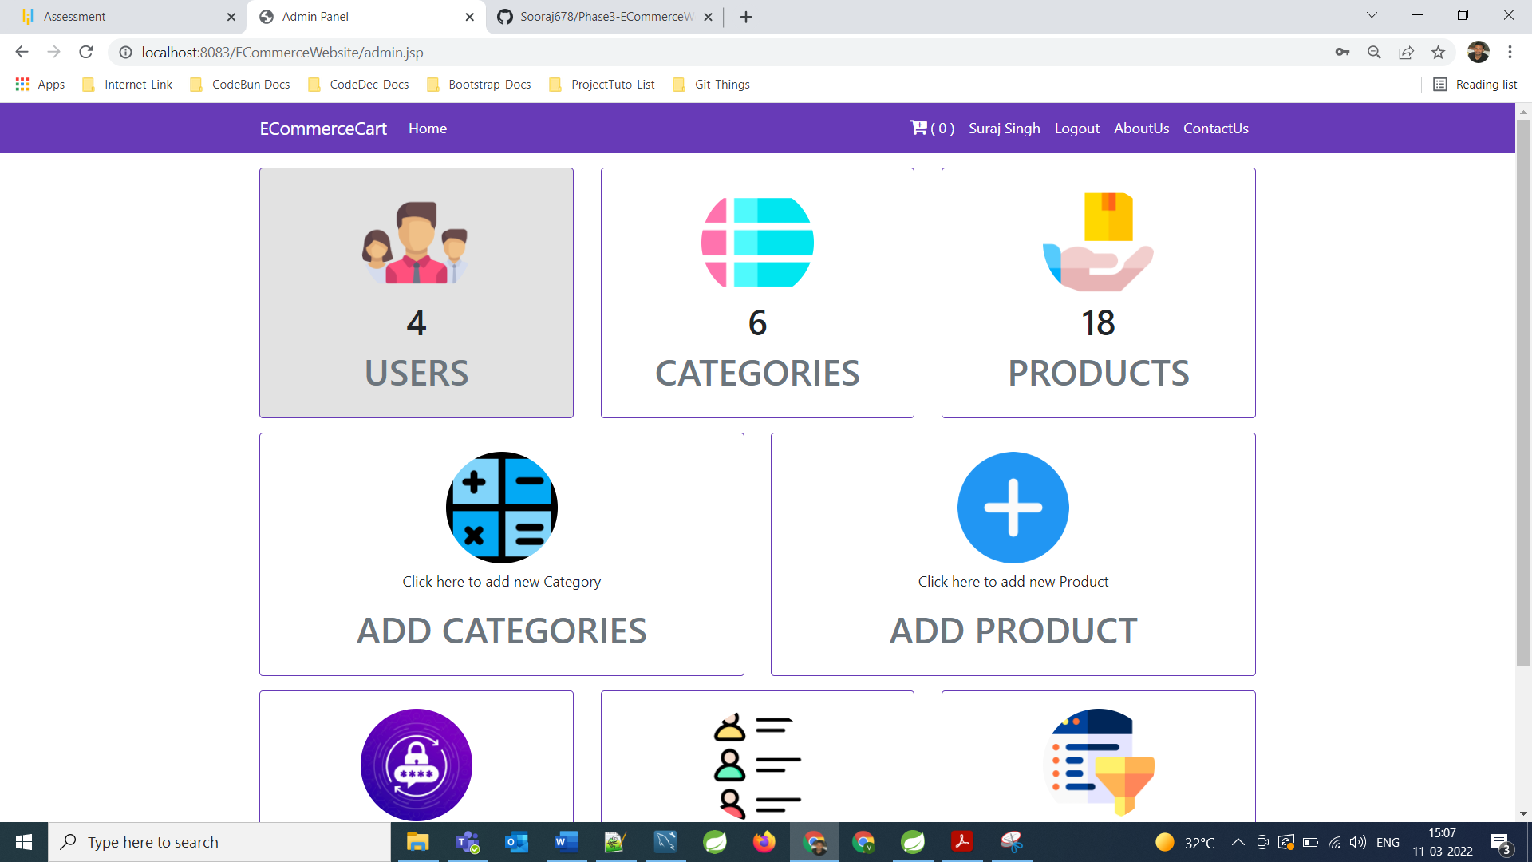

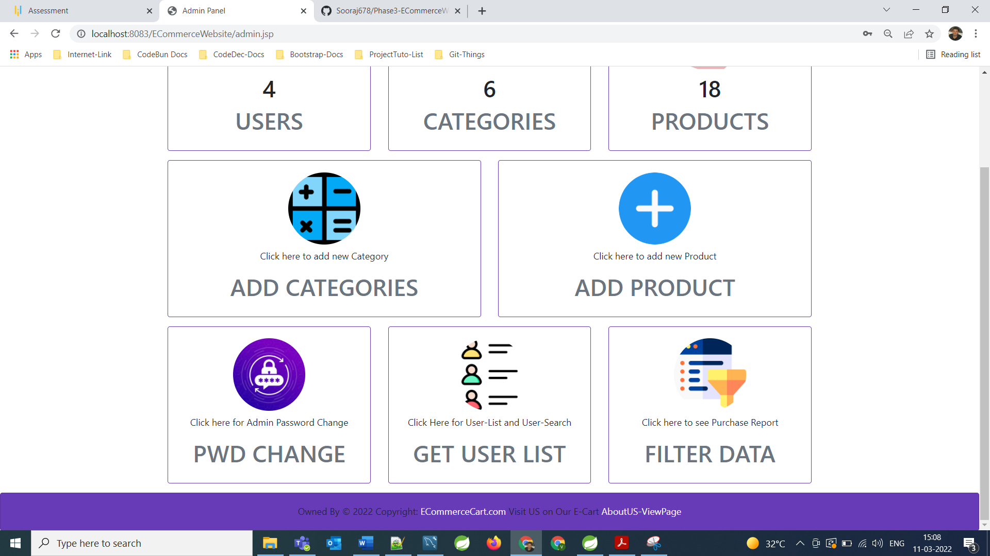

**Live Count Total Registered User**

**====================================================================================================================**

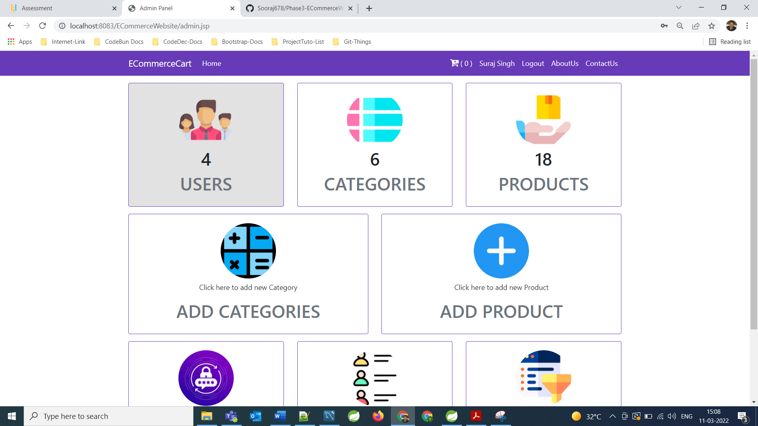

**Live Count Categories for Product**

**====================================================================================================================**

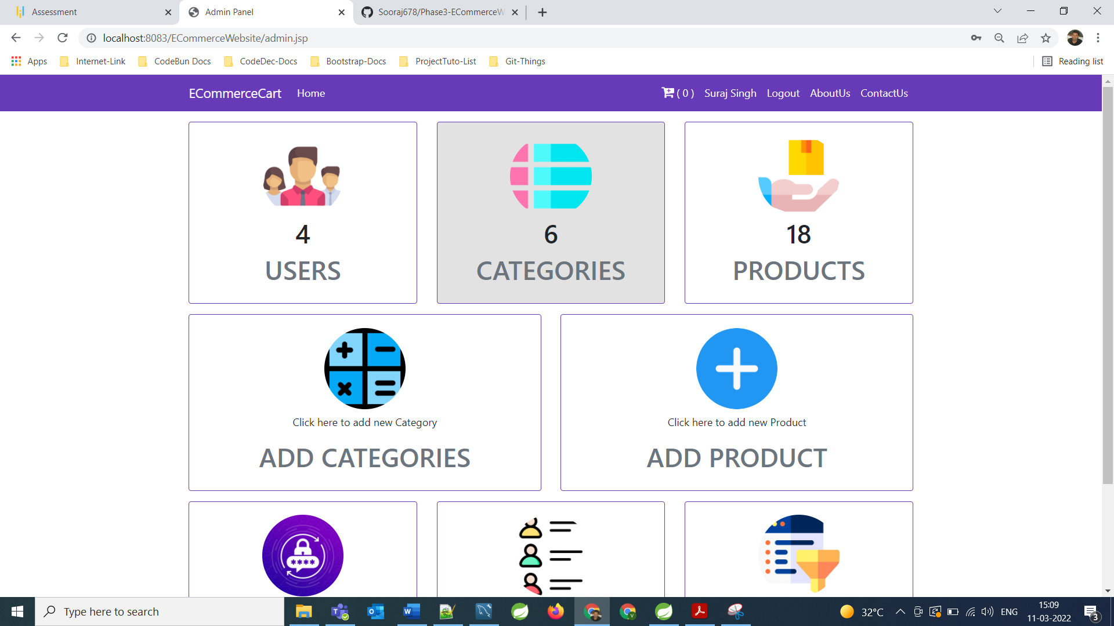

**Live Count of Products**

**====================================================================================================================**

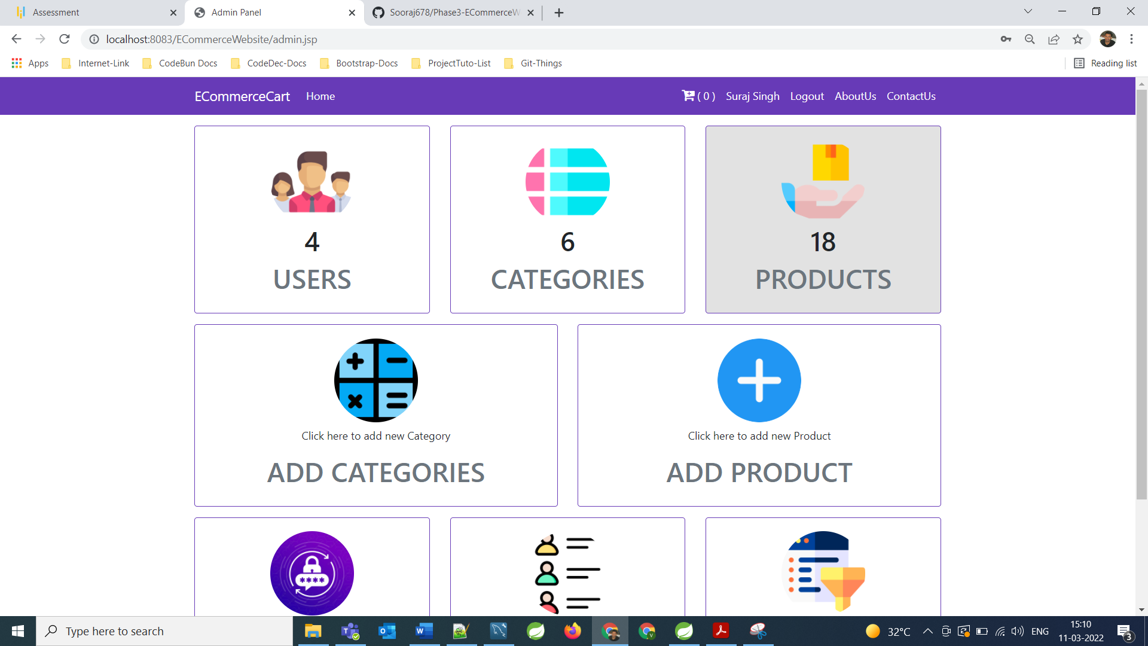

**Admin can Add categories for product**

**====================================================================================================================**

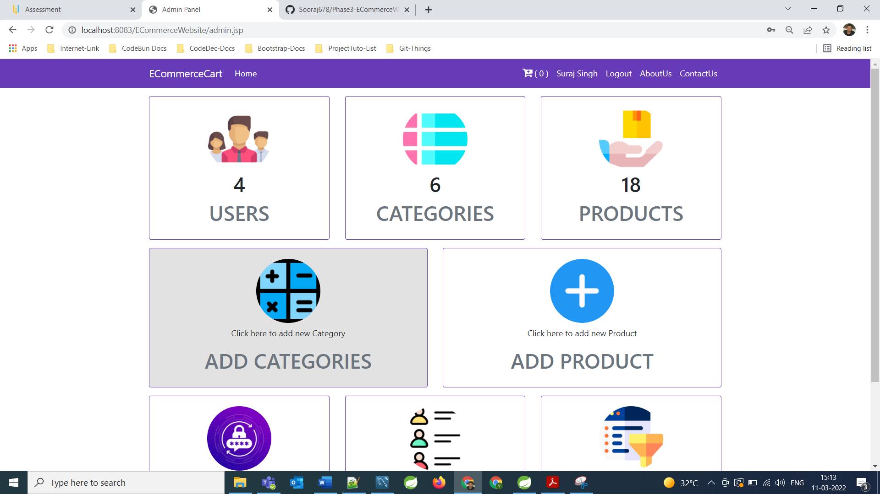

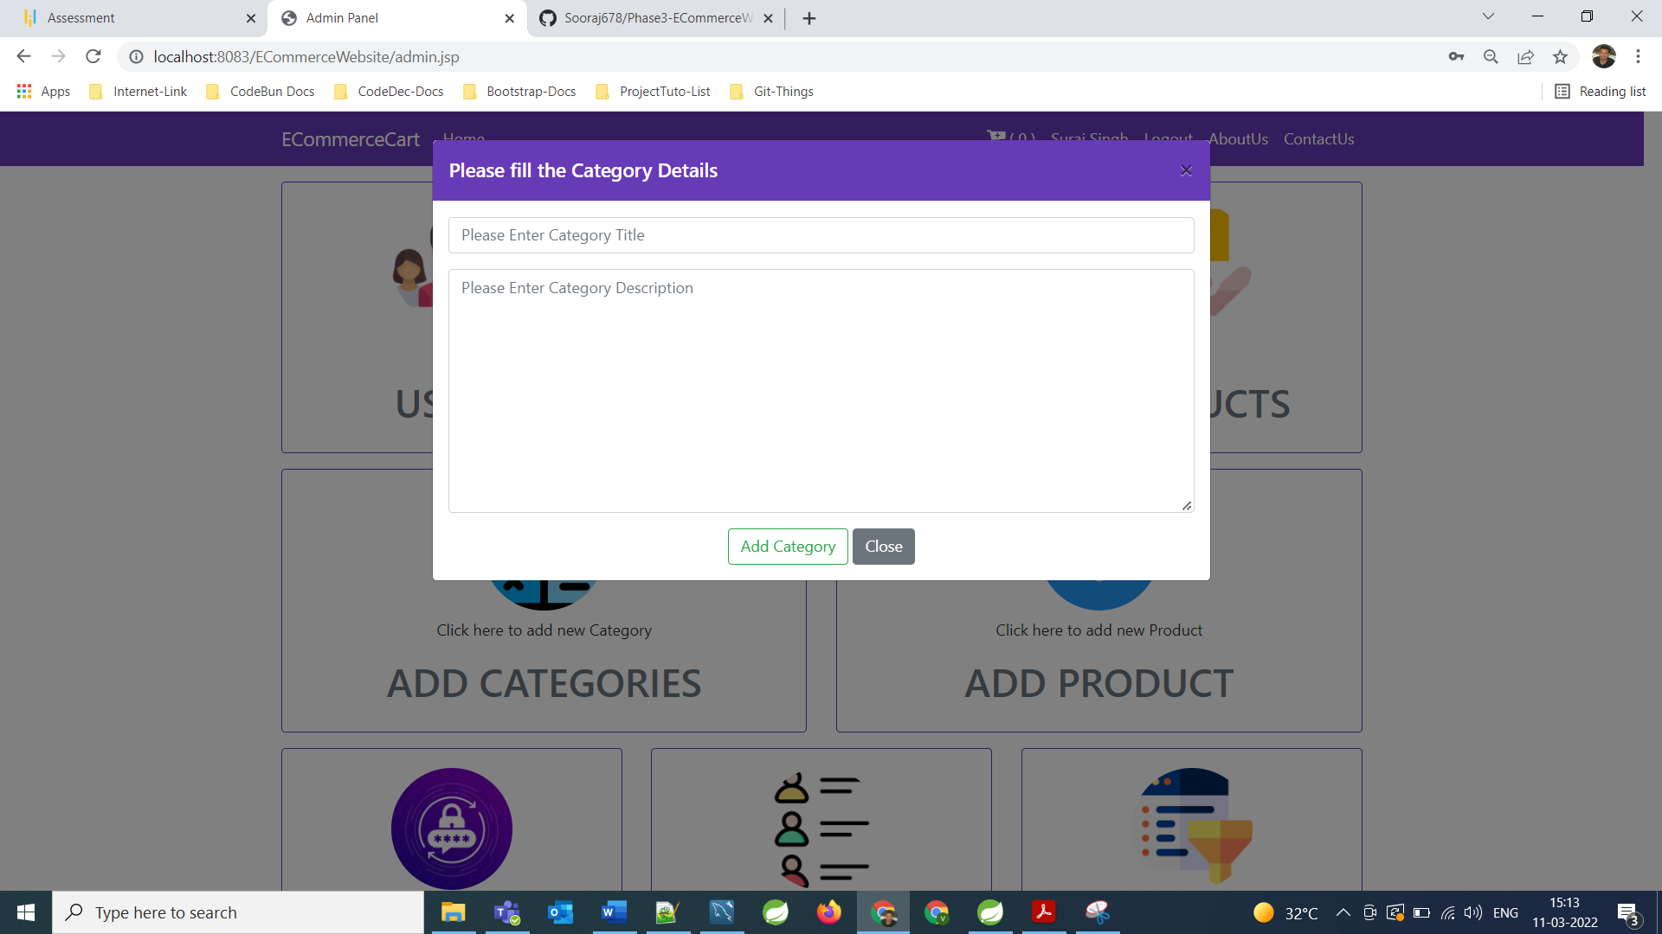

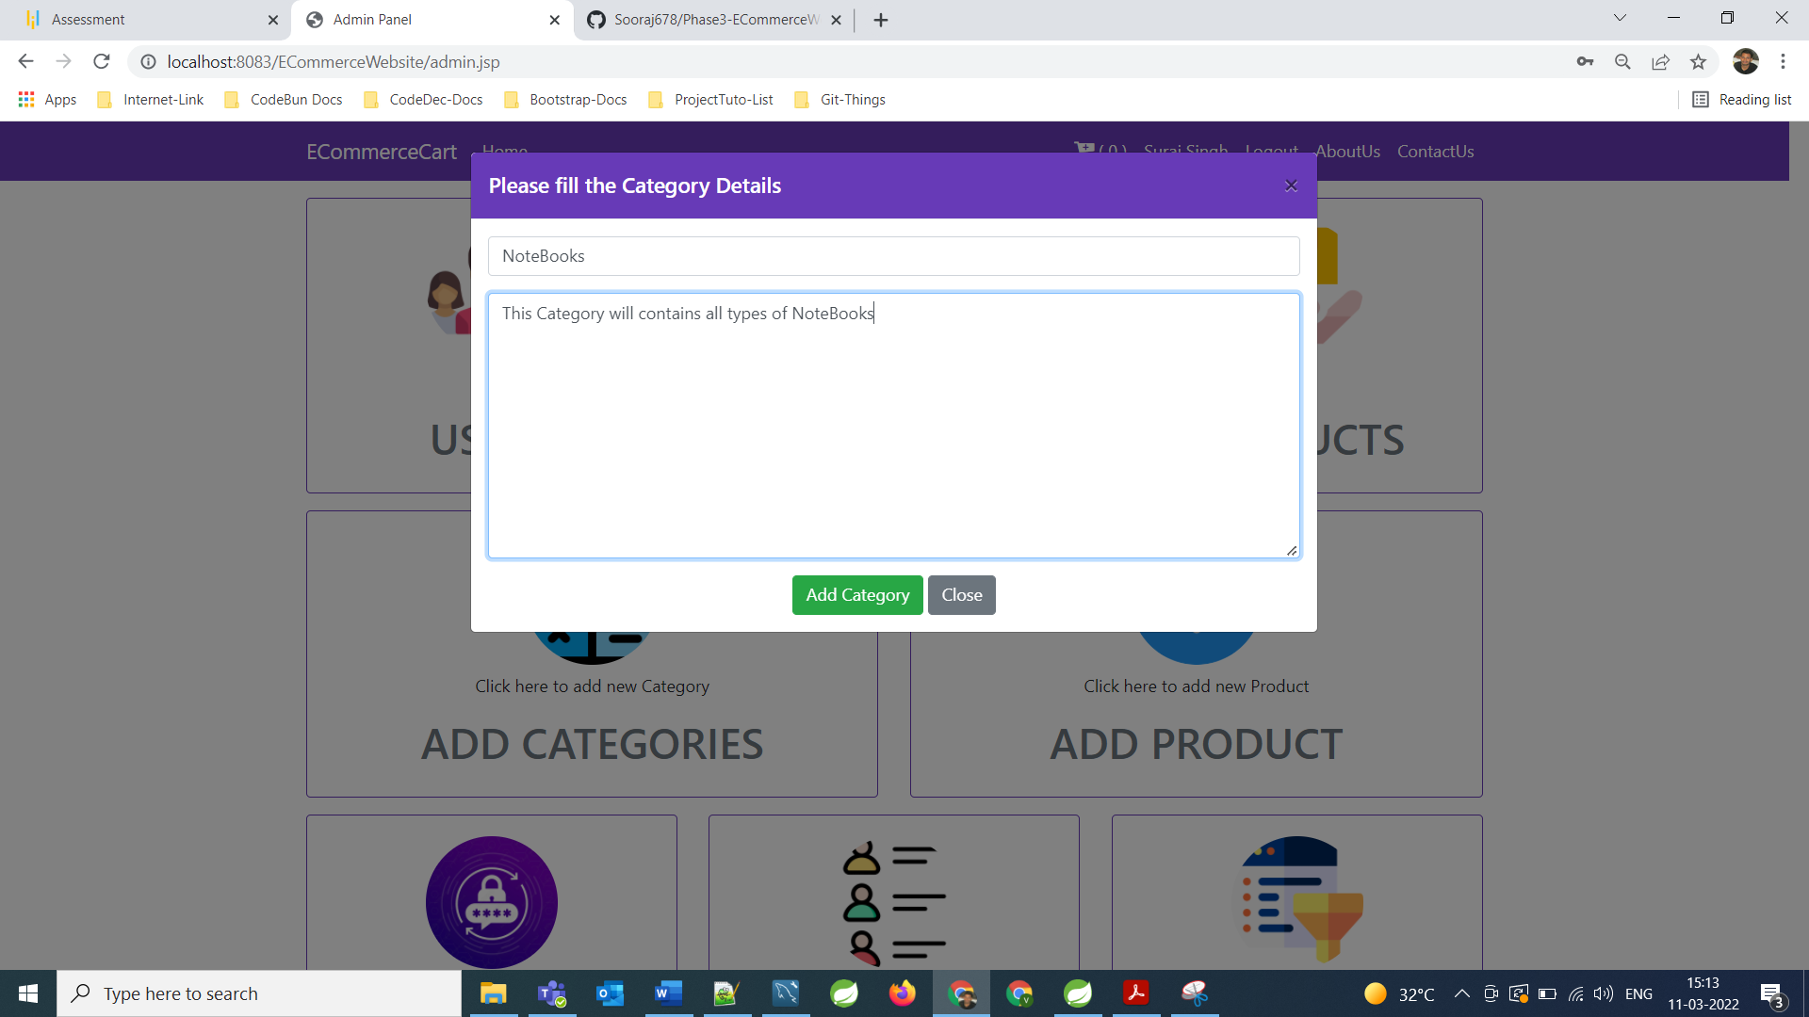

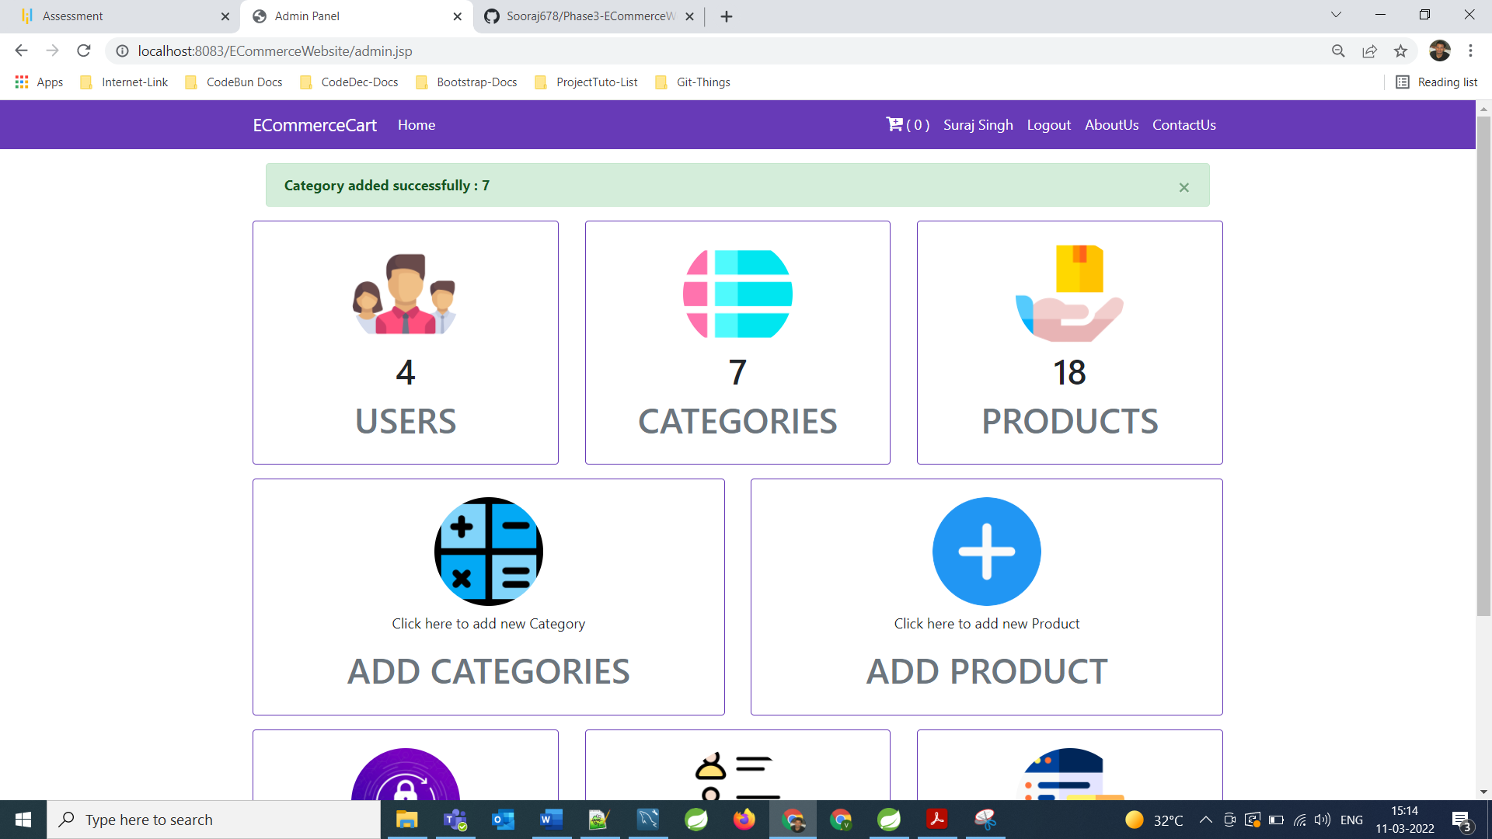

**As we can see Categories Live count got increased.**

**====================================================================================================================**

**Admin can Add Products for Added Categories**

**====================================================================================================================**

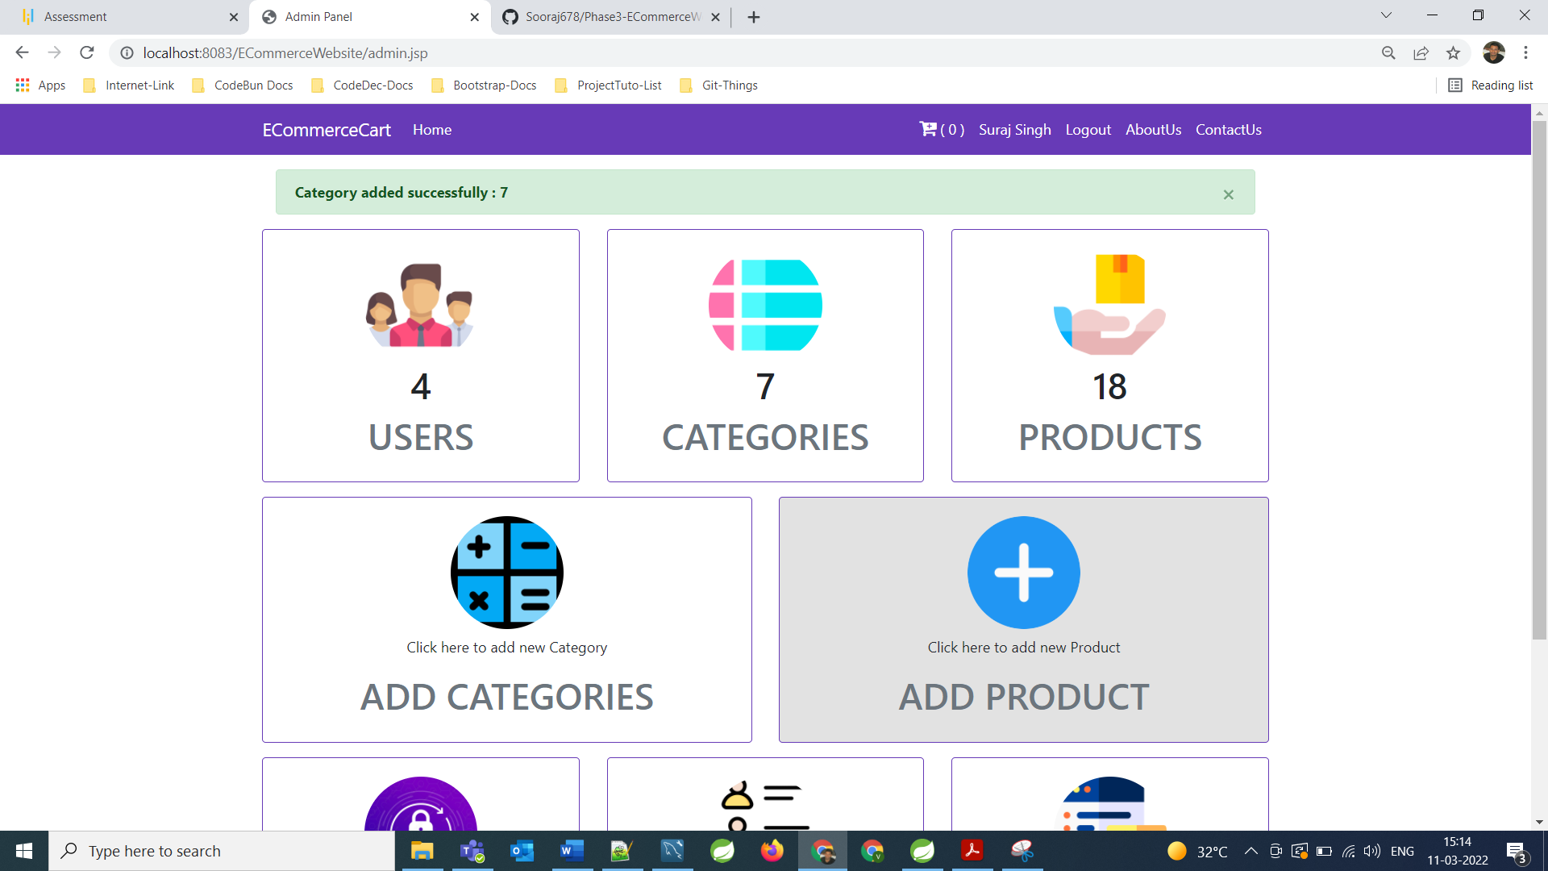

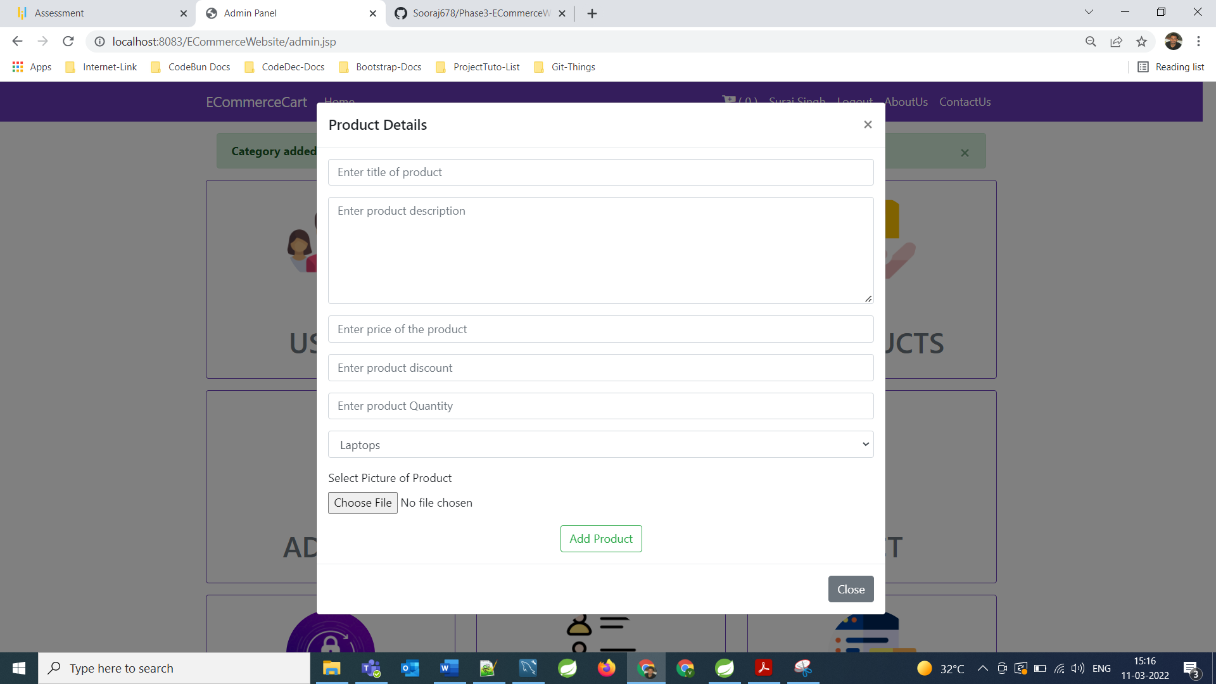

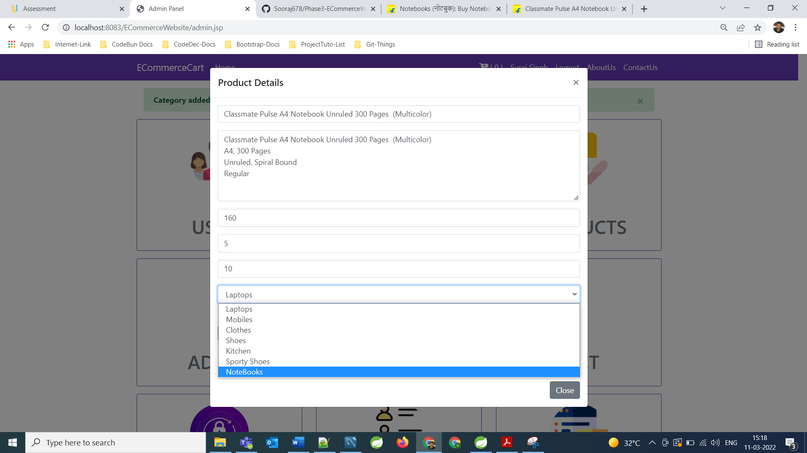

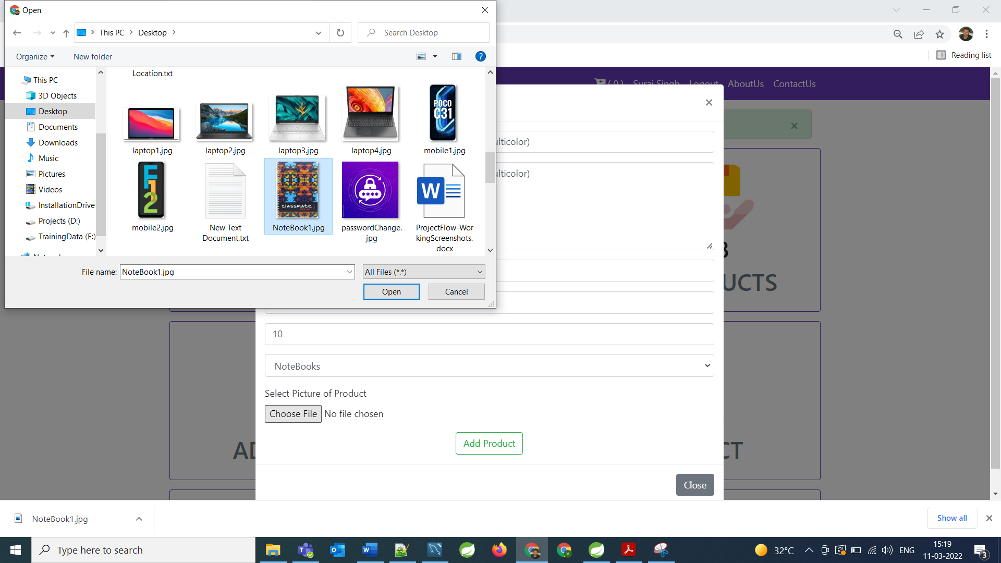

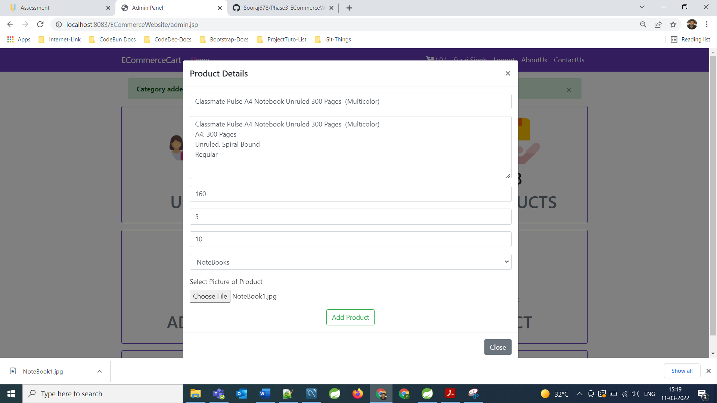

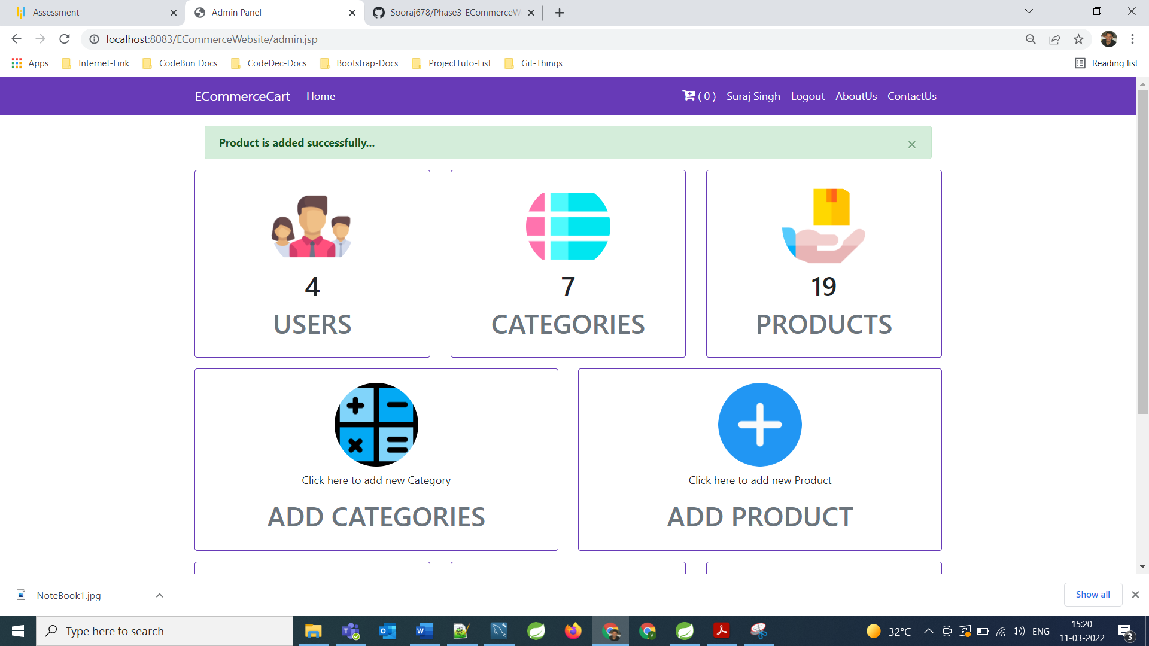

**As we can see product Count got Updated**

**====================================================================================================================**

**As we can see at the Home Page Category got Added and with respect to that category Product also got Added.**

**====================================================================================================================**

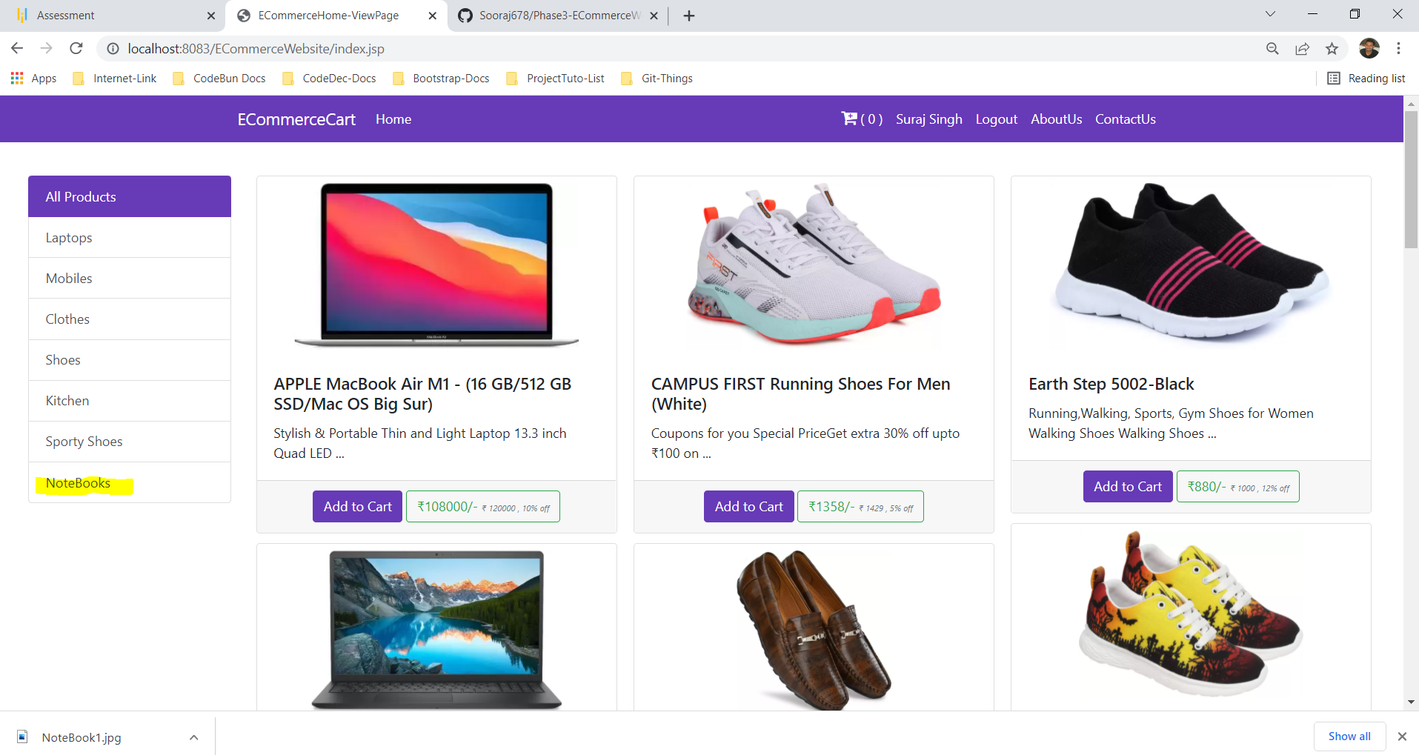

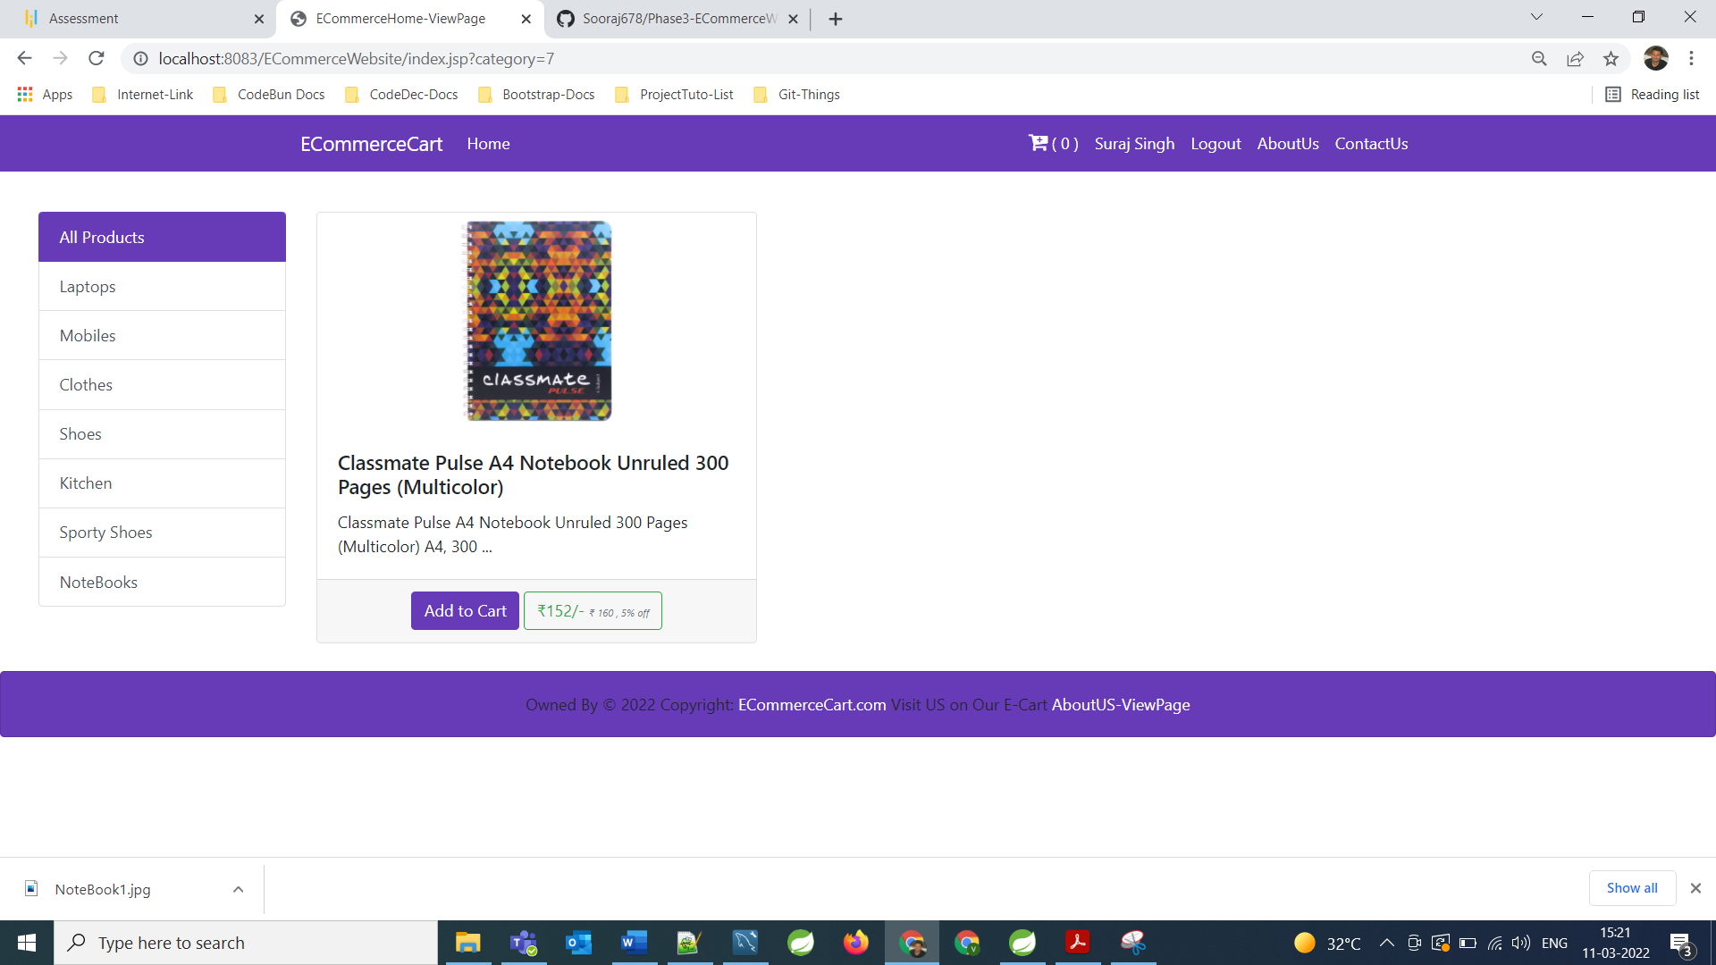

**As per requirement of application if admin wants then he/she can update his/her password.**

**====================================================================================================================**

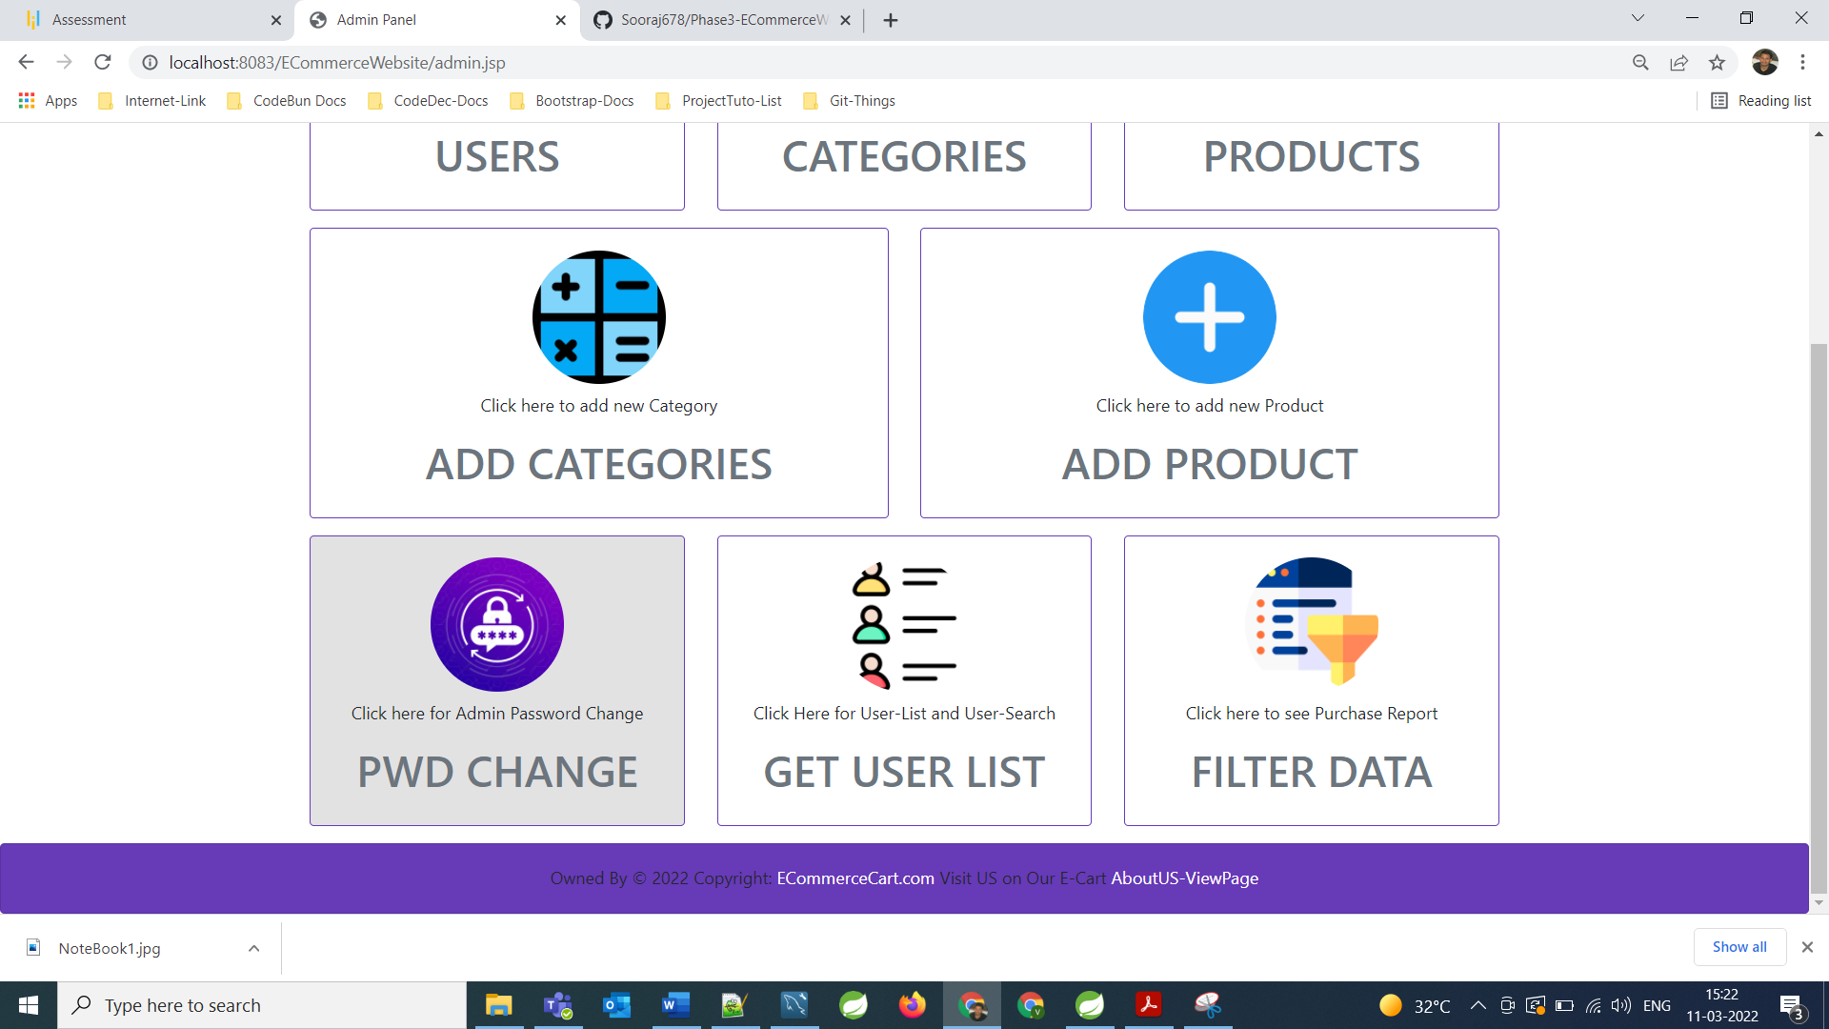

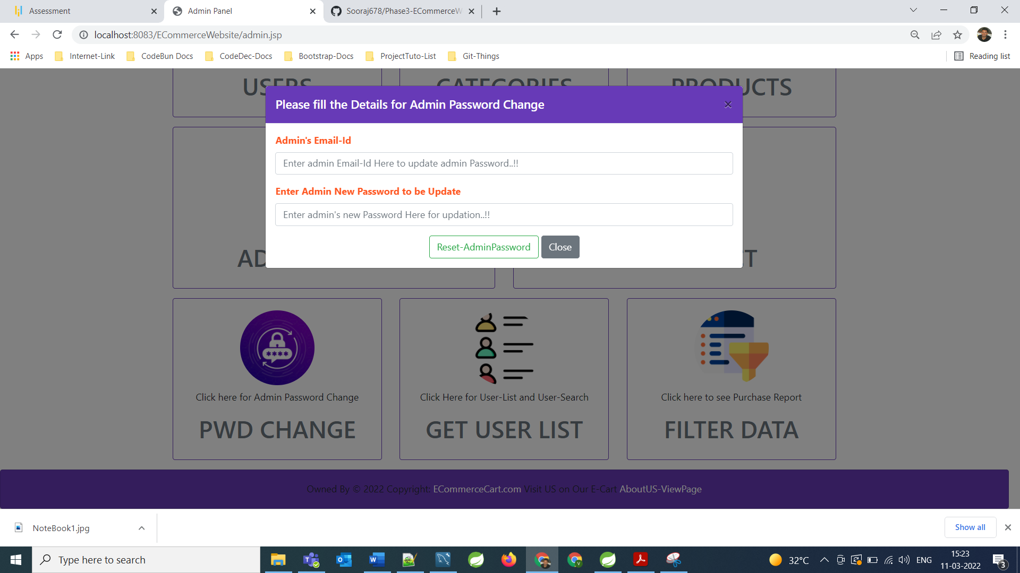

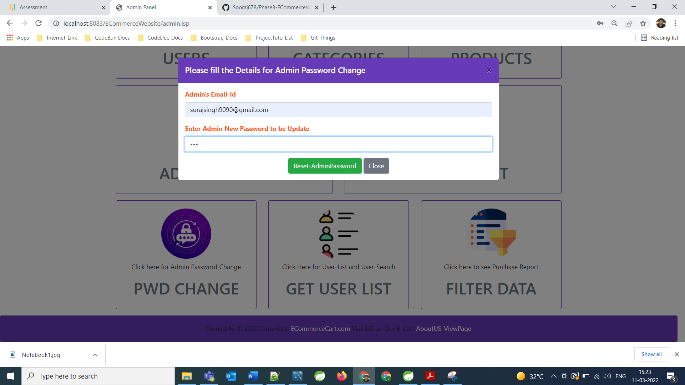

**As we can see Now Admin’s Password got updated**

**====================================================================================================================**

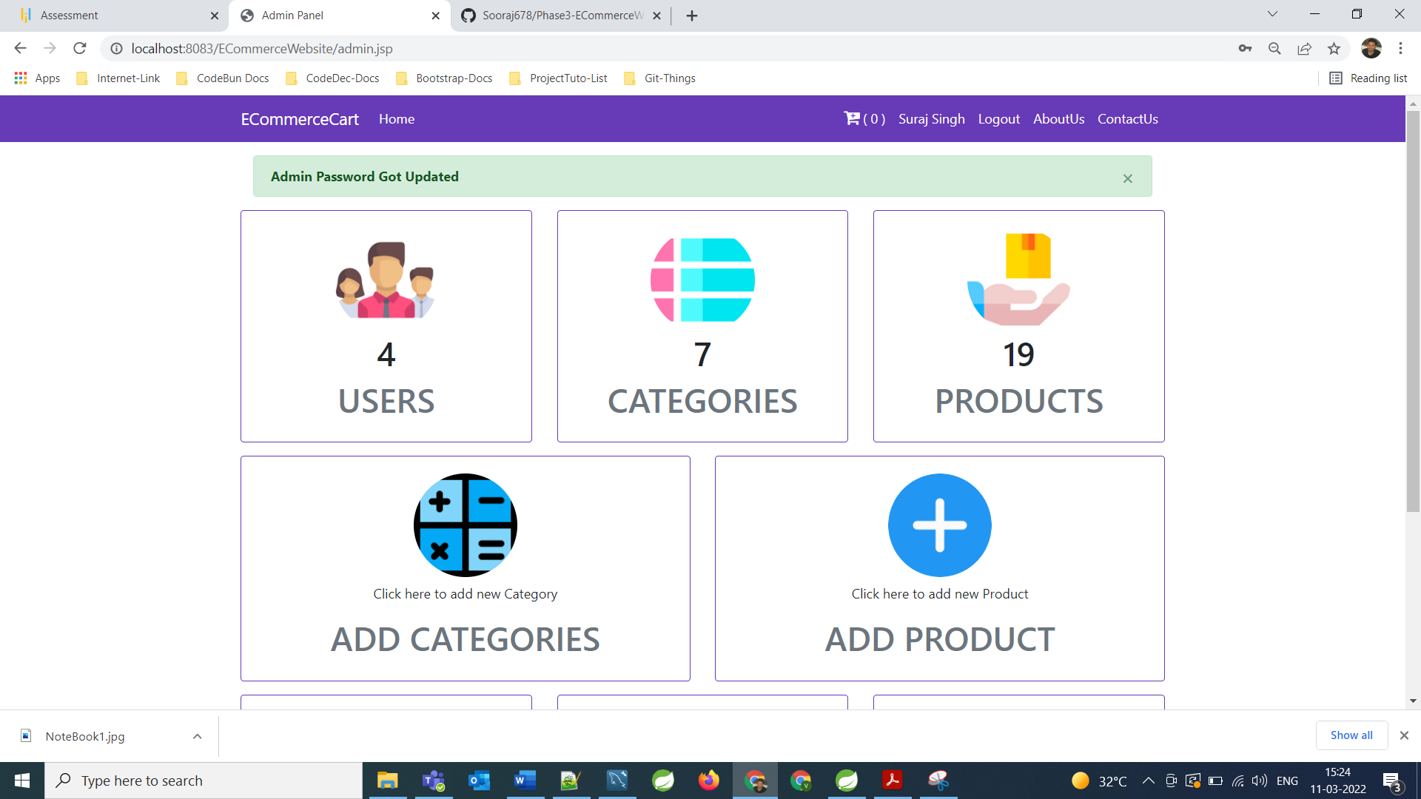

**Now admin can get all registered user list**

**====================================================================================================================**

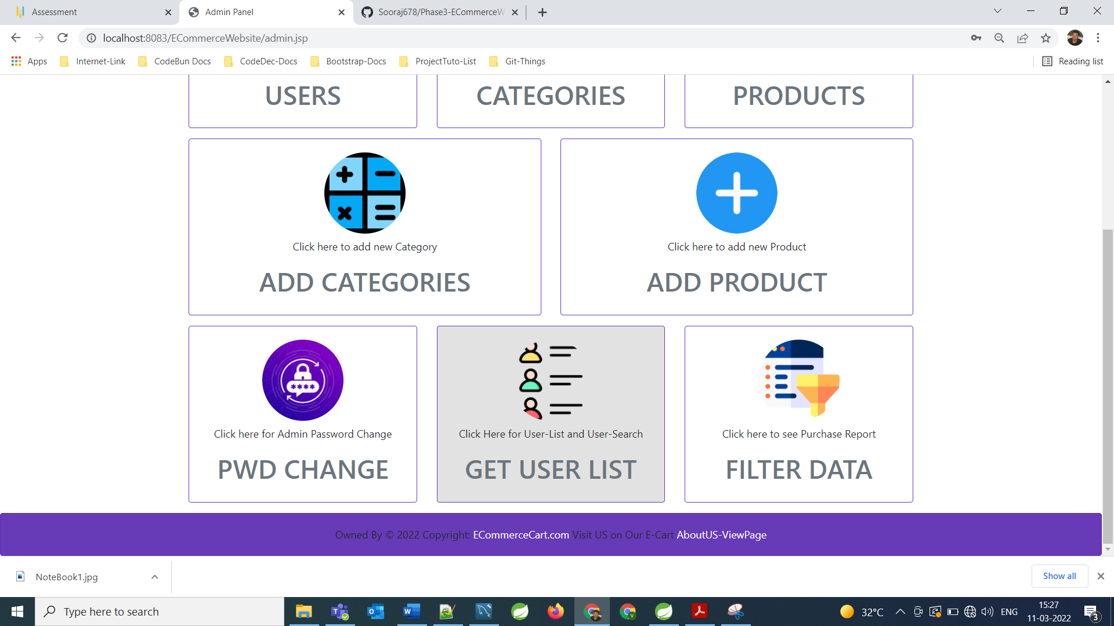

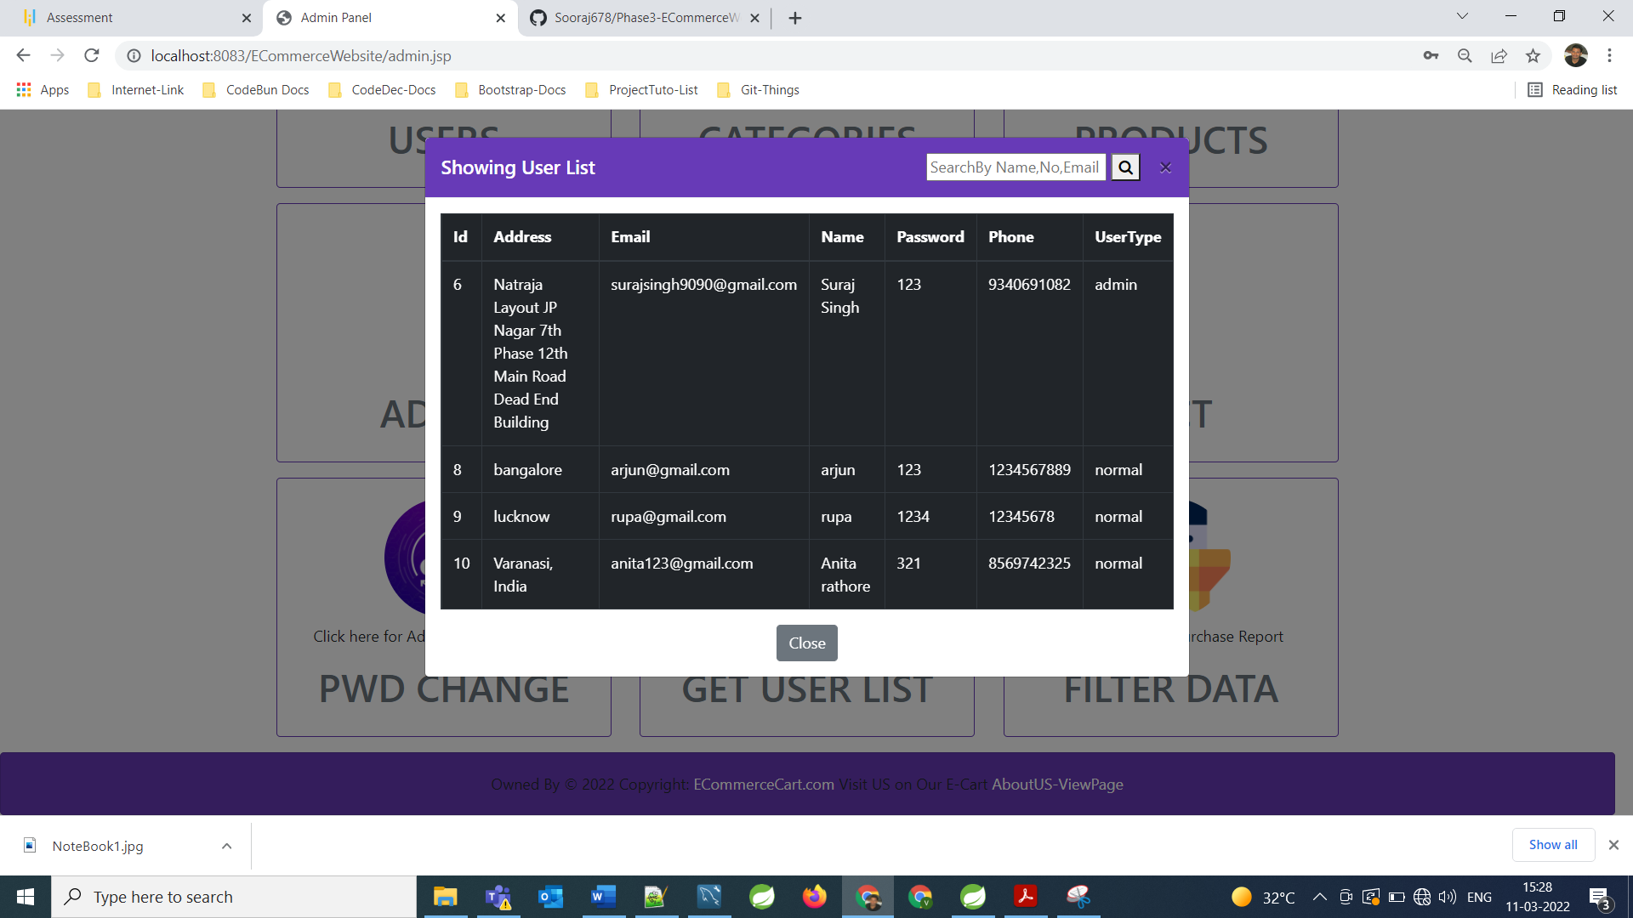

**Admin can filter user’s list by name, Mobile number and by email**

**====================================================================================================================**

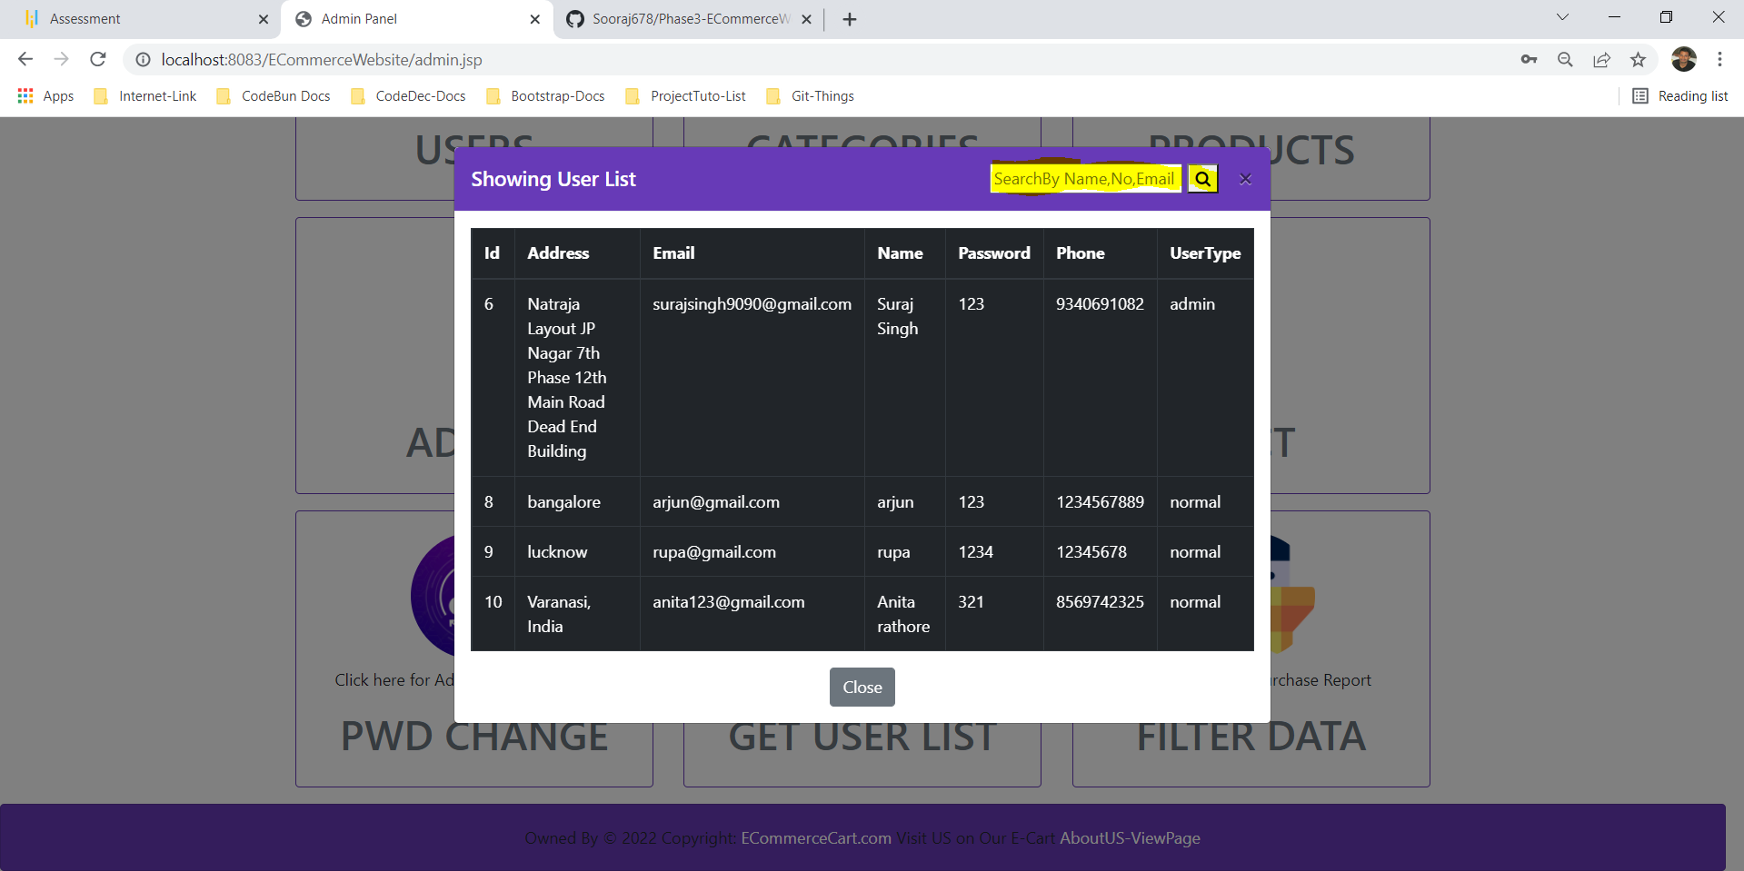

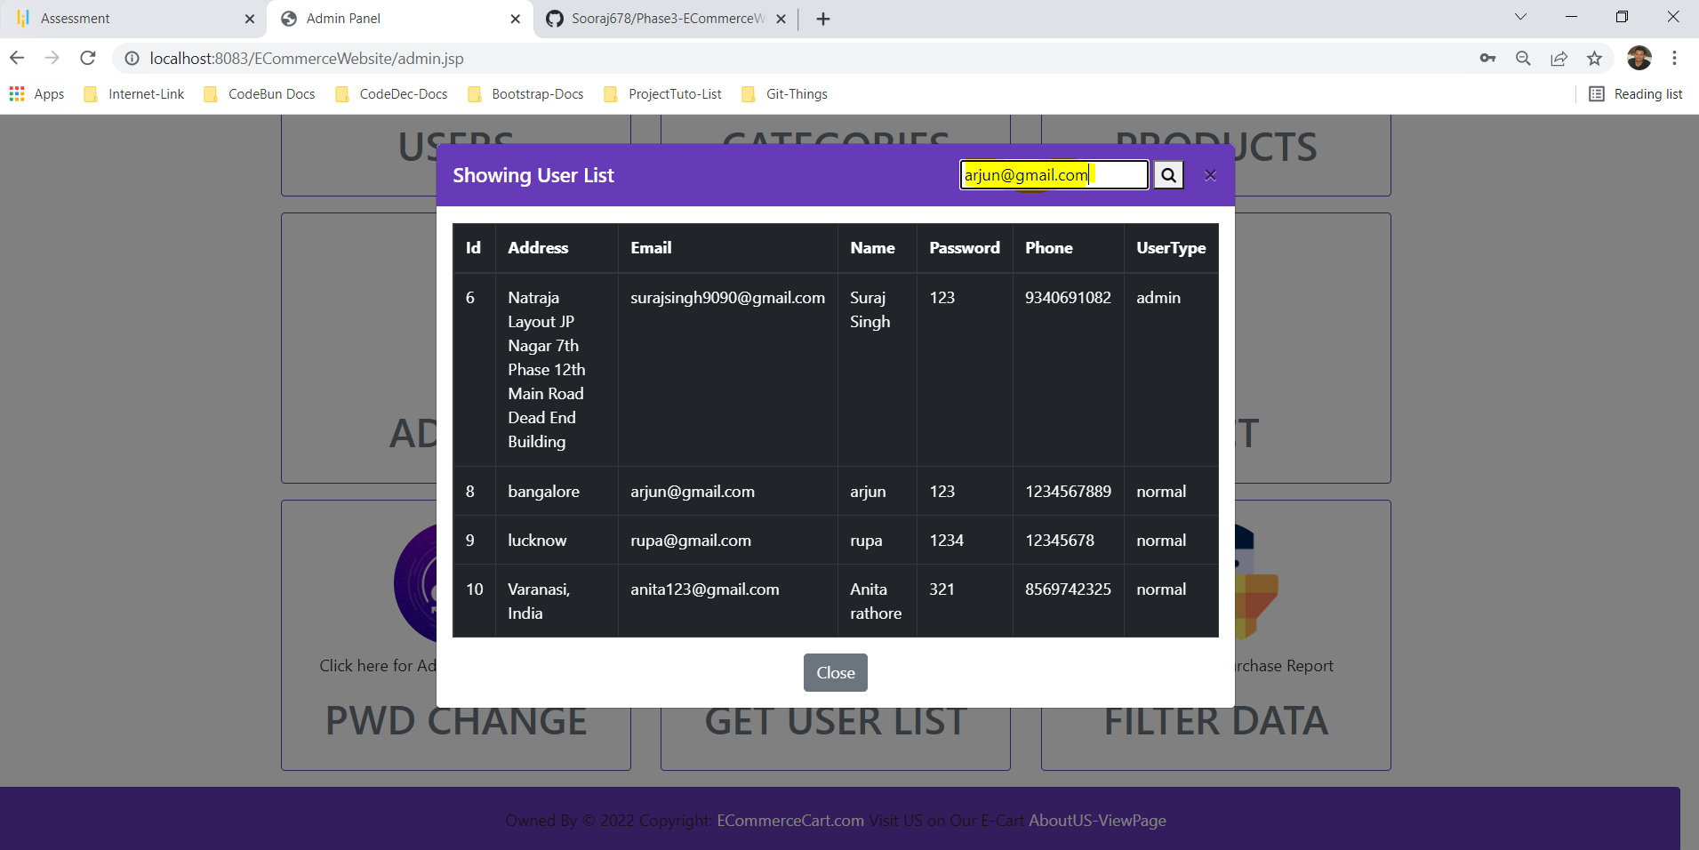

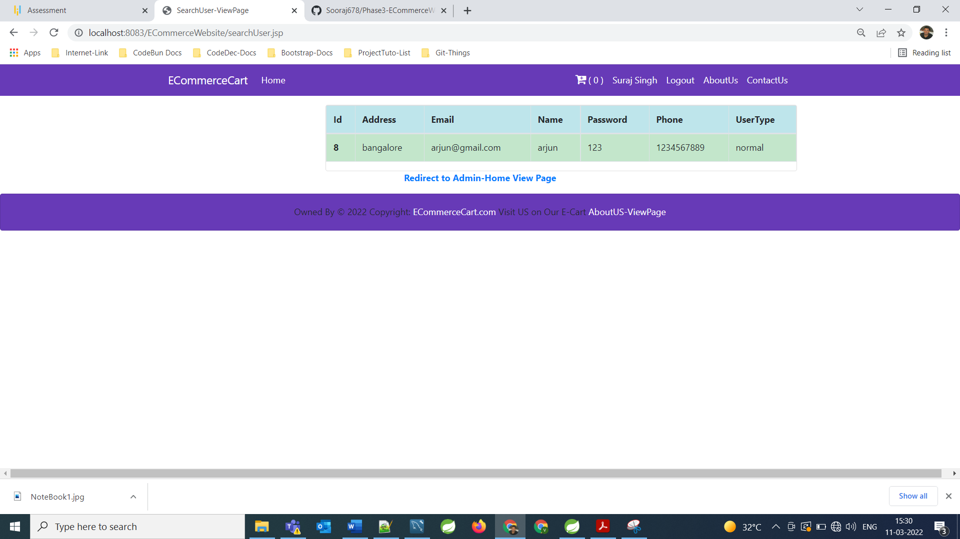

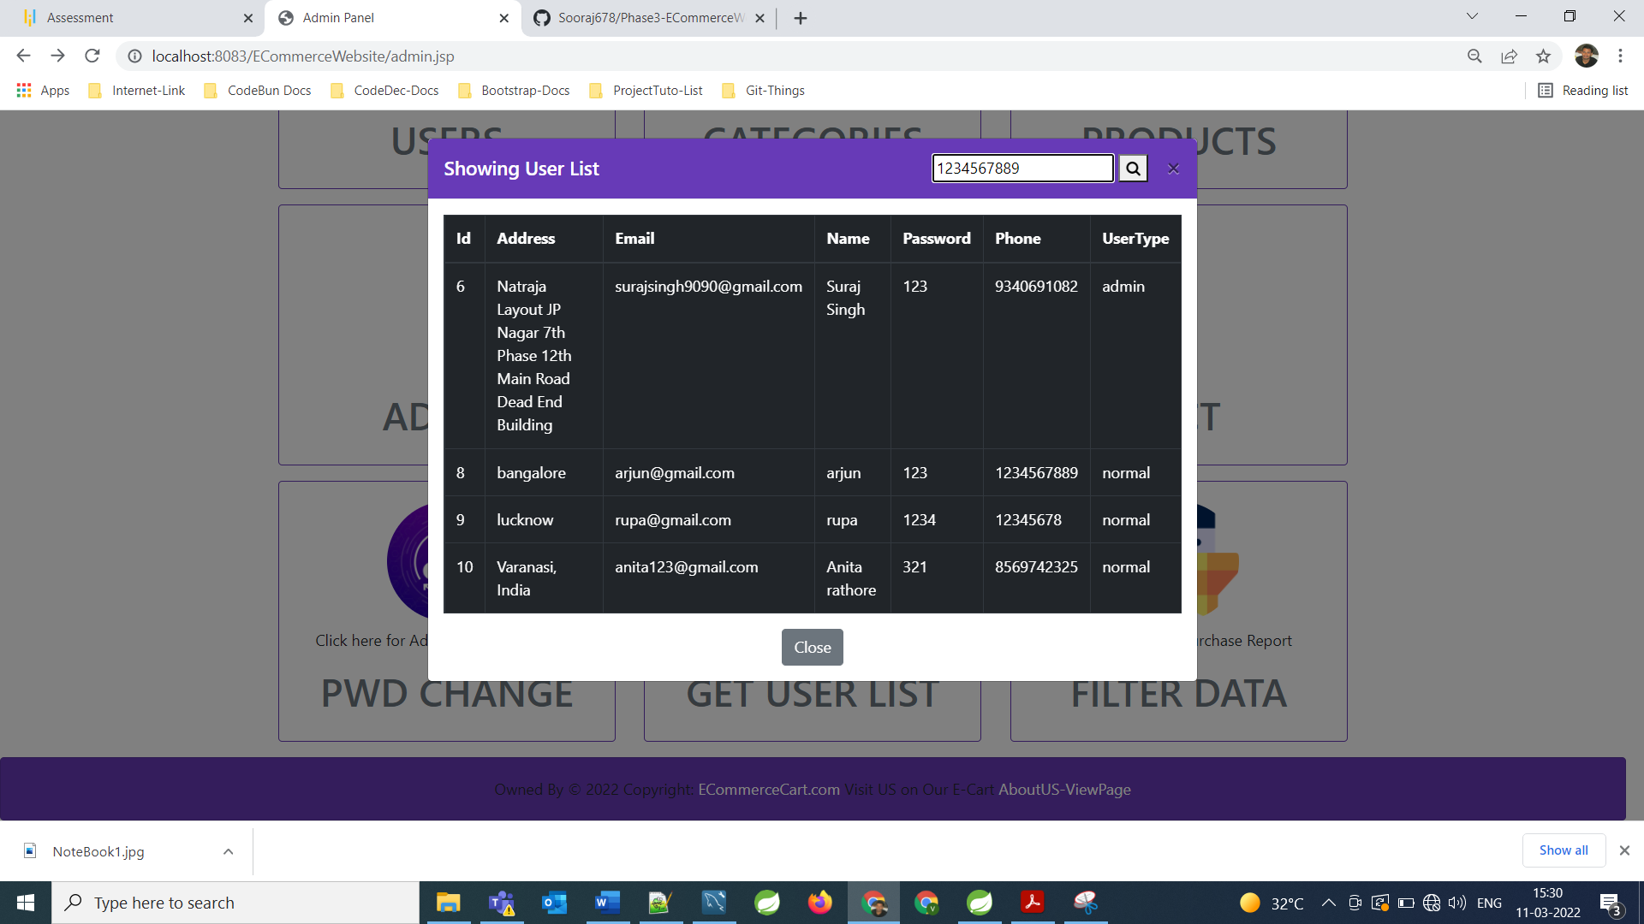

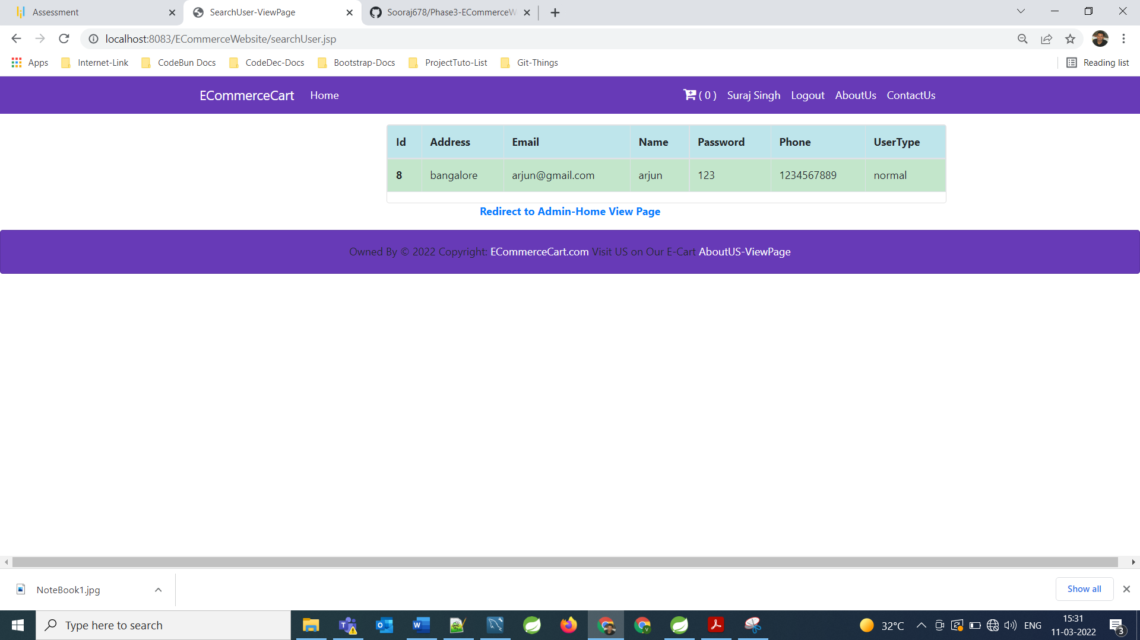

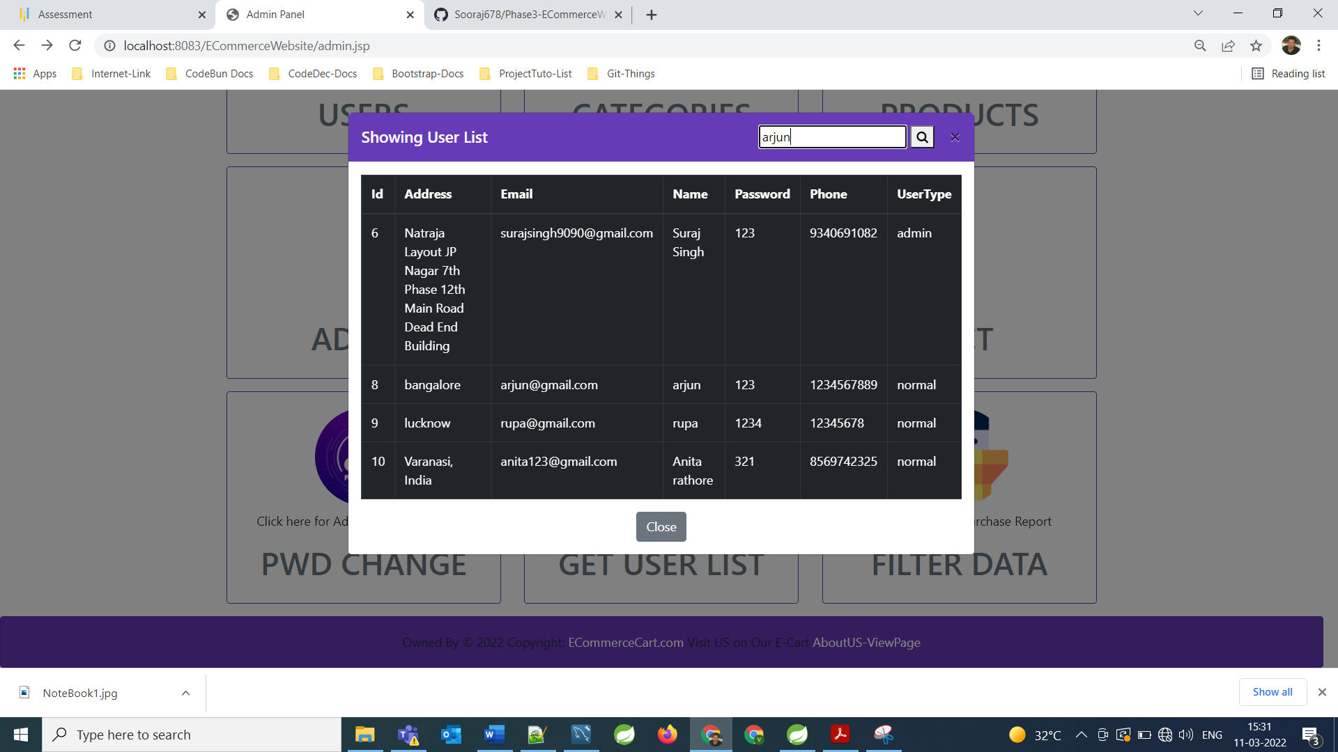



**Now Admin can get and filter purchase report of users**

**====================================================================================================================**

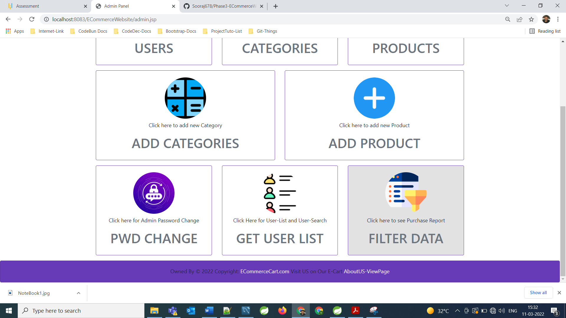

**Purchased Report**

**====================================================================================================================**

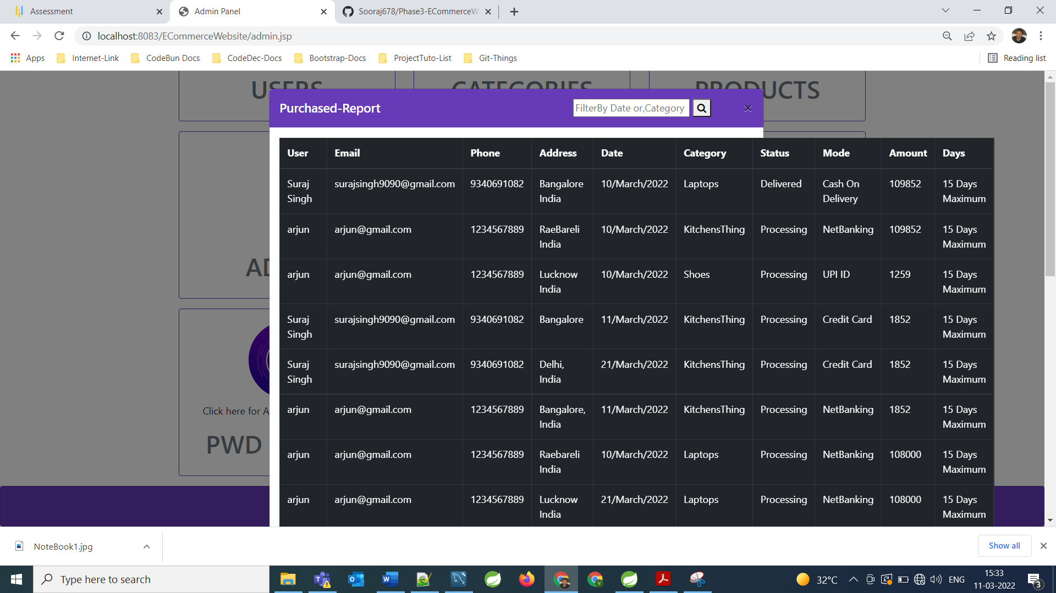 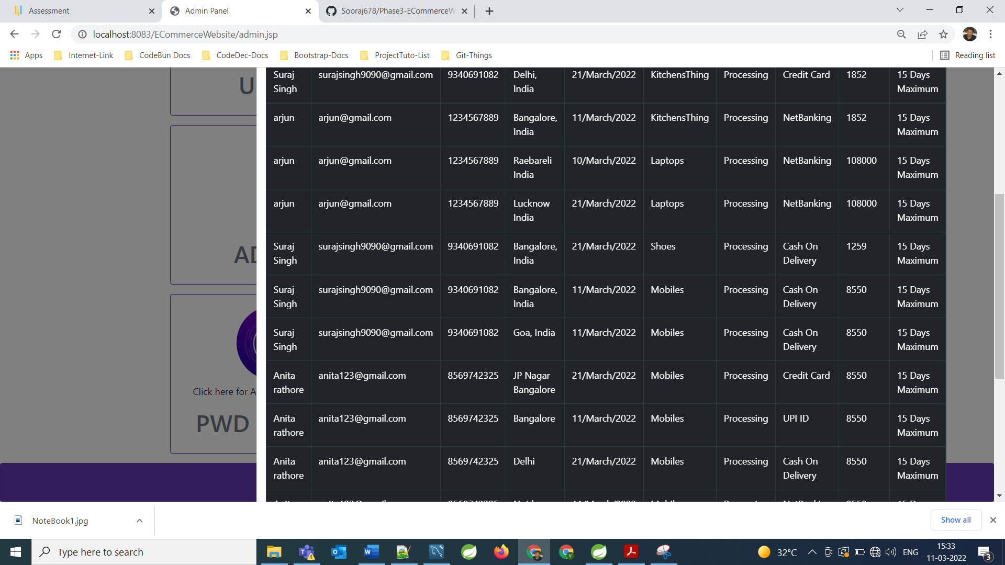

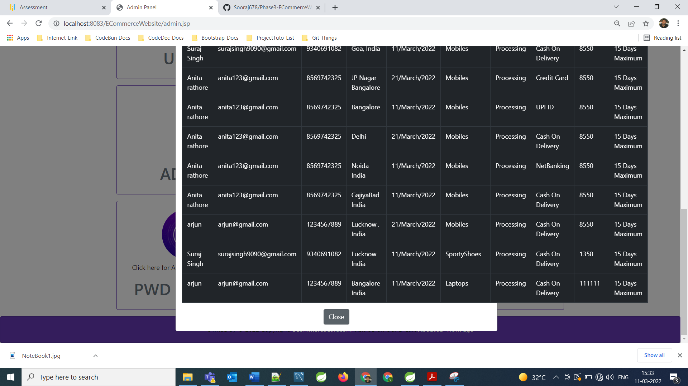

**Now admin can filter Purchase report on the basis of category or purchased date to get Purchase report**

**====================================================================================================================**

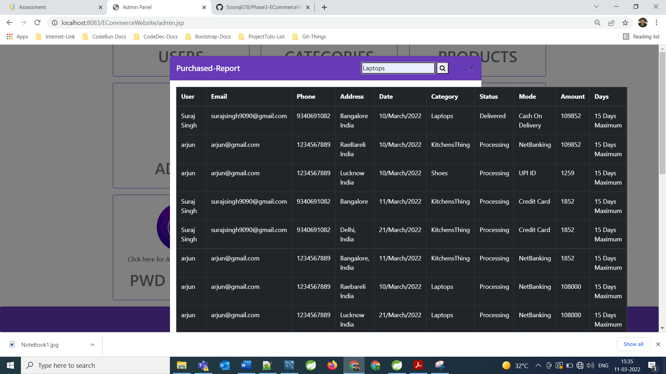 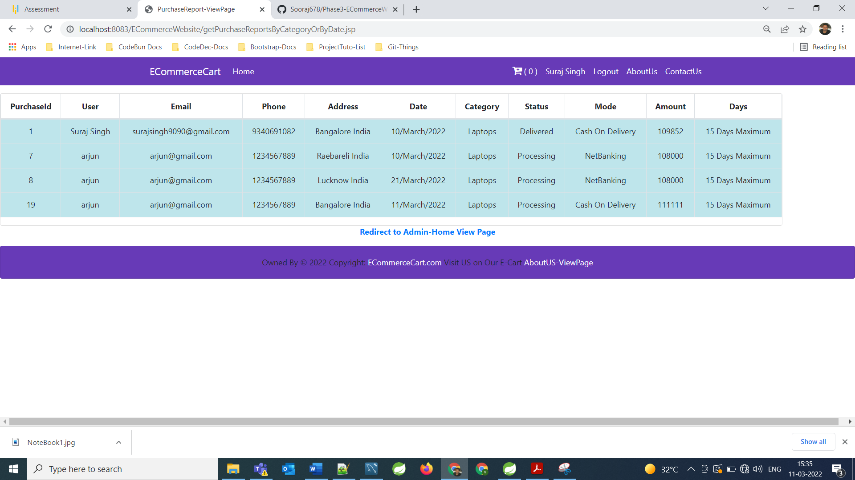

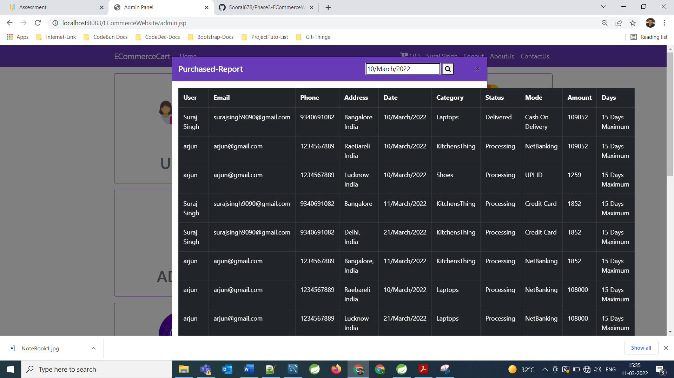

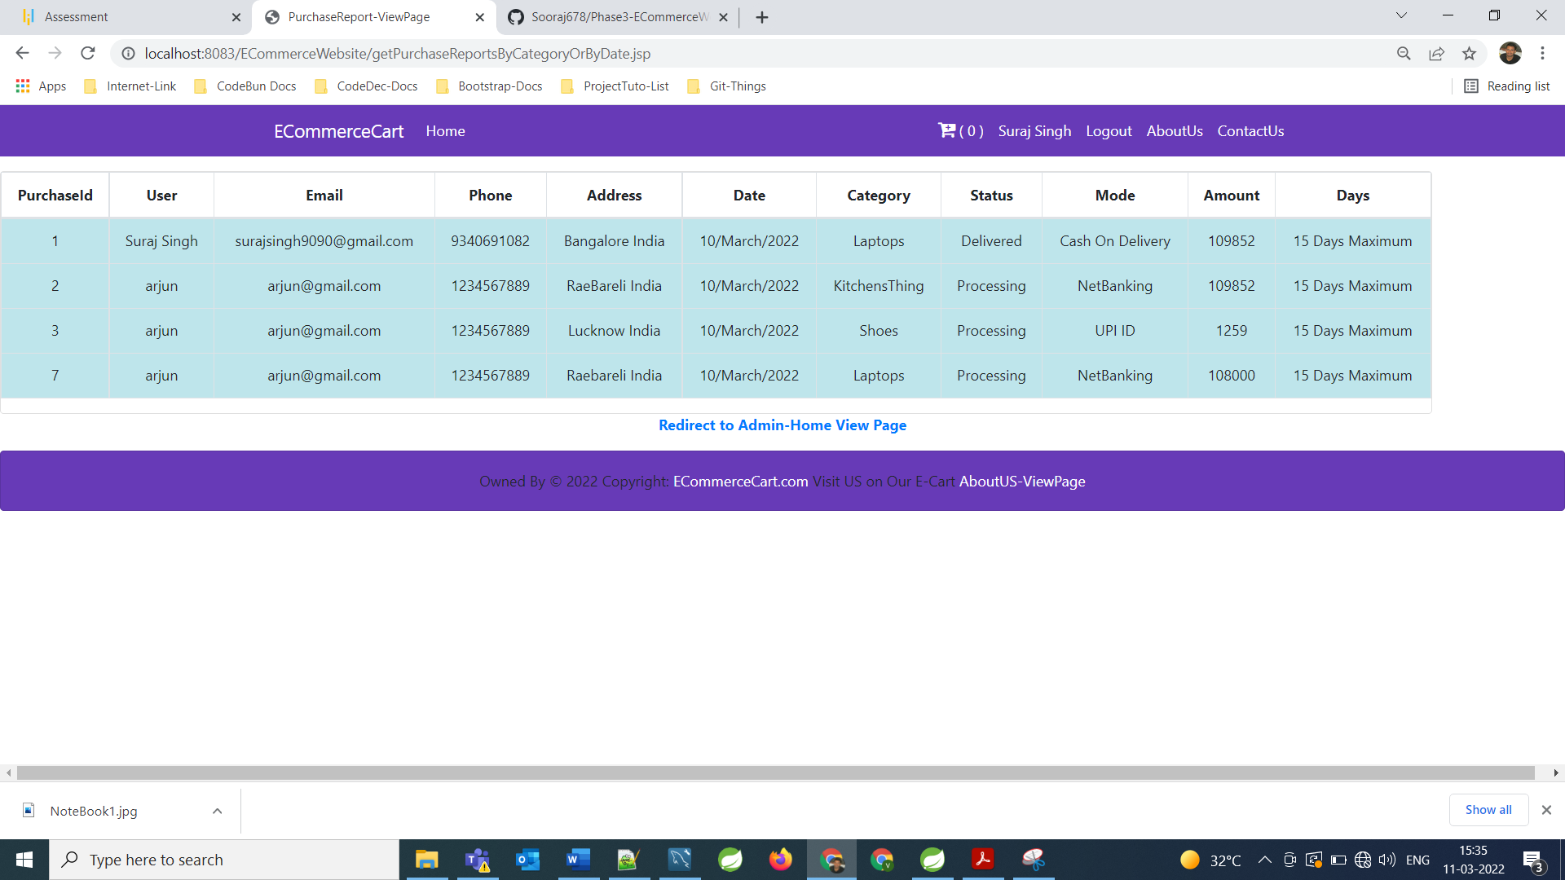

**These are the admin’s Operations that admin can perform at the Admin Portal**

**====================================================================================================================**

**Apart from these operations admin can shop also from this Website**

When a User or Admin is not login then also by home page, they can shop with us and during the checkout they need to provide Credentials for Purchase Operation.

Like we can see in the below screen shots:

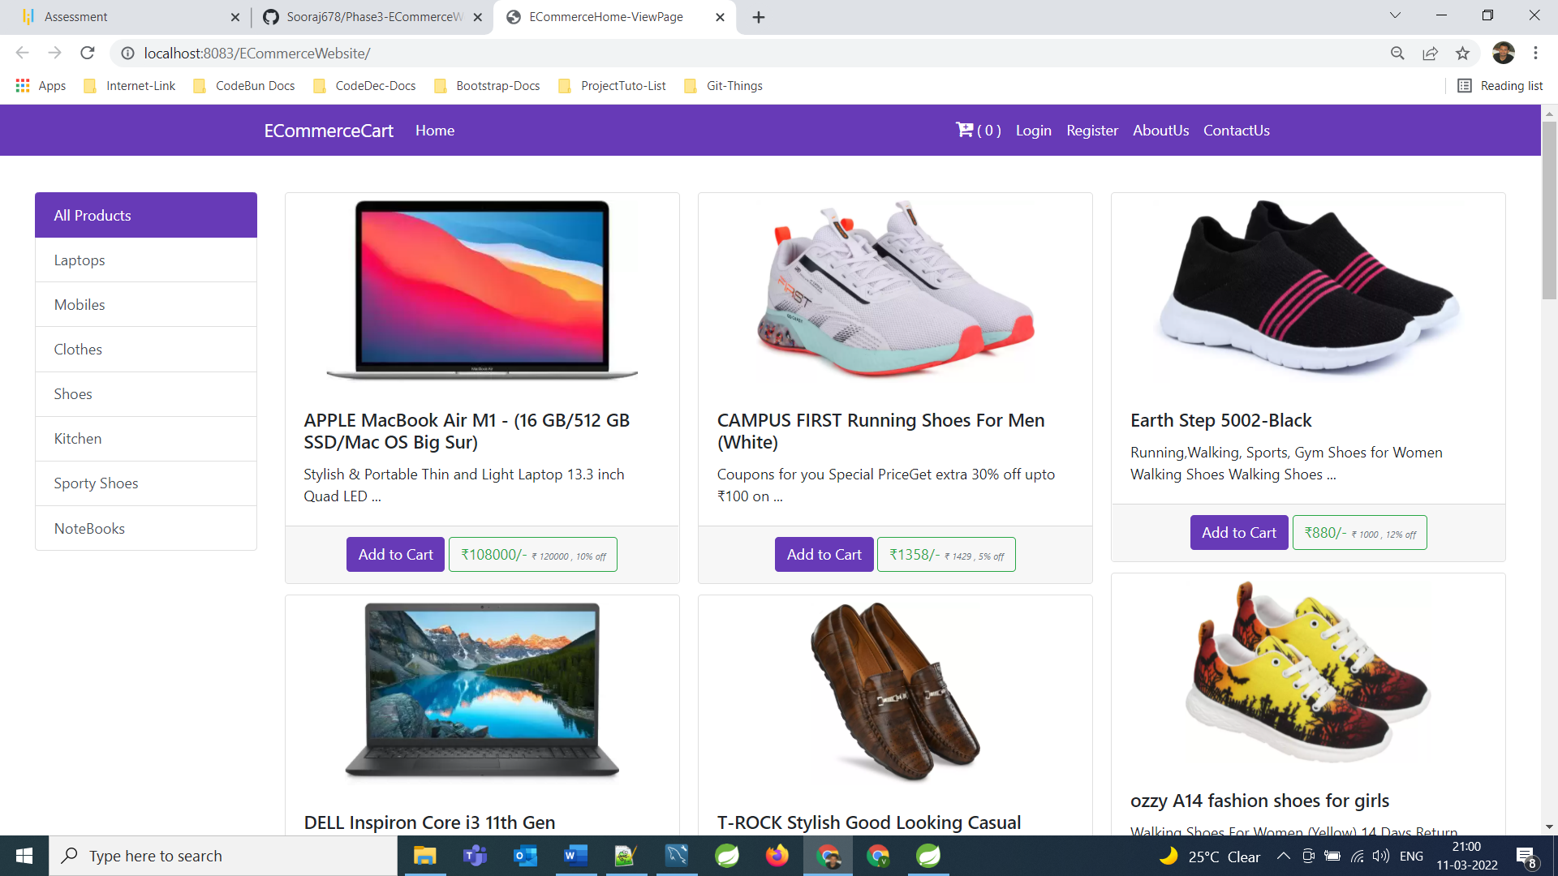

**For Now, no user is Logged In**

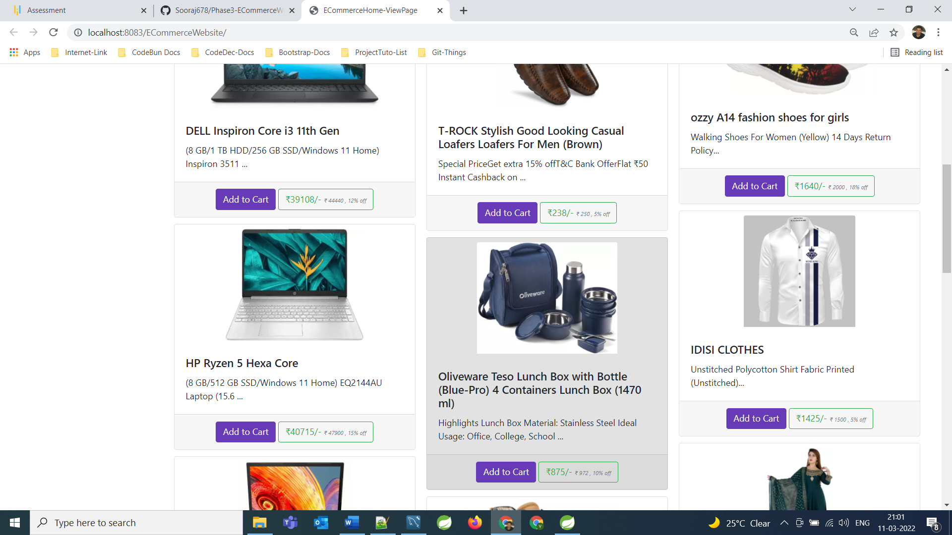

**====================================================================================================================**

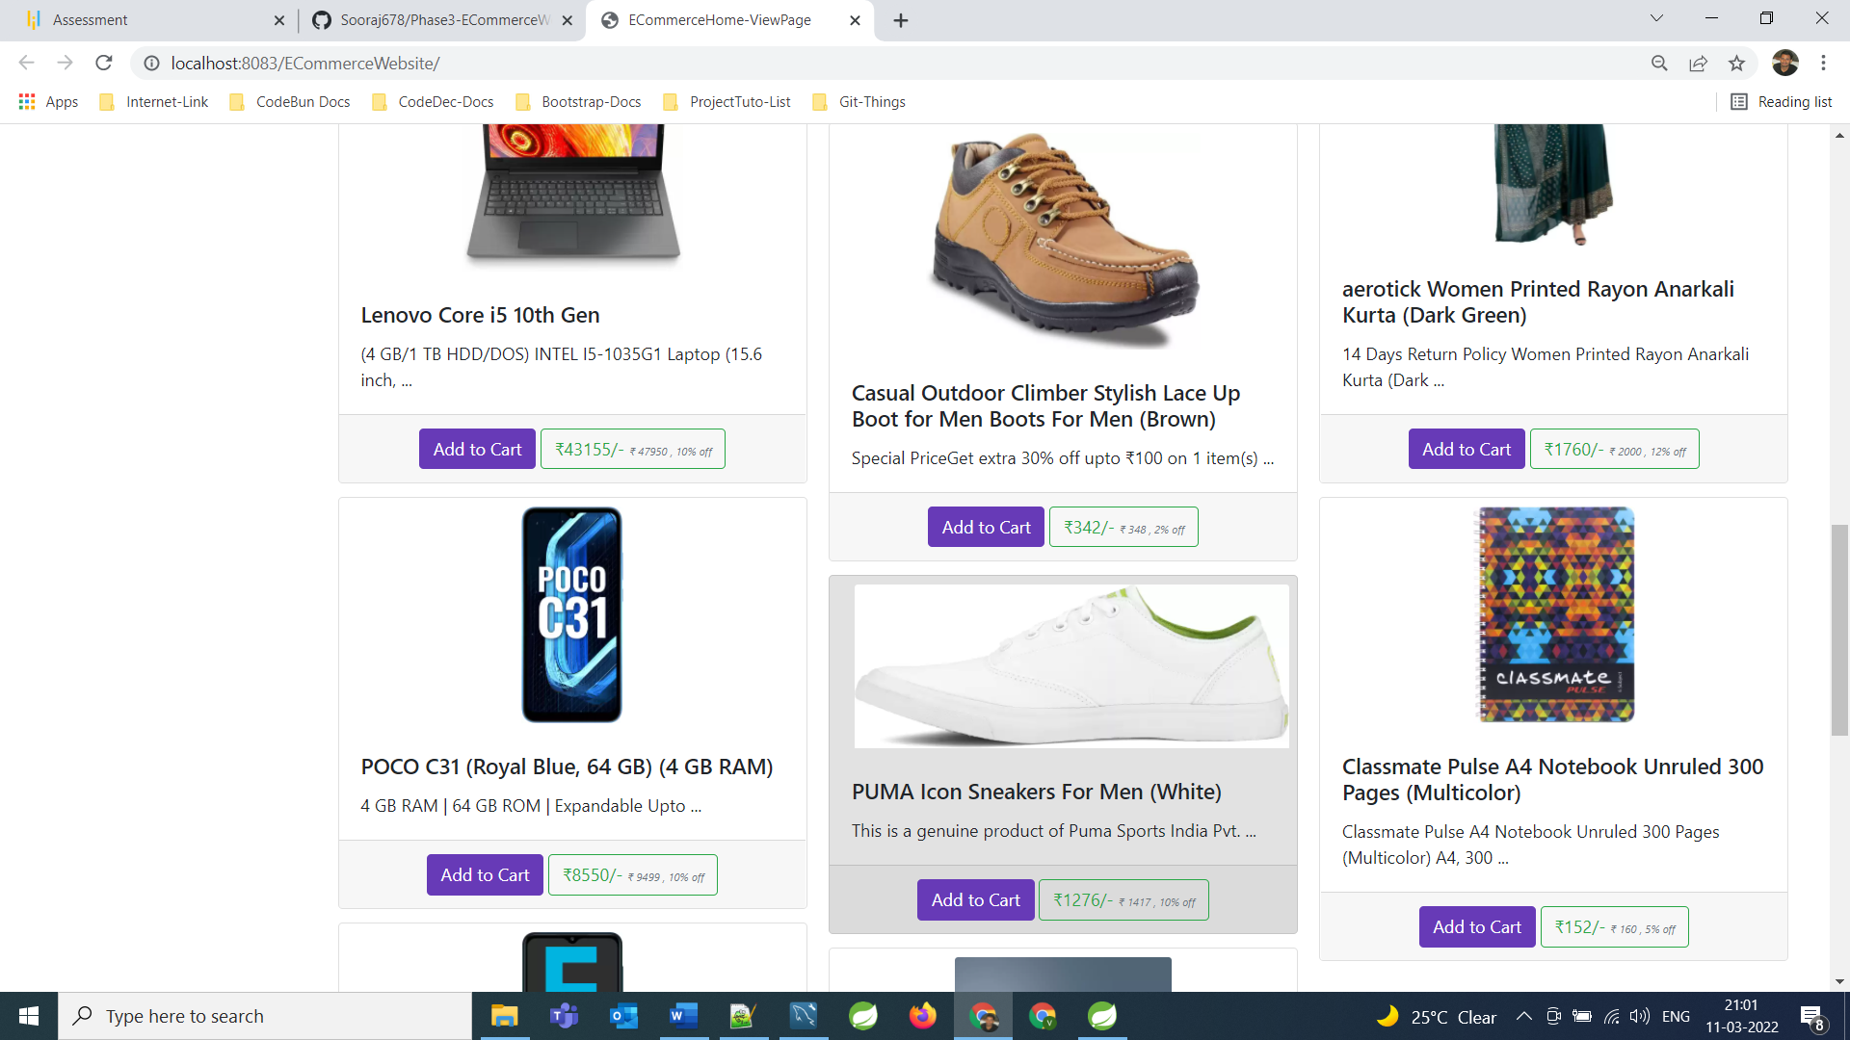

======================================================================================================================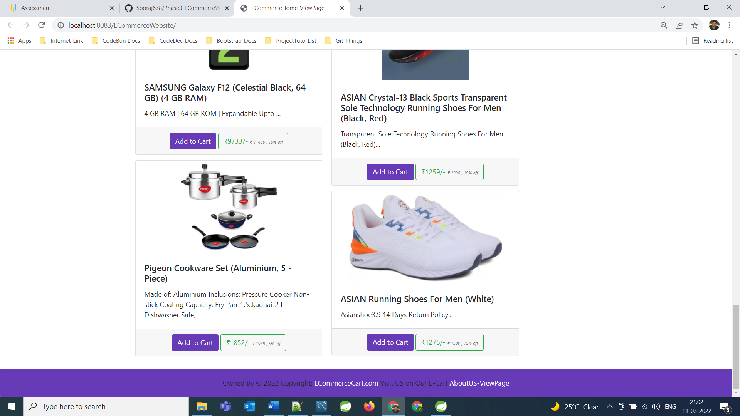

======================================================================================================================

**Now Add items/Products into the carts**

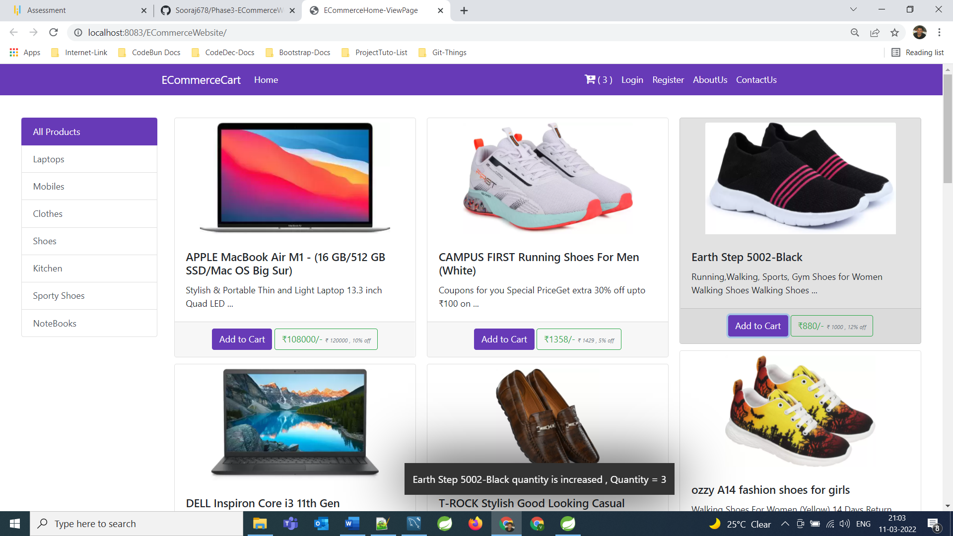

**====================================================================================================================**

**Added 5 items, 2 items are of different category and 3 item are of same category So, in the cart it is showing how many category’s products we have added and total items we can see inside cart …**

**====================================================================================================================**

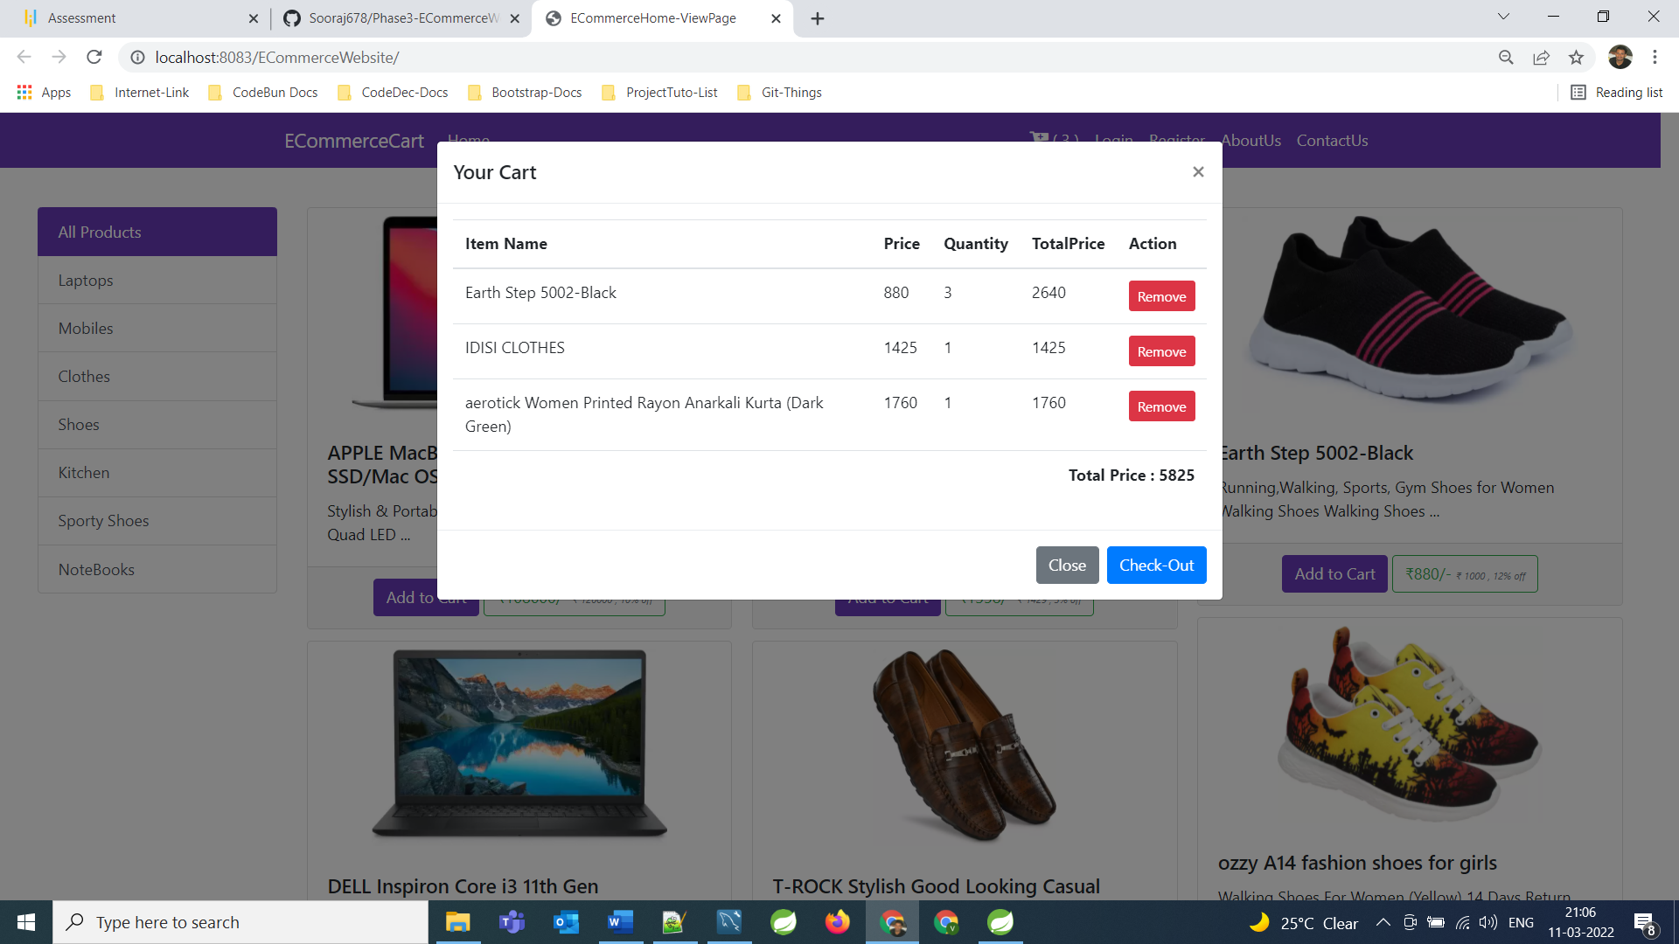

**====================================================================================================================**

**Now we go to for checkout Page**

**====================================================================================================================**

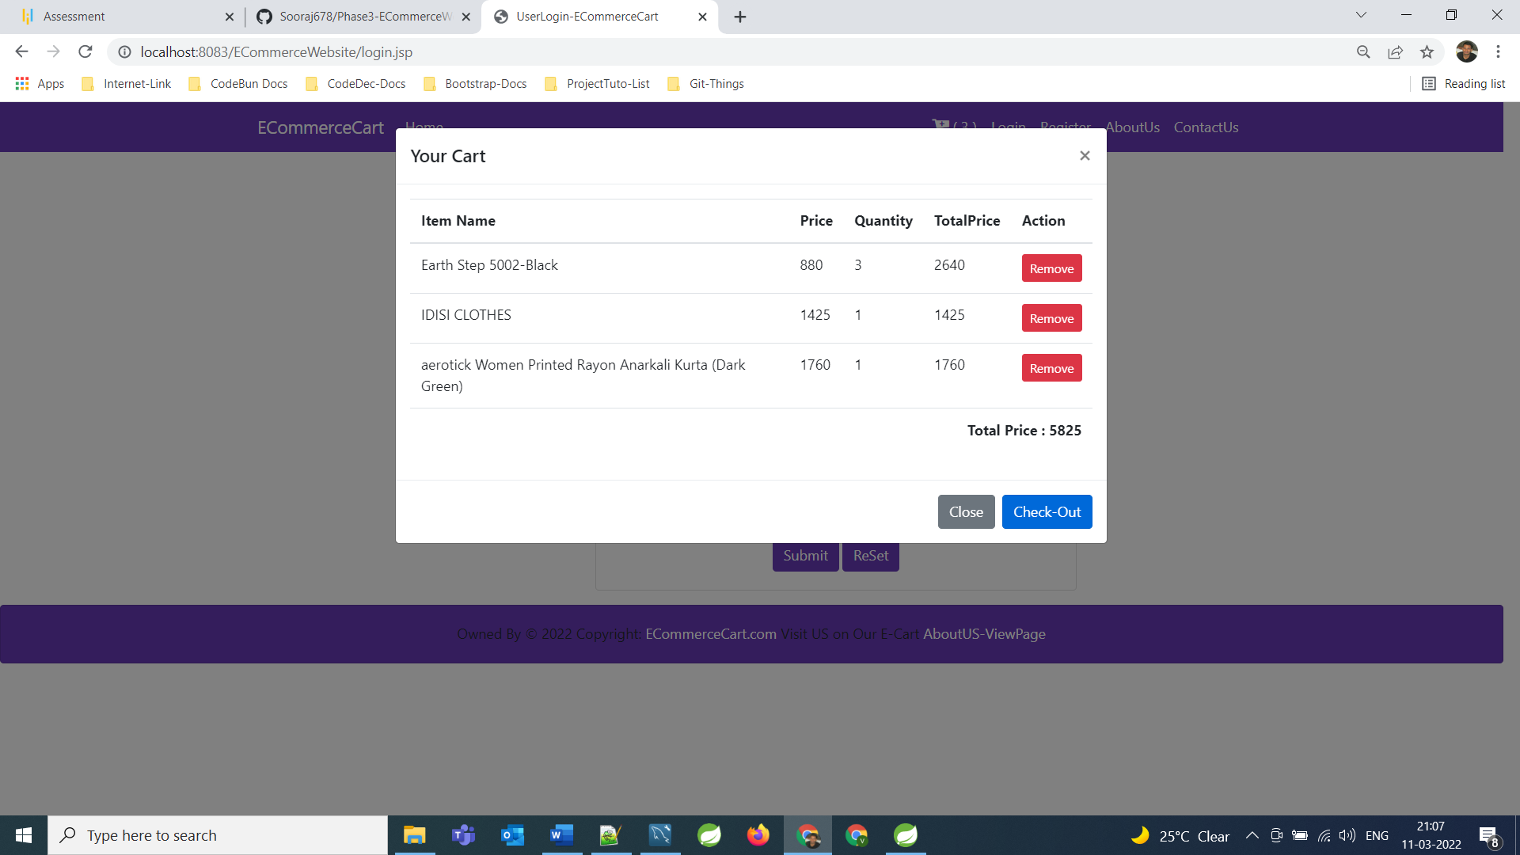

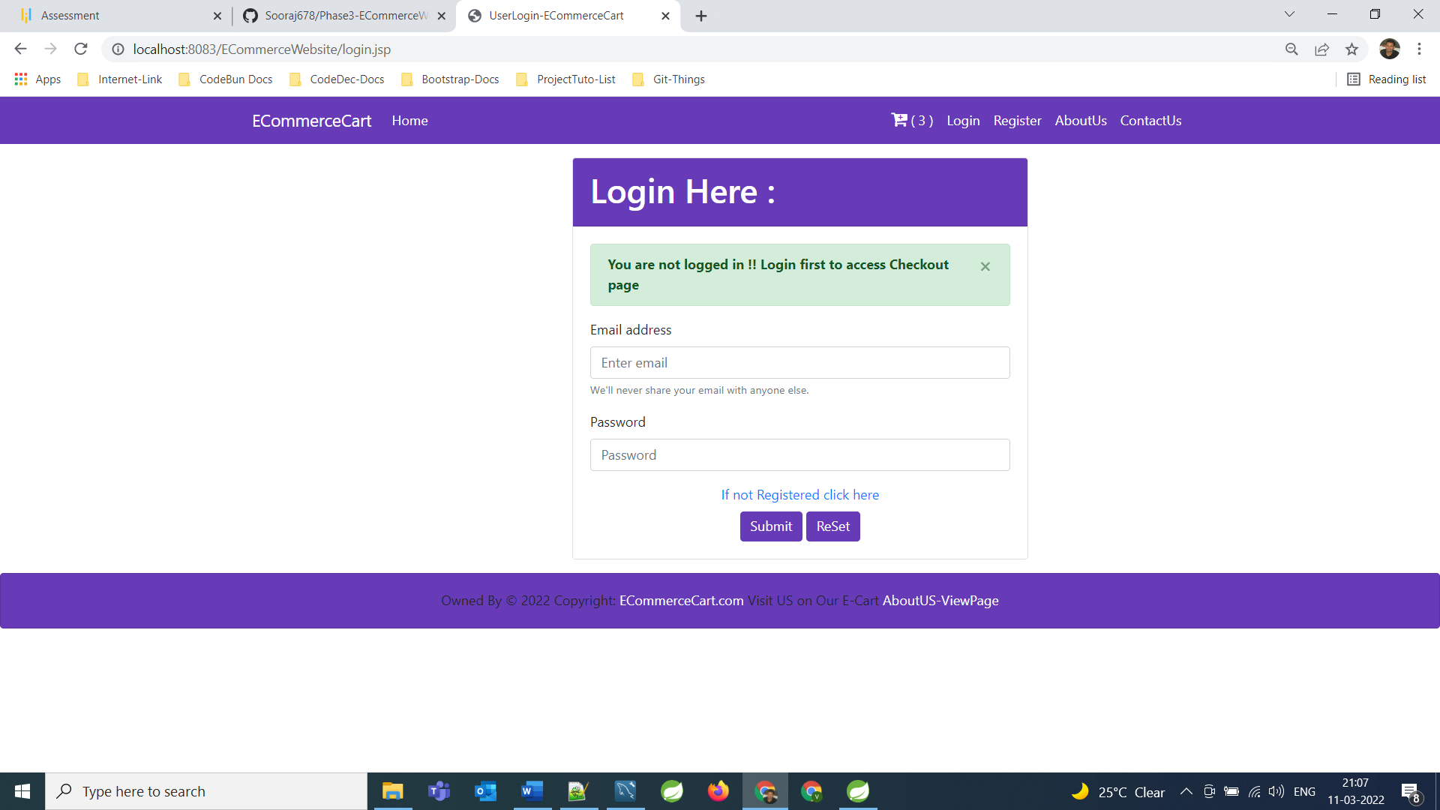

**As we can see we are not logged in so application is asking login credentials and after that we can go to checkout Page and rest Operation is same as we explained in user View Part.**

**====================================================================================================================**

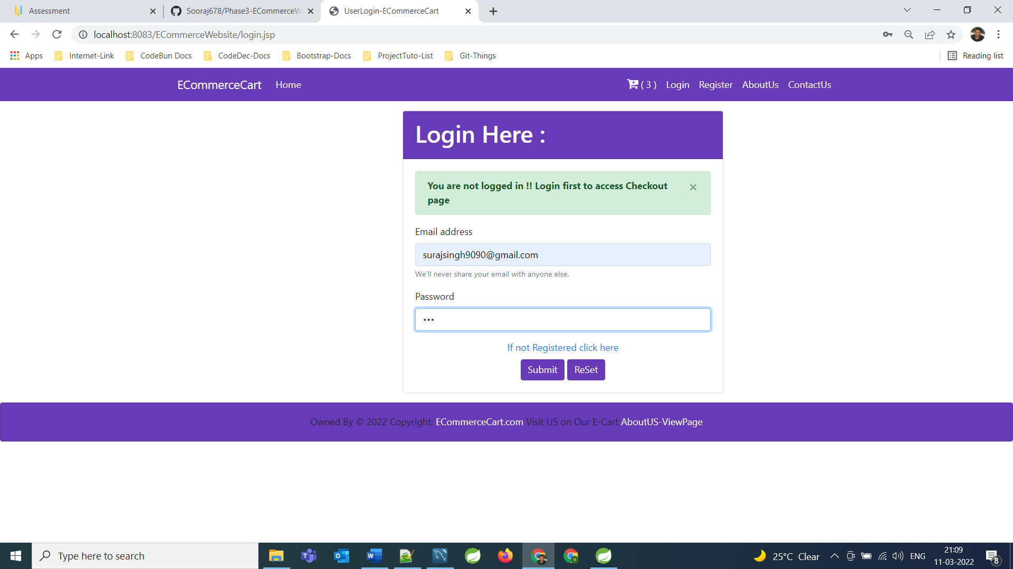

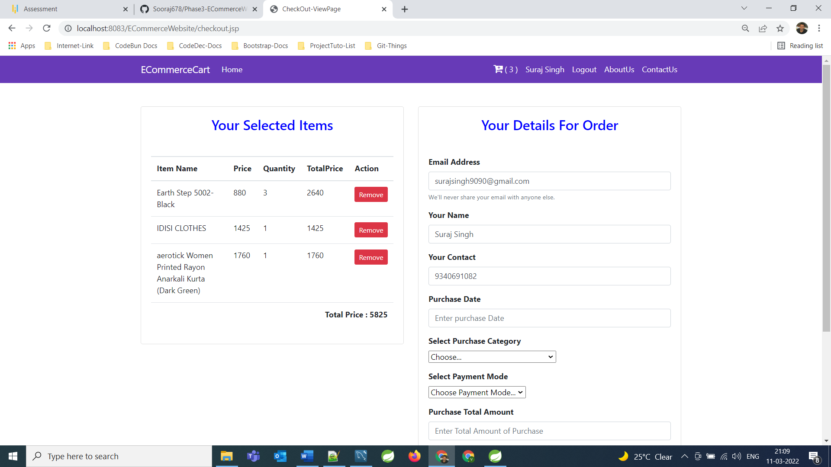

**Rest operations are same as we explained in User View Part**

**====================================================================================================================**

**About US View Page**

**====================================================================================================================**

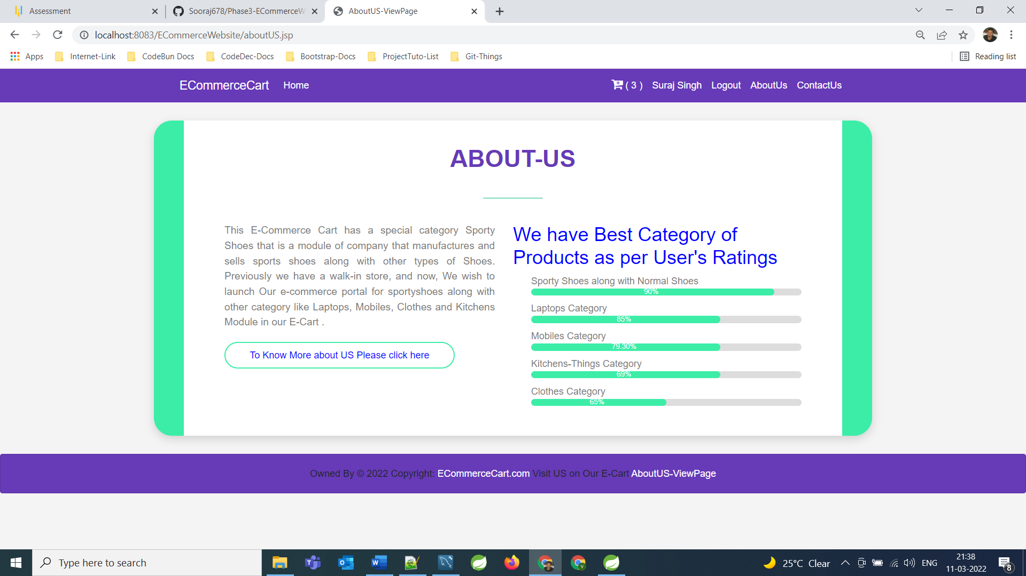

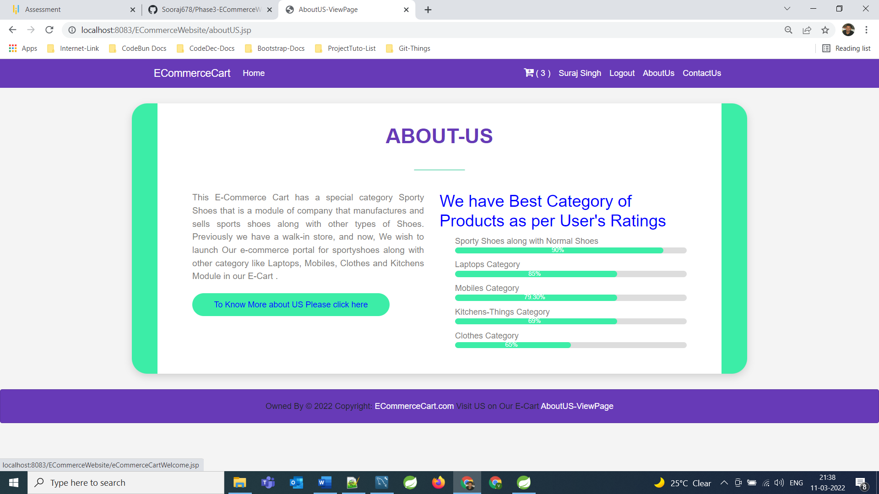

**====================================================================================================================**

**Contact US View Page**

**====================================================================================================================**

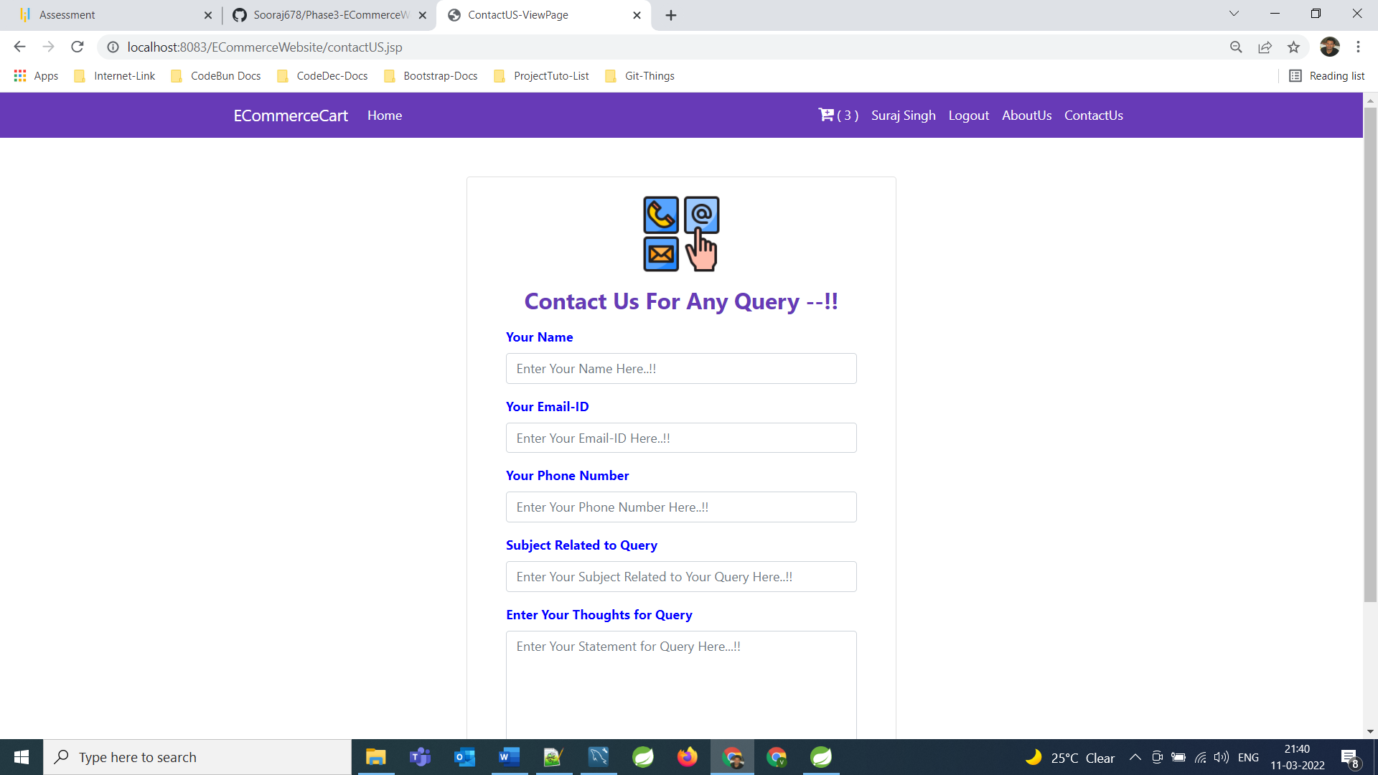

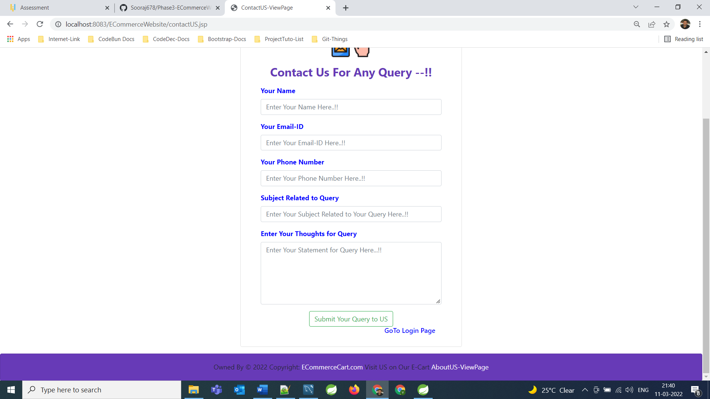

**From this Page User can submit their queries to the Application Owner. And this Queries data will get save in DB**

**====================================================================================================================**

**Database: -**

In order to store the data of the category , contactuser, product, user and purchasedrecord there is a master datatbase called ecommercewebsite-phase3.

There are 5 tables created to store the data.

1. Category: - all the added categories details go here.
2. Product: - contains all the detail data about products along with CategoryId for which current belongs
3. User: - contains all the data of users who has registered with us to Shop
4. PurchasedRecord: - contains all the records of purchased items by registered Users.
5. ContactUser: - contains query information coming from users

**The Backend (DATABASE)**

**Table 1: -Category**

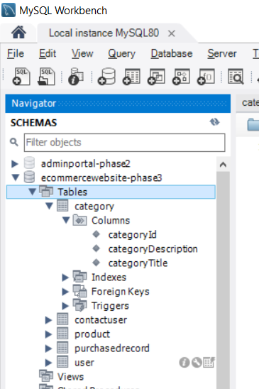

**Primary Key: - CategoryId**

**Not Null: - not any column.**

**Table 2: -Product**

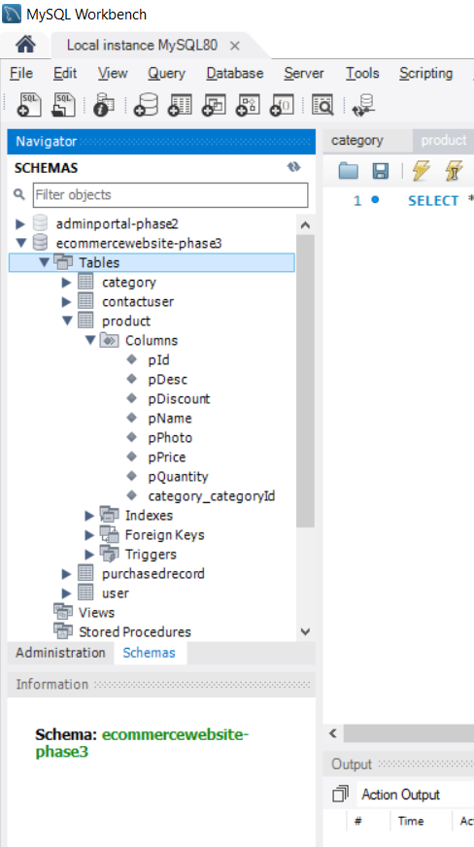

**Primary Key: - pId**

**Not Null: - category_categoryId.**

**Table 3: -User**

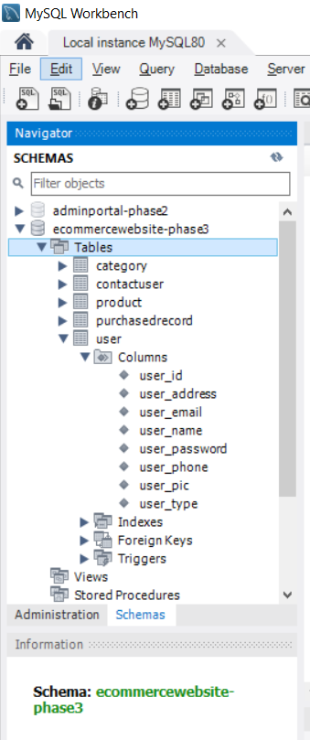

**Primary Key: -User-Id**

**Not Null: - not any column.**

**Table 4: -PurchasedRecord**

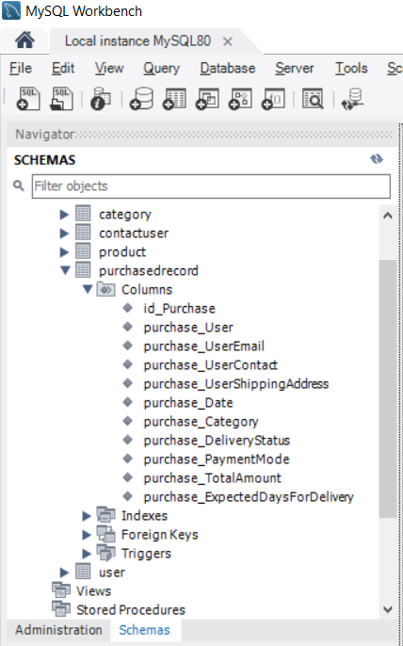

**Primary Key: - id_Purchase**

**Not Null: - not any column.**

**Table 5: -Contact User**

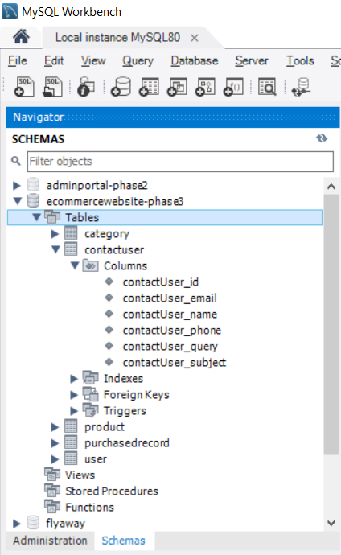

**Primary Key: - contactUser_id**

**Not Null: - All remaining ones.**

**For accessing ADMIN Portal given Credentials must be:**

Username [-surajsingh9090@gmail.com](mailto:-surajsingh9090@gmail.com)

Password -123

UserType -Admin

**6. GitHub link**

This section lists where the source code is located and from where the user can download and use it.

[**https://github.com/Sooraj678/Phase3-ECommerceWebsite**](https://github.com/Sooraj678/Phase3-ECommerceWebsite)